Dev Log

taper-web

# 1/11/18

## Initiate Project

### Github Setup

* create new repo called taper-web; keep it empty - no readme, ignore, license

### Create React App

Open Ubuntu shell

* cd /mnt/c/dev/src
* create-react-app taper-web

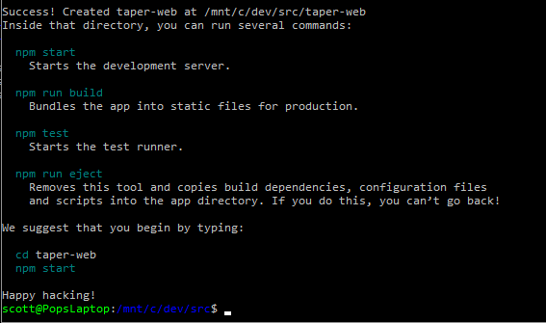

### Serve React App Locally

* cd taper-web
* npm start

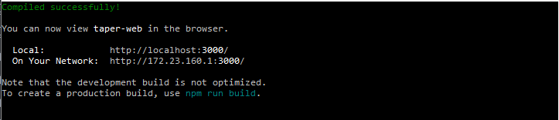

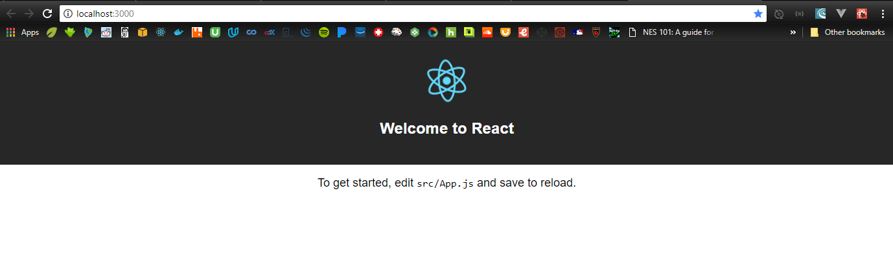

### Git Setup

Open a new Ubuntu shell

* cd taper-web
* mv README.md CreateReactApp-readme.md

(That readme is huge; it’s the one on create-react-app’s github repo. Make one for THIS project.)

* vi README.md
  + cut/paste the npm start, npm run, etc instructions into the readme
* git init
* git add .
* git commit –m “Initial commit: create-react-app scaffolding”

### Sync Git and Github

* git remote add origin <https://github.com/ScottHensen/taper-web.git>
* git push –u origin master

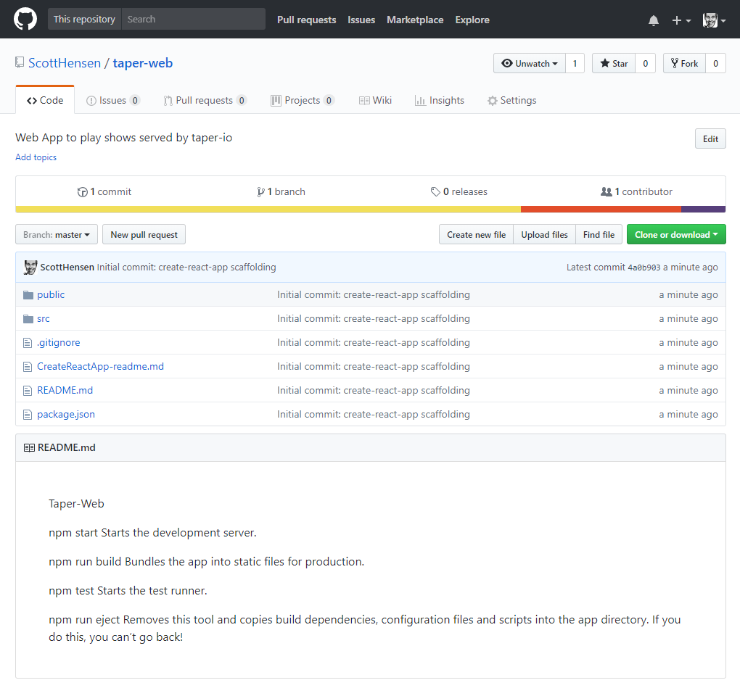

### Create this dev log

Woah… meta.

* mkdir doc
* save the log to taper-web/doc/devlog.docx
* git status
* git add .
* git commit –m “Add devlog doc”
* git push –u origin master

## Planning

A week of coding saves an hour of planning.

### Stories

GIVEN a user has [browser] open; WHEN the user navigates to taper web site; THEN the taper web landing page appears.

GIVEN taper landing page is open; WHEN the user clicks on an available show; THEN the show page replaces the landing page.

GIVEN the show page is open; WHEN the page loads; THEN the first song will begin playing at 70% volume.

GIVEN a song is playing; WHEN the song ends; THEN the next song will begin.

### Components

index.js

assets/

layouts/

primaryLayout

layout-helpers/

primaryHeader

sideMenu

aside

band/

tour/

show/

setlist/

set/

track/

styles/

utils/

xhr

## Build Landing Page

* Import project into editor
* Update manifest.json and index.html to use my title and favicon.
* Build the directory structure
* Move the files to the right directories; change the imports as I move them to keep the app working.

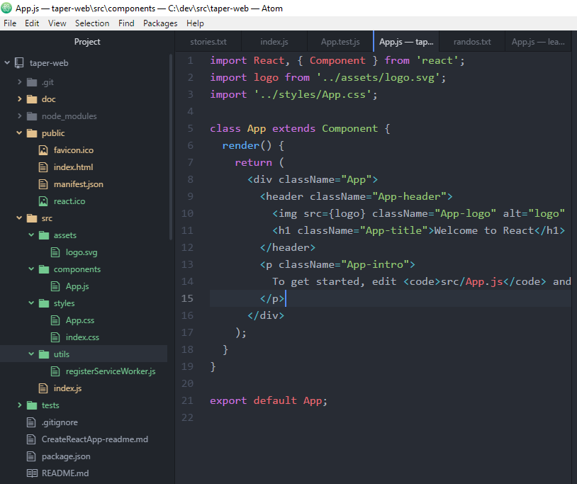

* Replace react boilerplate in App js with my content
* Swiped some layout and xhr code to use as boiler plate from [Brad Westfall’s phx react meetup example](https://github.com/bradwestfall/PhxReactMeetupTalk)

# 1/12/18

* Got missing module errors, so added these two…
* npm install –save react-router-dom
* npm install –save axios
* here’s how it looks now

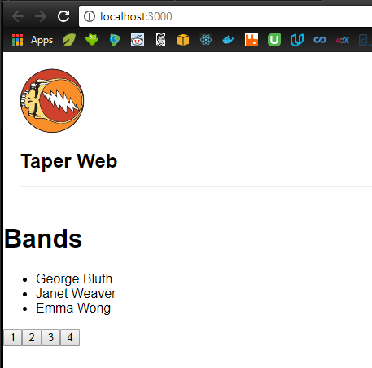

* git status
* git add .
* git commit –m “Add layout, bands page and simple xhr functionality”
* git push –u origin master

# 1/13/18

* removed the paging stuff from landing page
* added second page for bands
* added routing for the following
  + / -> landing
  + /bands -> landing
  + /bands/2 -> bands

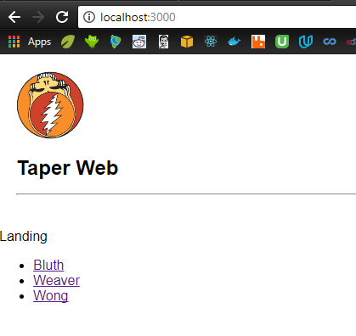

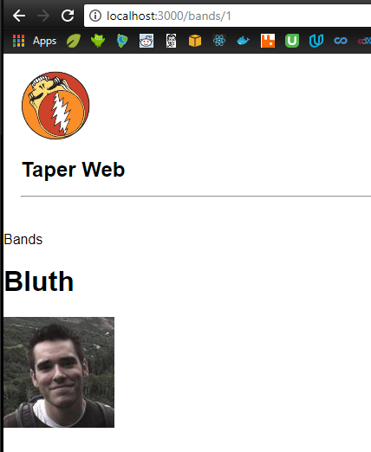

* git status
* git add .
* git commit –m “Add routing between landing page and bands page; removed paging.”
* git push –u origin master

## Build taper back-end

### Stories

#### receive taperRequest objects

* Band
* showDate
* showContainsSong
* showVenue
* Order: first, last, random, all

#### parse them to determine how best to call archive.org

* if Band not valid, return error
* if showDate valid, use it in filter
* if showSong valid, use it in filter
* if showVenue valid, use it in filter
* if orderValid, use it in response construction
* // allow just year, just mo/year, or the whole thing; note that archive.org uses “ccyy-mm-ddThr:mn:scZ”
* // band, song, venue must be escaped
* // band, song, venue could be mapped to dictionary if that’ll help make the searches more robust

#### construct the url

* base url = https: //archive.org/services/search/v1/scrape?fields=dir,title,date,subject,venue,sources&sorts=date&q=collection%3A
* append (<bandName>)
* If (showDate) append %20AND%20(<formatted showDate>)
* If (showSong) append %20AND%20(<showSong>)
* If (showVenue) append %20AND%20(<showVenue>)

#### call archive.org to get archiveResponse object

#### parse archiveResponse

* when order=first
  + title = items[0].title; venue = …
  + url = EMBED_URL_HDR + items[0].identifier // this is vulnerable to cross-site scripting; remember the right way to do it.
* When order=last, get items.length for index
* When random, generate a rando index
* When all

#### return taperResponse

### Hand-built archive.org get requests

#### play a random dead show.

<https://archive.org/services/search/v1/scrape?fields=dir,title,date,subject,venue,source&sorts=date&q=collection%3AGratefulDead>

pick one at random from json, then build this url...

https://archive.org/embed/<identifier>&autoplay=1

#### play a random dead show with IKO IKO

<https://archive.org/services/search/v1/scrape?fields=dir,title,date,subject,venue,source&sorts=date&q=collection%3A(GratefulDead)%20AND%20(Iko%20Iko)>

pick one at random from json, then build this url...

https://archive.org/embed/<identifier>&autoplay=1

#### play the last dead show with IKO IKO

<https://archive.org/services/search/v1/scrape?fields=dir,title,date,subject,venue,source&sorts=date&q=collection%3A(GratefulDead)%20AND%20(Iko%20Iko)>

pick the last one from json, then build this url...

https://archive.org/embed/<identifier>&autoplay=1

#### play IKO IKO from the 1995 show at Riverport

<https://archive.org/services/search/v1/scrape?fields=dir,title,date,subject,venue,source&sorts=date&q=collection%3A(GratefulDead)%20AND%20(Iko%20Iko)%20AND%20(Riverport)%20AND%20(1995)>

pick one from json, then build this url...

https://archive.org/metadata/<identifier>

find name where title="IKO IKO", then build this url...

https://archive.org/embed/<identifier>/<name><&autoplay=1

#### play every IKO IKO [in chrological order | in the 90s | at Madison Square Garden]

<https://archive.org/embed/jj2008-06-14.mk4&autoplay=1>

<https://archive.org/details/deadco2017-07-01.travitz.schoepsMK4v.fob.flac16>

#### Get all dead shows from archive.org ...

<https://archive.org/services/search/v1/scrape?fields=dir,title,date&q=collection%3ADeadAndCompany>

<https://archive.org/services/search/v1/scrape?fields=dir,title,date,subject,venue,source&sorts=date&q=collection%3ADeadAndCompany>

<https://archive.org/services/search/v1/scrape?fields=dir,title,date,subject,venue,source&sorts=date&q=collection%3AGratefulDead>

#### Now, just the ones that have IKO IKO in them...

<https://archive.org/services/search/v1/scrape?fields=dir,title,date,subject,venue,source&sorts=date&q=collection%3A(GratefulDead)%20AND%20(Iko%20Iko)>

#### Here's the last IKO IKO show - 95 STL...

<https://archive.org/embed/gd95-07-05.sbd.9370.sbeok.shnf&autoplay=1>

#### And here's the IKO IKO from 95 STL show...

<https://archive.org/embed/gd95-07-05.sbd.9370.sbeok.shnf/gd95-07-05d1t08.shn&autoplay=1>

#### Slap this in your app, and you'll be playing der chicago show! snoit!

<https://archive.org/embed/deadco2017-07-01.travitz.schoepsMK4v.fob.flac16&autoplay=1>

<https://archive.org/embed/10-29-15DeadAndCompanyTimesUnionCenterAlbanyNy&autoplay=1>

Curl…

<https://archive.org/services/search/v1/scrape?fields=dir,title,date,subject,venue,source&sorts=date&q=collection%3AGratefulDead>

https://archive.org/services/search/v1/scrape?q=collection%3AGratefulDead&fields=dir,title,date,subject,venue,source

# 1/14/18 14:30

## NOTE: Lex chatbot to Alexa Skill

<https://aws.amazon.com/about-aws/whats-new/2017/09/export-your-amazon-lex-chatbot-to-the-alexa-skills-kit/>

you can port a lex app to alexa ; see Lex [doc](http://docs.aws.amazon.com/lex/latest/dg/export.html) and [faq](https://aws.amazon.com/lex/faqs/#alexa)

## New plan

At first, I thought about building the lambda/gateway backend all by itself instead of hooking it to awsmobile, but I am deciding now that awsmobile + a very simple web front end kind of belong together, so I will let awsmobile handle do the scaffolding for me. The front-end will probably remain webby and unpolished. I will create a separate mobile/web app to consume the taper api; that’s the one that will be user-facing.

Because of this decision, I realize I’ve named the project wrong. I’m going to rename taper-web to taper. Starting from a clean slate, I will build a taper react app, put it in a new github repo, add awsmobile, build out the interface to archive.org, configure the backend’s analytics, messaging, etc.

## Start a brand new AWS Mobile Hub app

### Scaffold React Front-End

Open Ubuntu shell

* cd /mnt/c/dev/src
* create-react-app taper-web

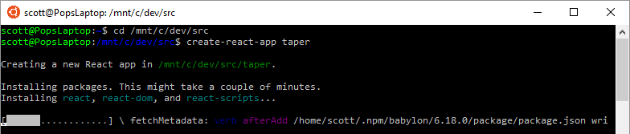

… five minutes later …

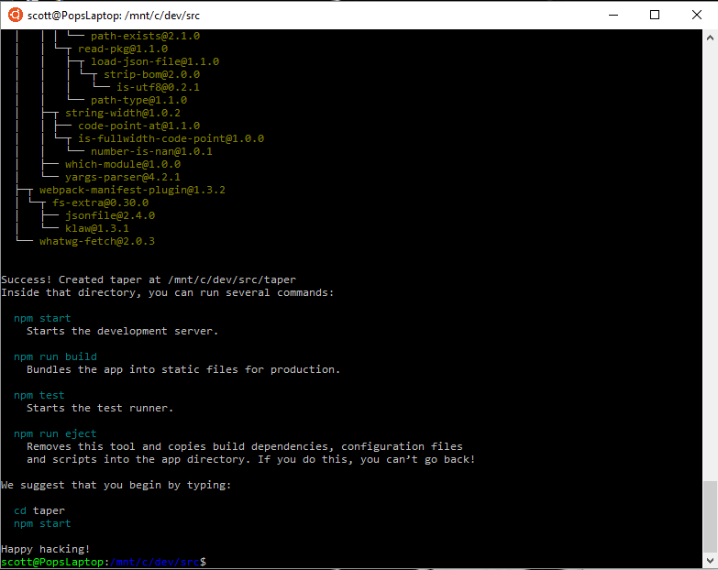

### Serve React App Locally

* cd taper-web
* npm start

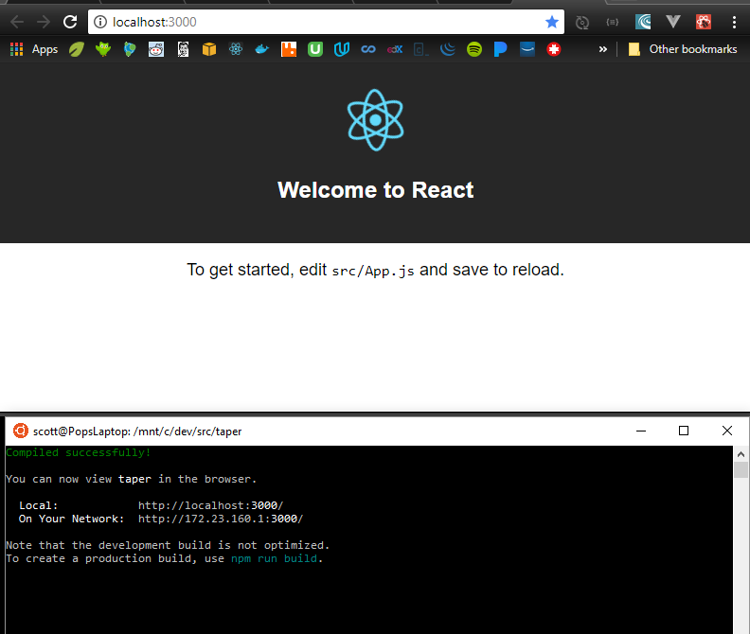

### Scaffold Node Back-end

Open Ubuntu shell

* cd /dev/src/taper
* awsmobile init

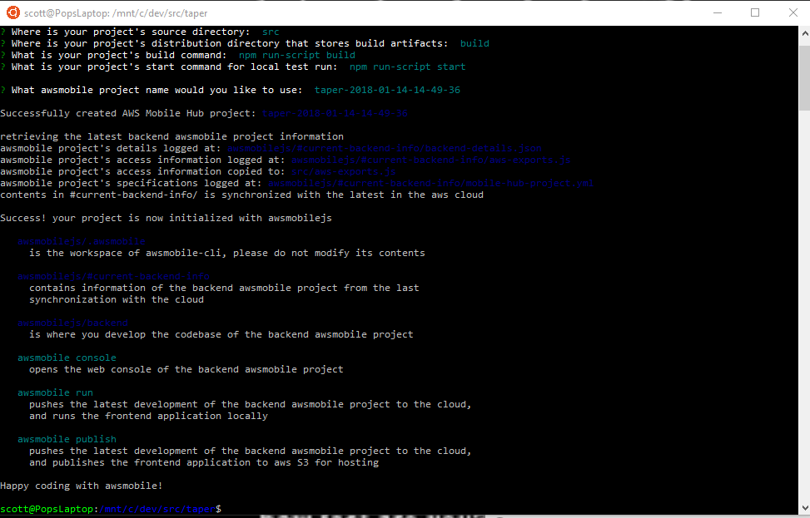

### Connect Front-end to Back-end with Amplify

* add to index.js: import Amplify from ‘aws-amplify’;
* add to index.js: import aws_exports from ‘./aws-exports.js’;
* add to index.js: Amplify.configure(aws_exports);
* note: this will break the locally running app because aws-amplify isn’t in node_modules yet.
* Awsmobile run // runs npm install to load new npm_modules, syncs local and cloud backends, pushes synced backend to awsmobile, then runs npm start

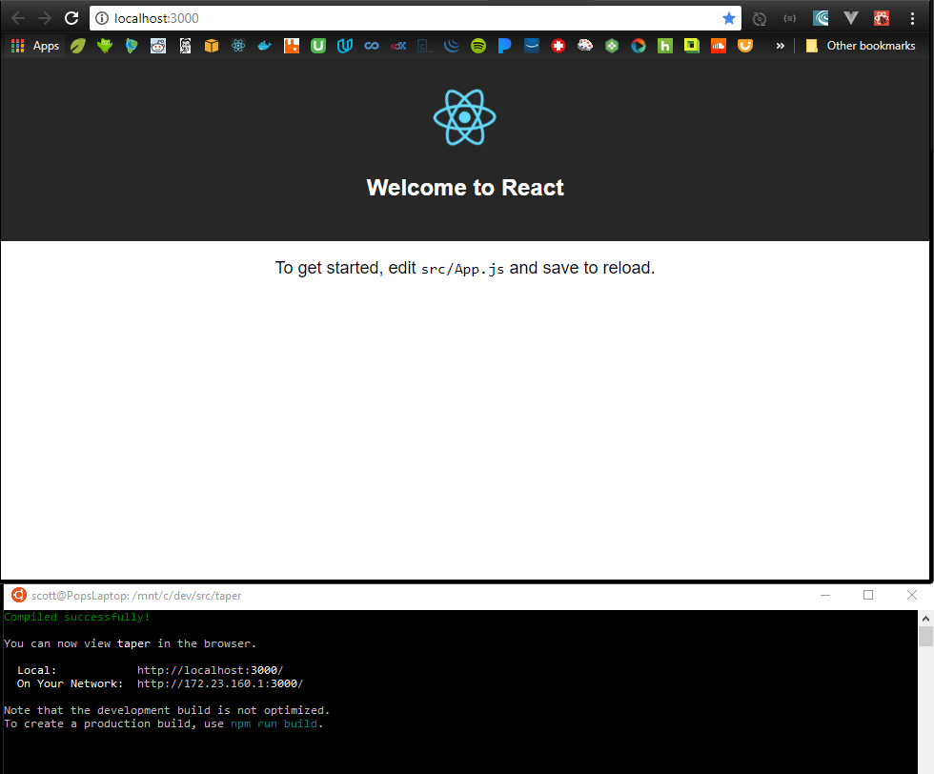

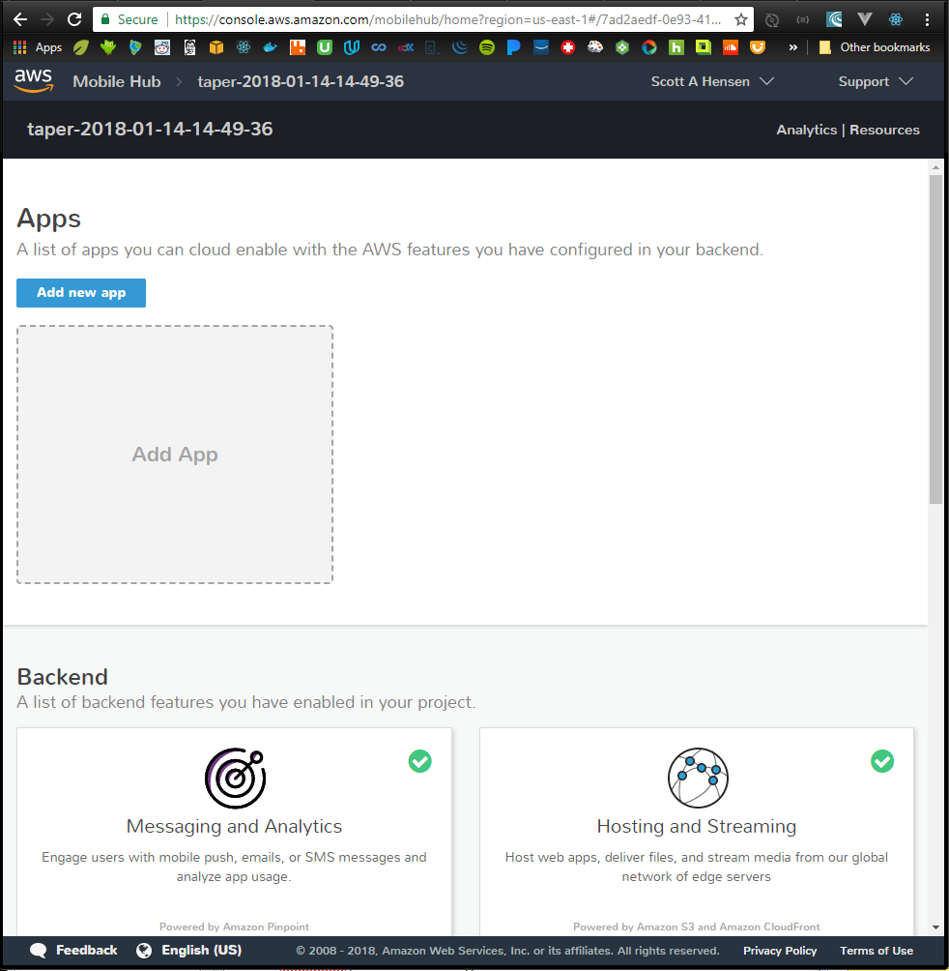

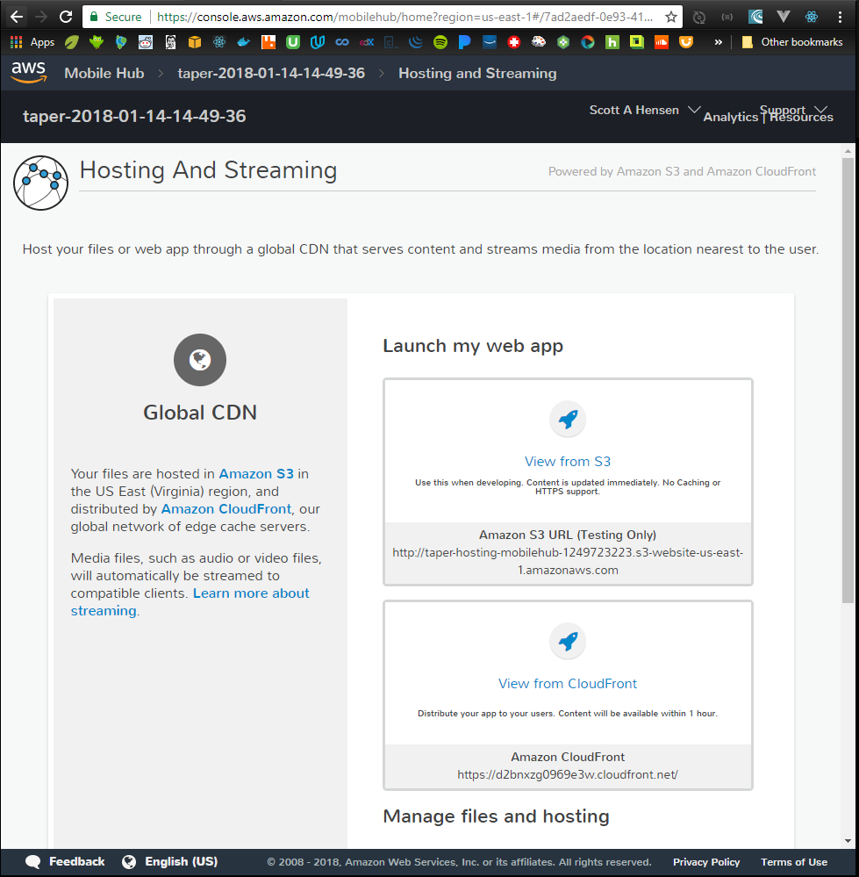

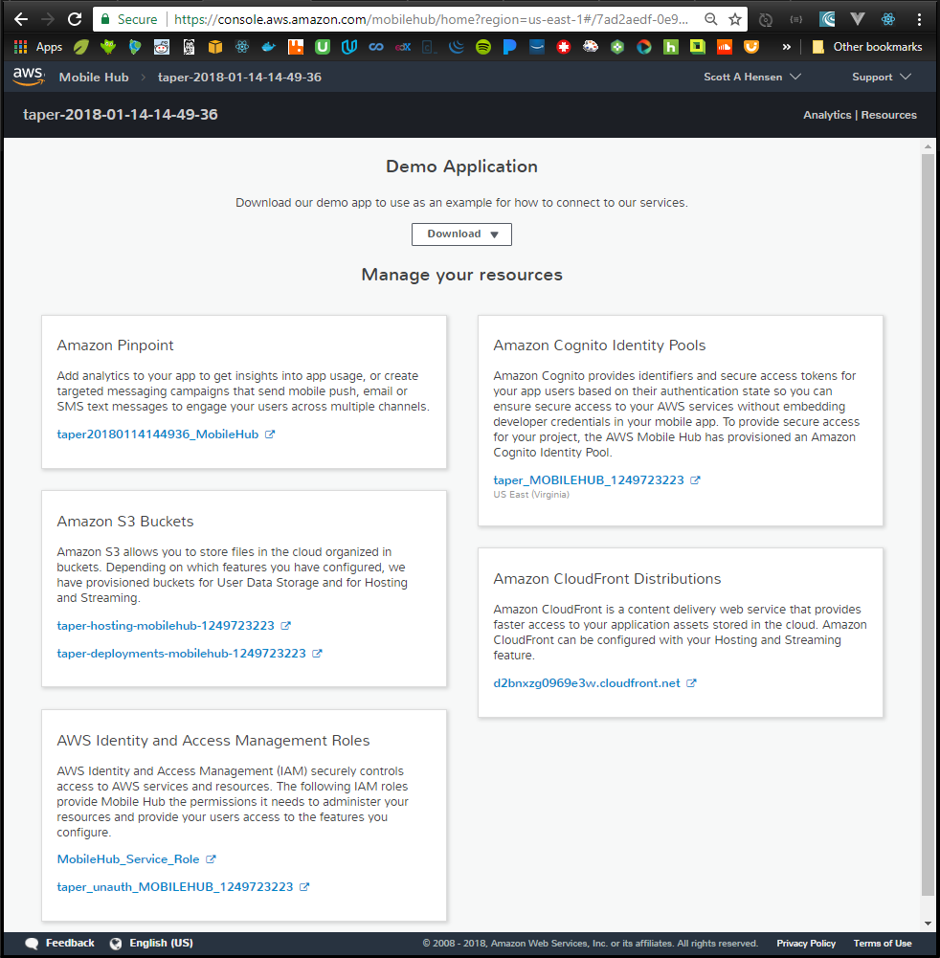

### Set up Repository

* Create new github repo – completely empty; no .gitignores, no readmes
* cd /mnt/c/dev/src/taper
* replace the huge react readme with one specific to taper
  + > mv README.md react-README.md
  + > vi README.md
  + add some basic stuff
* git init
* git status
* git add .
* git commit –m “Initial commit: create-react-app & awsmobile scaffolding”
* create github repo
* git remote add origin <https://github.com/ScottHensen/taper.git>
* git push –u origin master

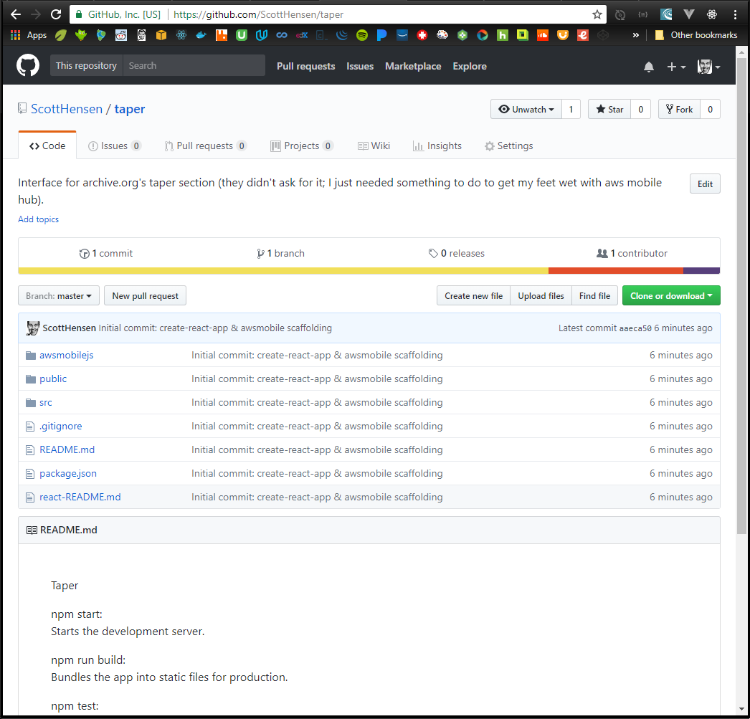

### Deploy the front-end

* Pick One:
  + > awsmobile publish // does a prod build, deploys, serves it on mobile hub s3
  + > awsmobile publish –test // dash-dash; deploys it and runs it through aws device farm test service

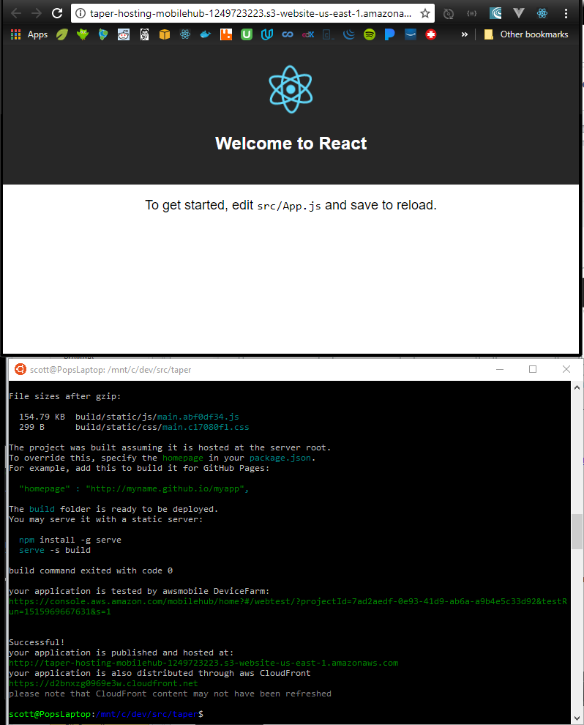

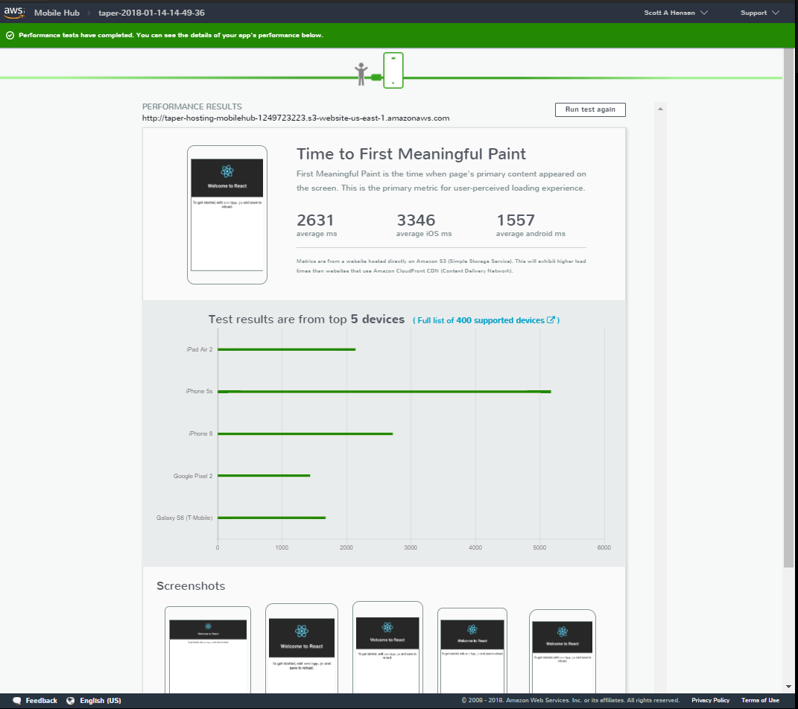

### Finished!

* Start Time = 14:30
* Scaffolded a new react front-end with create-react-app
* Scaffolded a new node back-end with awsmobile init
* Connected the two
* Committed the working app to a repository before I started breaking things
* Deployed the front-end to aws mobile hub (the backend was deployed when it was scaffolded)
* Verified the app on aws device farm
* Stop Time = 15:50

## Build a basic front-end

* Rearrange the project folders/files to how I like them.
  + Add these folders to source: /assets, /components, /utils
  + Add these folders to components: /app, /layouts
  + Move App.* from /src to /src/app. Fix the bugs created by the move.
  + Move logo.svg to /src/assets. Fix the bug created.
  + Move registerServiceWorker.js to /src/utils. Fix the bug created.
* Update public components
  + index.html’s title,
  + manifest’s metadata, and
  + replace react favicon with Bob
* Add primary header and layout components; hook it into app.js
* Git commit
* Stop Time = ~1hr

## Add archiveRequestForm component

#### Story: receive taperRequest objects

* Band
* showDate
* showContainsSong
* showVenue
* Order: first, last, random, all

##### Build it

* Make this component a class so that a state object can be maintained
* Build a label/input-value table for each search parameter
* Add handleInputChange() to update state when a value is updated
* Add submit button and handleSubmit()
* Add archiveRequestForm.css to make it a little nicer looking
* Hook archiveRequestForm into PrimaryLayout component
* Git commit
* Stop Time = ~1hr

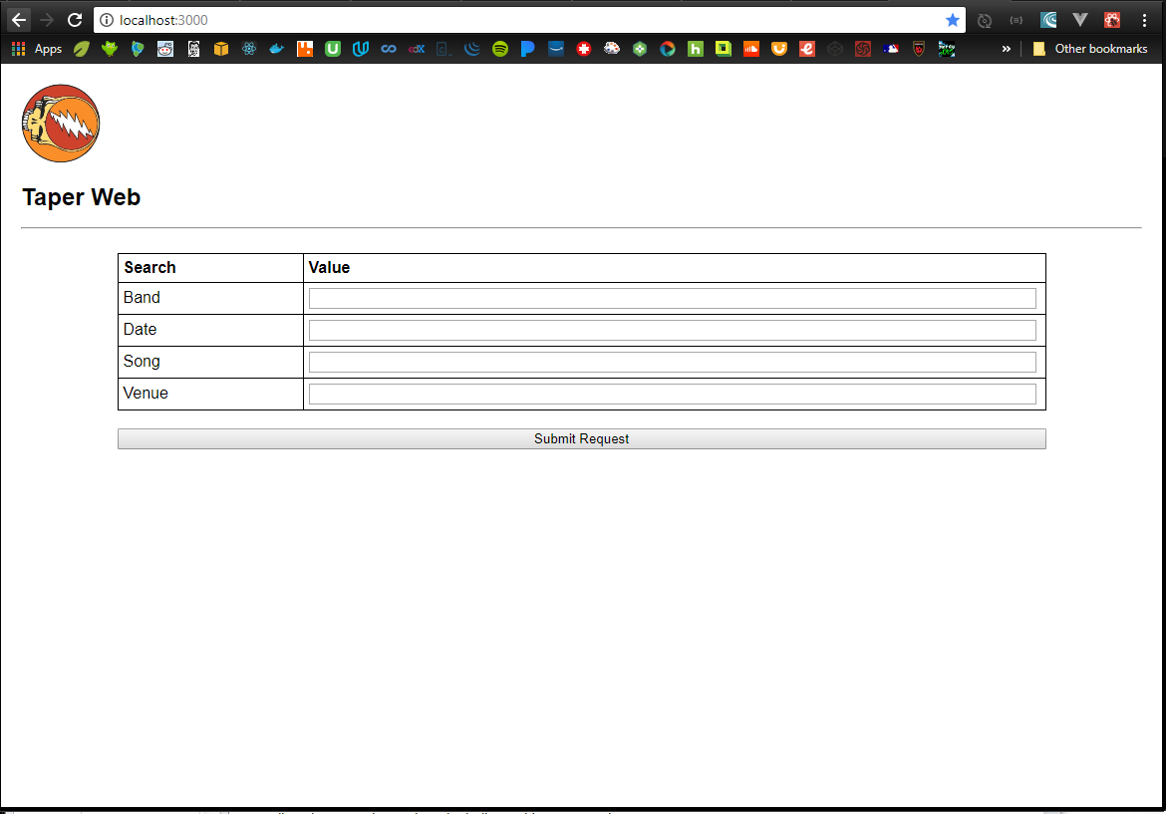

#### Story: parse them to determine how best to call archive.org

* if Band not valid, return error
* if showDate valid, use it in filter
* if showSong valid, use it in filter
* if showVenue valid, use it in filter
* if orderValid, use it in response construction
* // allow just year, just mo/year, or the whole thing; note that archive.org uses “ccyy-mm-ddThr:mn:scZ”
* // band, song, venue must be escaped
* // band, song, venue could be mapped to dictionary if that’ll help make the searches more robust

Build It

* Add buildArchiveRequest to utils
* Hook it to ArchiveRequestForm

#### Story: construct the url

* Modified buildArchiveRequest to encode, filter, join and build final url
* Returning url to caller ArchiveRequestForm
* Git commit
* Stop time = ~2hr

## Add archiveResponse component (to dispay json)

* Added component, hooked it into ArchiveRequestForm

## Add a get api to back-end

* Added xhr to archive.org with the built searchUrl
* Got a CORS error (testing on chrome local host)
* Executed npm run build (build a prod version, so I can run it on a server)
* npm install –g serve
* serve –s build

## Add an api call to the front-end

* added. Getting cors error

## Error Will Robinson! Design Error!

The /services searches work fine from browser url bar and curl, but they are being blocked by CORS when running from my domain. Try the advancedsearch feature…

* <https://archive.org/help/json.php>
* https://archive.org/advancedsearch.php?q=licenseurl:(*creativecommons.org*)&fl[]=identifier,title,mediatype,collection&rows=1&output=json
* <https://archive.org/services/search/v1/scrape?fields=dir,title,date,subject,venue,source&sorts=date&q=collection%3A(GratefulDead)%20AND%20(Iko%20Iko)%20AND%20(Riverport)%20AND%20(1995)>
* [https://archive.org/advancedsearch.php?q=Grateful+Dead+Iko+Iko+Riverport&fl[]=dir,title,date,venue,source&rows=50&output=json&callback=callback](https://archive.org/advancedsearch.php?q=Grateful+Dead+Iko+Iko+Riverport&fl%5b%5d=dir,title,date,venue,source&rows=50&output=json&callback=callback)
* LOOKS LIKE ARCHIVE.ORG DEFECTS ARE TRACKED IN A PRIVATE TOOL AND WORKED BY A PRIVATE TEAM, SO I CAN’T JUST GO UPDATE THE CORS HEADER. [SOMEONE ELSE MUST HAVE ALREADY TRIED THIS AND IT FAILED FOR SOME REASON; THERE’S NO WAY THIS PROBLEM WOULD STILL EXIST IF THE ANSWER WERE A SIMPLE CONFIG CHANGE. GOING TO LOOK FOR A PLAN B.

## Plan B: See if archive.org provides another way

internet archive s3 search <http://archive.org/help/abouts3.txt>

the new api… <https://archive.readme.io/docs/fulltext-search>

this works!... <https://api.archivelab.org/search?q=collection%3A(GratefulDead)>

NEXT… figure out how to add search criteria and sort to this new api call…. If that stuff exists.

The github repo is here… <https://github.com/ArchiveLabs/api.archive.org>

Could always go fix archive.org by adding the cors header and making a pull request.

# 1/16/18

## Plan C: Where there’s a will

If I can’t get api.archivelab.org to return the data I want, then I will do this…

* Build a little ETL script to
  + hit the search service from a linux shell
  + save the json as a flat file
  + Store the data in dynamoDB
* Change the front-end to pull data from dynamo to create embed url
* Phase 2 – build a batch job that’ll pull data and update the database with delta

At first, I’ll run the script manually. If that works, then I’ll see about adding a daily batch job to keep my dynamo instance in sync with archive.org.

Get all date/file items for GratefulDead =

<https://archive.org/services/search/v1/scrape?fields=date,identifier&sorts=date&q=collection%3AGratefulDead>

// that doesn’t work with curl, but this does…

<https://archive.org/services/search/v1/scrape?q=collection%3AGratefulDead>

// it only returns items[] of identifier. Page contains 5000 of 12868

Results =

{

"items":

[

{"date":"1965-11-01T00:00:00Z","identifier":"gd1965-11-01.sbd.bershaw.5417.sbeok.shnf"},

{"date":"1965-11-03T00:00:00Z","identifier":"gd65-11-03.sbd.vernon.9044.sbeok.shnf"},

…

{"date":"1983-04-16T00:00:00Z","identifier":"gd1983-04-16.137372.set2.m160.miller.flac24"}

],

"count":5000,

"cursor":"W3siZGF0ZSI6IjE5ODMtMDQtMTZUMDA6MDA6MDAuMFoifSx7ImlkZW50aWZpZXIiOiJnZDE5ODMtMDQtMTYuMTM3MzcyLnNldDIubTE2MC5taWxsZXIuZmxhYzI0In1d",

"total":11972

}

Get metadata for each identifier =

<https://archive.org/details/gd1994-07-27.AKG451.Darby.119473.Flac1648> <https://archive.org/metadata/gd1994-07-27.AKG451.Darby.119473.Flac1648>

// this works in curl

Results =

{

"created": 1516147639,

"d1": "ia601609.us.archive.org",

"d2": "ia801609.us.archive.org",

"dir": "/9/items/gd1994-07-27.AKG451.Darby.119473.Flac1648",

"files": Array[89][

{

"name": "Gd1994-07-27TicketStub.jpg",

"source": "original",

"format": "JPEG",

"title": "gd1994-07-27 Ticket Stub",

"mtime": "1331694768",

"size": "213444",

"md5": "d17966760d9e9fd79080da4834fe0727",

"crc32": "29ac3ca5",

"sha1": "738d9076fbd7975a6a969924519312fcb7c41993",

"rotation": "0"

},

…

{

"name": "gd1994-07-27.AKG451.t11.flac",

"source": "original",

"format": "Flac",

"length": "567",

"mtime": "1331695776",

"size": "75792100",

"md5": "b86a9962e8ce520a2cb4430c09589378",

"crc32": "31404c1e",

"sha1": "5df71d0984c7caaf2774968089679995538937b3",

"title": "Iko Iko",

"creator": "Grateful Dead",

"album": "1994-07-27 - Riverport Amphitheatre",

"track": "11",

"height": "768",

"width": "1024",

"external-identifier": "urn:acoustid:e45e5912-d461-4eaf-9a9c-5a522e08821f"

},

{

"name": "gd1994-07-27.AKG451.t11.mp3",

"source": "derivative",

"creator": "Grateful Dead",

"title": "Iko Iko",

"track": "11",

"album": "1994-07-27 - Riverport Amphitheatre",

"bitrate": "211",

"length": "09:27",

"format": "VBR MP3",

"original": "gd1994-07-27.AKG451.t11.flac",

"mtime": "1331782525",

"size": "14949603",

"md5": "aed3282ca048901503ef7ecefc25161f",

"crc32": "c91a2a66",

"sha1": "dc8c4fda1a72ad481f805c103d40d8ca69712806",

"height": "0",

"width": "0"

},

…

{

"name": "gd1994-07-27.AKG451.t19.png",

"source": "derivative",

"format": "PNG",

"original": "gd1994-07-27.AKG451.t19.flac",

"mtime": "1414116625",

"size": "10220",

"md5": "ec8d5ce97d121f8d3fbbedc1cfd830d0",

"crc32": "240685b3",

"sha1": "5e8ae221cee6e7f2cd2d5fd64e2c78d4406c7569"

}

],

"files_count": 89,

"item_size": 1691293493,

"metadata": {

"identifier": "gd1994-07-27.AKG451.Darby.119473.Flac1648",

"uploader": "mvernon54@yahoo.com",

"addeddate": "2012-03-14 12:31:28",

"date": "1994-07-27",

"title": "Grateful Dead Live at Riverport Amphitheatre on 1994-07-27",

"creator": "Grateful Dead",

"mediatype": "etree",

"collection": Array[2][

"GratefulDead",

"etree"

],

"type": "sound",

"description": "Set 1\n\nHere Comes Sunshine, Walkin' Blues, Jack-A-Roe, Black Throated Wind, Just Like Tom Thumb's Blues, Ramble On Rose, Let It Grow\n\nSet 2\n\nBox Of Rain, Iko Iko, Way to Go Home, Corinna-> Jam-> Drums-> Space-> The Last Time-> The Days Between-> Around & Around, E: Liberty\n\n* Weir on acoustic guitar",

"year": "1994",

"subject": "Audience;Darby;Keo",

"venue": "Riverport Amphitheatre",

"coverage": "Maryland Heights, MO",

"source": "<b>flac16/48kHz</b>; Master Audience Recorded By Mr. Darby; AKG451EB/CK1's (DIN/DFC/First 1/4 Of OTS/9 Feet High)> Whirlwind Phantoms>Teac DA-P20 @ 16/48; Transfer Information:Sony R500>Tascam HD-P2 @ 16/48> HDD>Amadeus Pro (Tracking/Fades/FLAC8); Tracks Renamed/Metadata Tagging With Tag&Rename By Keo",

"taper": "Mike Darby",

"transferer": "Keo",

"md5s": "9b7c3b591a6cb4a8446e8769f29b46df *gd1994-07-27.AKG451.t01.flac a8cb1189881ce869ec65594d81b78344 *gd1994-07-27.AKG451.t02.flac d5aaac6f2004352bf408b426902cad07 *gd1994-07-27.AKG451.t03.flac d260e5b593b323dcfbeee780a7a997cd *gd1994-07-27.AKG451.t04.flac 88e7342cfcacf90e62bd0d542495faab *gd1994-07-27.AKG451.t05.flac c3f3d7d0b5660261f98e362a808315f8 *gd1994-07-27.AKG451.t06.flac a42a1f6c042bdc663eef41de00549653 *gd1994-07-27.AKG451.t07.flac adbbd065c0b6a542f44911896c4e000a *gd1994-07-27.AKG451.t08.flac 9abf6ebc8435dac484d606134f89dd64 *gd1994-07-27.AKG451.t09.flac 8570c727d5d0ac69d53b49e974663500 *gd1994-07-27.AKG451.t10.flac b86a9962e8ce520a2cb4430c09589378 *gd1994-07-27.AKG451.t11.flac 959cbae08a4261357c3b1e42d8ba8de9 *gd1994-07-27.AKG451.t12.flac a0a1e1fdca8d38e743e4f39f97e9b91a *gd1994-07-27.AKG451.t13.flac b950e8f176df0395a9ce9813c9343a17 *gd1994-07-27.AKG451.t14.flac d00b5f1e264c9bf2912911b91e748d80 *gd1994-07-27.AKG451.t15.flac ea66fe1ae31c1aace8b7885c9ade49e7 *gd1994-07-27.AKG451.t16.flac 7c927fa008ba678ede649afd5944d476 *gd1994-07-27.AKG451.t17.flac 18de235cb766a7df5d76aa9f480f33ae *gd1994-07-27.AKG451.t18.flac 80e1e74a8582740eb43230ebb95691ac *gd1994-07-27.AKG451.t19.flac",

"notes": "* Bob Weir On Acoustic Guitar *\n\n Comments:And another Huge Thanks out to Mr. Darby\nfor recording and sharing his source for this GD\n1994 summer show!Another fantastic recording from\nthe Darby collection!Mr. Darby has a second set of\nmaster tapes from cassettes to share down the line!\nAs always ENJOY!!!!!!!!!!!!!!!!!!!!!!",

"publicdate": "2012-03-15 03:09:42",

"backup_location": "ia903800_9"

},

"server": "ia801609.us.archive.org",

"uniq": 1101409973,

"workable_servers": Array[2][

"ia801609.us.archive.org",

"ia601609.us.archive.org"

]

}

Date 1994-07-27 = files[n].name // alt track | files[n].title | files[n].original //orig track

Venue Riverport

Song Iko Iko

# 1/20/18

## Pull all GD shows; will take multiple GETs using cursor

Sorted by addeddate, so that it’ll be easer to pull/merge updated files.

curl -X GET --header 'Accept: application/json' 'https://archive.org/services/search/v1/scrape?sorts=addeddate%20desc%2cidentifier%20asc&fields=addeddate%2cidentifier%2cdate%2cnum_reviews%2cavg_rating%2cdownloads%2ctitle%2cmediatype&q=collection%3AGratefulDead' >> curl_GD_sorted_1.json

{"date":"1980-10-26T00:00:00Z","identifier":"gd1980-10-26.mtx.seamons.101967.flac16","addeddate":"2009-10-13T22:04:23Z","downloads":8550,"avg_rating":"4.57","num_reviews":7,"title":"Grateful Dead Live at Radio City Music Hall on 1980-10-26","mediatype":"etree"},{"date":"1981-05-12T00:00:00Z","identifier":"gd1981-05-12.nak300.friend.andrewf.101925.flac1644","addeddate":"2009-10-13T06:02:27Z","downloads":1423,"avg_rating":"3.00","num_reviews":1,"title":"Grateful Dead Live at Veterans' Memorial Coliseum on 1981-05-12","mediatype":"etree"}],"count":5000,"cursor":"W3siYWRkZWRkYXRlIjoiMjAwOS0xMC0xM1QwNjowMjoyNy4wWiJ9LHsiaWRlbnRpZmllciI6ImdkMTk4MS0wNS0xMi5uYWszMDAuZnJpZW5kLmFuZHJld2YuMTAxOTI1LmZsYWMxNjQ0In1d","total":12004}s

curl -X GET --header 'Accept: application/json' 'https://archive.org/services/search/v1/scrape?cursor=W3siYWRkZWRkYXRlIjoiMjAwOS0xMC0xM1QwNjowMjoyNy4wWiJ9LHsiaWRlbnRpZmllciI6ImdkMTk4MS0wNS0xMi5uYWszMDAuZnJpZW5kLmFuZHJ

ld2YuMTAxOTI1LmZsYWMxNjQ0In1d&sorts=addeddate%20desc%2cidentifier%20asc&fields=addeddate%2cidentifier%2cdate%2cnum_reviews%2cavg

_rating%2cdownloads%2ctitle%2cmediatype&q=collection%3AGratefulDead' >> curl_GD_sorted_2.json

{"date":"1982-07-18T00:00:00Z","identifier":"gd82-07-18.fob-senn441-weinberg.unknown.17030.sbeok.shnf","addeddate":"2004-06-16T14:31:52Z","downloads":23296,"avg_rating":"4.50","num_reviews":12,"title":"Grateful Dead Live at Ventura County Fairgrounds on 1982-07-18","mediatype":"etree"},{"date":"1982-05-28T00:00:00Z","identifier":"gd82-05-28.sbd.skinner.11362.sbeok.shnf","addeddate":"2004-06-16T14:31:51Z","downloads":10375,"avg_rating":"4.60","num_reviews":6,"title":"Grateful Dead Live at Moscone Convention Center on 1982-05-28","mediatype":"etree"}],"count":5000,"cursor":"W3siYWRkZWRkYXRlIjoiMjAwNC0wNi0xNlQxNDozMTo1MS4wWiJ9LHsiaWRlbnRpZmllciI6ImdkODItMDUtMjguc2JkLnNraW5uZXIuMTEzNjIuc2Jlb2suc2huZiJ9XQ==","previous":"W3siYWRkZWRkYXRlIjoiMjAwOS0xMC0xM1QwNjowMjoyNy4wWiJ9LHsiaWRlbnRpZmllciI6ImdkMTk4MS0wNS0xMi5uYWszMDAuZnJpZW5kLmFuZHJld2YuMTAxOTI1LmZsYWMxNjQ0In1d","total":7004}

curl -X GET --header 'Accept: application/json' 'https://archive.org/services/search/v1/scrape?cursor=W3siYWRkZWRkYXRlIjoiMjAwNC0wNi0xNlQxNDozMTo1MS4wWiJ9LHsiaWRlbnRpZmllciI6ImdkODItMDUtMjguc2JkLnNraW5uZXIuMTEzNjIuc2Jlb2suc2huZiJ9XQ%3D%3D&sorts=addeddate%20desc%2cidentifier%20asc&fields=addeddate%2cidentifier%2cdate%2cnum_reviews%2cavg_rating%2cdownloads%2ctitle%2cmediatype&q=collection%3AGratefulDead' >> curl_GD_sorted_3.json

{"date":"1986-03-31T00:00:00Z","identifier":"gd86-03-31.fob-schoeps-pasternak.miller.25527.sbeok.shnf","downloads":21533,"avg_rating":"3.00","num_reviews":3,"title":"Grateful Dead Live at on 1986-03-31","mediatype":"etree"},{"date":"1990-06-16T00:00:00Z","identifier":"gd90-06-16.sbd.ladner.8571.sbeok.shnf","downloads":12509,"avg_rating":"4.47","num_reviews":15,"title":"Grateful Dead Live at Shoreline Amphitheatre on 1990-06-16","mediatype":"etree"}],"count":2004,"previous":"W3siYWRkZWRkYXRlIjoiMjAwNC0wNi0xNlQxNDozMTo1MS4wWiJ9LHsiaWRlbnRpZmllciI6ImdkODItMDUtMjguc2JkLnNraW5uZXIuMTEzNjIuc2Jlb2suc2huZiJ9XQ==","total":2004}

## Munge all shows files together

## For each show, add details metadata

curl -X GET --header 'Accept: application/json' 'https://archive.org/metadata/gd1980-08-30.nak300.morris.102015.sbeok.flac16' >> curl_GD_metadata_gd1980-08-30.nak300.morris.102015.sbeok.flac16.json

{

"created":1516495893,

"d1":"ia600503.us.archive.org",

"d2":"ia800503.us.archive.org",

"dir":"/27/items/gd1980-08-30.nak300.morris.102015.sbeok.flac16",

"files":[

{"name":"gd1980-08-30.nak300.morris.102015.sbeok.flac16_reviews.xml","source":"original","format":"Metadata","mtime":"1255721038","size":"917","md5":"0aef3a557a4f81446294f55f13c3eb7d","crc32":"21272227","sha1":"a142e2222bb5a8ef05a8358806511e28c592b9ba"},

{"name":"gd1980-08-30.102015.ffp","source":"original","format":"Flac FingerPrint","md5":"0a917b294a5bc9c9e6db94ac2bd3e882","mtime":"1255541143","size":"1538","crc32":"2b64201e","sha1":"80c11e5a0e13e74e74e0c38f49371695903e5d14"},

Note:

http://<d1>+<dir> gives you this… [the whole show]

[../](http://ia600503.us.archive.org/27/items/)

[gd1980-08-30.102015.ffp](http://ia600503.us.archive.org/27/items/gd1980-08-30.nak300.morris.102015.sbeok.flac16/gd1980-08-30.102015.ffp) 14-Oct-2009 17:25 1538

[gd1980-08-30.102015.md5](http://ia600503.us.archive.org/27/items/gd1980-08-30.nak300.morris.102015.sbeok.flac16/gd1980-08-30.102015.md5) 14-Oct-2009 17:28 1565

[gd1980-08-30.102015.txt](http://ia600503.us.archive.org/27/items/gd1980-08-30.nak300.morris.102015.sbeok.flac16/gd1980-08-30.102015.txt) 14-Oct-2009 17:25 1202 << set list and description

[gd1980-08-30.nak300.morris.102015.sbeok.flac16_..>](http://ia600503.us.archive.org/27/items/gd1980-08-30.nak300.morris.102015.sbeok.flac16/gd1980-08-30.nak300.morris.102015.sbeok.flac16_archive.torrent) 20-Jun-2016 18:34 69503 << torrent

[gd1980-08-30.nak300.morris.102015.sbeok.flac16_..>](http://ia600503.us.archive.org/27/items/gd1980-08-30.nak300.morris.102015.sbeok.flac16/gd1980-08-30.nak300.morris.102015.sbeok.flac16_files.xml) 20-Jun-2016 18:34 91598 << files.xml

[gd1980-08-30.nak300.morris.102015.sbeok.flac16_..>](http://ia600503.us.archive.org/27/items/gd1980-08-30.nak300.morris.102015.sbeok.flac16/gd1980-08-30.nak300.morris.102015.sbeok.flac16_meta.xml) 20-Jun-2016 18:33 3140 << meta.xml

[gd1980-08-30.nak300.morris.102015.sbeok.flac16_..>](http://ia600503.us.archive.org/27/items/gd1980-08-30.nak300.morris.102015.sbeok.flac16/gd1980-08-30.nak300.morris.102015.sbeok.flac16_reviews.xml) 16-Oct-2009 19:23 917 << reviews.xml

[gd80-08-30audd1t01.afpk](http://ia600503.us.archive.org/27/items/gd1980-08-30.nak300.morris.102015.sbeok.flac16/gd80-08-30audd1t01.afpk) 28-Apr-2015 23:54 25376

[gd80-08-30audd1t01.flac](http://ia600503.us.archive.org/27/items/gd1980-08-30.nak300.morris.102015.sbeok.flac16/gd80-08-30audd1t01.flac) 14-Oct-2009 17:26 11147763

[gd80-08-30audd1t01.mp3](http://ia600503.us.archive.org/27/items/gd1980-08-30.nak300.morris.102015.sbeok.flac16/gd80-08-30audd1t01.mp3) 28-Apr-2015 23:11 2655232

[gd80-08-30audd1t01.ogg](http://ia600503.us.archive.org/27/items/gd1980-08-30.nak300.morris.102015.sbeok.flac16/gd80-08-30audd1t01.ogg) 28-Apr-2015 23:23 1429982

[gd80-08-30audd1t01.png](http://ia600503.us.archive.org/27/items/gd1980-08-30.nak300.morris.102015.sbeok.flac16/gd80-08-30audd1t01.png) 28-Apr-2015 23:25 8001

[gd80-08-30audd1t01_esshigh.json.gz](http://ia600503.us.archive.org/27/items/gd1980-08-30.nak300.morris.102015.sbeok.flac16/gd80-08-30audd1t01_esshigh.json.gz) 28-Apr-2015 23:59 1821

[gd80-08-30audd1t01_esslow.json.gz](http://ia600503.us.archive.org/27/items/gd1980-08-30.nak300.morris.102015.sbeok.flac16/gd80-08-30audd1t01_esslow.json.gz) 28-Apr-2015 23:31 22703

[gd80-08-30audd1t01_spectrogram.png](http://ia600503.us.archive.org/27/items/gd1980-08-30.nak300.morris.102015.sbeok.flac16/gd80-08-30audd1t01_spectrogram.png) 28-Apr-2015 23:29 250268

…

[gd80-08-30audd3t10.afpk](http://ia600503.us.archive.org/27/items/gd1980-08-30.nak300.morris.102015.sbeok.flac16/gd80-08-30audd3t10.afpk) 28-Apr-2015 23:51 59344

[gd80-08-30audd3t10.flac](http://ia600503.us.archive.org/27/items/gd1980-08-30.nak300.morris.102015.sbeok.flac16/gd80-08-30audd3t10.flac) 14-Oct-2009 18:01 33081077

[gd80-08-30audd3t10.mp3](http://ia600503.us.archive.org/27/items/gd1980-08-30.nak300.morris.102015.sbeok.flac16/gd80-08-30audd3t10.mp3) 28-Apr-2015 23:13 6709248

[gd80-08-30audd3t10.ogg](http://ia600503.us.archive.org/27/items/gd1980-08-30.nak300.morris.102015.sbeok.flac16/gd80-08-30audd3t10.ogg) 28-Apr-2015 23:21 3560787

[gd80-08-30audd3t10.png](http://ia600503.us.archive.org/27/items/gd1980-08-30.nak300.morris.102015.sbeok.flac16/gd80-08-30audd3t10.png) 28-Apr-2015 23:24 10330

[gd80-08-30audd3t10_esshigh.json.gz](http://ia600503.us.archive.org/27/items/gd1980-08-30.nak300.morris.102015.sbeok.flac16/gd80-08-30audd3t10_esshigh.json.gz) 28-Apr-2015 23:58 1840

[gd80-08-30audd3t10_esslow.json.gz](http://ia600503.us.archive.org/27/items/gd1980-08-30.nak300.morris.102015.sbeok.flac16/gd80-08-30audd3t10_esslow.json.gz) 28-Apr-2015 23:35 26622

[gd80-08-30audd3t10_spectrogram.png](http://ia600503.us.archive.org/27/items/gd1980-08-30.nak300.morris.102015.sbeok.flac16/gd80-08-30audd3t10_spectrogram.png) 28-Apr-2015 23:29 265580

<http://ia600503.us.archive.org/27/items/gd1980-08-30.nak300.morris.102015.sbeok.flac16/gd1980-08-30.102015.txt>

Grateful Dead - August 30, 1980

Spectrum - Philadelphia, Pennsylvania

Nakamichi CM-300 (CP-1) x2 > Cassette Master

(Marantz Superscope CD320/Maxell UDXLII)

Cassette Master (Nakamichi DR-1) > Korg MR-1000 (1-bit/5.6MHz) >

Audiogate (1-bit/5.6MHz > 16-bit/44.1KHz) > cdwav (edits)

Disc One

Set 1:

01 tuning

02 Feel Like A Stranger

03 Peggy-O

04 Cassidy

05 Friend of the Devil

06 New Minglewood Blues

07 Cold Rain & Snow ->

08 Looks Like Rain

09 tuning

10 Easy To Love You

11 Althea

12 tuning

13 Jack Straw

Set 2:

Disc Two

01 Scarlet Begonias ->

02 Fire on the Mountain

03 C.C. Rider ->

04 Ramble On Rose

Disc Three

01 tuning

02 Estimated Prophet ->

03 Eyes of the World ->

04 drums ->

05 space ->

06 Not Fade Away ->

07 Black Peter ->

08 Sugar Magnolia

Encore

09 tuning

06 One More Saturday Night

Notes - Tape flip in drums at 5:15 -- spliced using Soundforge 9.0.

Dropout in C.C. Rider (at 0:57) edited using CD Wave Editor.

Left-channel noise in drums patched with right channel:

1:09-1:29; 1:54-1:59; 2:34; 4:03-4:09; 4:18.

Recorded by Bob Morris -- thanks to Sam for help & Dave B for his Naks.

Transferred, edited, & patched by Bob M 7/09.

Flaced and shared by Chuck T./Crazyfingers

<http://ia600503.us.archive.org/27/items/gd1980-08-30.nak300.morris.102015.sbeok.flac16/gd1980-08-30.nak300.morris.102015.sbeok.flac16_meta.xml>

<metadata>

<script id="tinyhippos-injected"/>

<identifier>gd1980-08-30.nak300.morris.102015.sbeok.flac16</identifier>

<title>Grateful Dead Live at The Spectrum on 1980-08-30</title>

<creator>Grateful Dead</creator>

<mediatype>etree</mediatype>

<collection>GratefulDead</collection>

<collection>etree</collection>

<type>sound</type>

<description>

Set 1 Feel Like A Stranger, Peggy-O, Cassidy, Friend Of The Devil, Minglewood Blues, Cold Rain & Snow-> Looks Like Rain, Easy To Love You, Althea, Jack Straw Set 2 Scarlet Begonias-> Fire On The Mountain, CC Rider-> Ramble On Rose, Estimated Prophet-> Eyes Of The World-> Drums-> Not Fade Away-> Black Peter-> Sugar Magnolia, E: One More Saturday Night

</description>

<date>1980-08-30</date>

<year>1980</year>

<subject>Audience;Bob Morris</subject>

<publicdate>2009-10-15 06:15:24</publicdate>

<addeddate>2009-10-14 19:53:38</addeddate>

<uploader>mvernon54@yahoo.com</uploader>

<venue>The Spectrum</venue>

<coverage>Philadelphia, PA</coverage>

<source>

Nakamichi CM-300 (CP-1) x2 > Cassette Master (Marantz Superscope CD320/Maxell UDXLII)

</source>

<lineage>

Cassette Master (Nakamichi DR-1) > Korg MR-1000 (1-bit/5.6MHz) > Audiogate (1-bit/5.6MHz > 16-bit/44.1KHz) > cdwav (edits)

</lineage>

<taper>Bob Morris</taper>

<transferer>Bob Morris</transferer>

<runtime>175:23.40</runtime>

<md5s>

d35d0698b49668e58789dbaa4f4f7fb8 *gd80-08-30audd1t01.flac cc15058069160c1341667506e01a22f3 *gd80-08-30audd1t02.flac 69a0622a359fd64dac01e09358e2a5d6 *gd80-08-30audd1t03.flac c70f8c5ef8f78ebcfacb24f74d8e66bd *gd80-08-30audd1t04.flac ed9893ac29cb316dc4e8a88ed907e0fc *gd80-08-30audd1t05.flac 3dd3f4d06cab6363391b526c0a7436ca *gd80-08-30audd1t06.flac ef82a6dbdbef25728eb135e9e43c9110 *gd80-08-30audd1t07.flac ca07864fd30d8d65a92ea4e5157d7a84 *gd80-08-30audd1t08.flac 850be369841c7d696b0e9376323aa41c *gd80-08-30audd1t09.flac 57be65cce144302f8f24d441a380c16e *gd80-08-30audd1t10.flac e847a39a75db07adc3b79547f423814a *gd80-08-30audd1t11.flac 8262ecefcc3d082ddd13535395b6bf83 *gd80-08-30audd1t12.flac 7af04ec878a8a5a672438b01c35a1af6 *gd80-08-30audd1t13.flac 4437bc4671a9dc3efac43d95cbb1aeb5 *gd80-08-30audd2t01.flac fc8c506ee8f15dd26d8b05a7242e555c *gd80-08-30audd2t02.flac 4d8d1e5a72bc2d625b8c205b1575057c *gd80-08-30audd2t03.flac 21979bffaa607409ec1012329ce3bd6a *gd80-08-30audd2t04.flac f1c93556769cfdb556724b9f4247e8b6 *gd80-08-30audd3t01.flac 5c4a08971d03495eb04188fb0eb7f857 *gd80-08-30audd3t02.flac 86af5f23708d3f9ccdea9eb6855aa889 *gd80-08-30audd3t03.flac 6406691144e4937d911e7e695f5a04b3 *gd80-08-30audd3t04.flac 5068a6678fc4b358422c8e53a977abdc *gd80-08-30audd3t05.flac e9e83a63284b632de2909e181b7a44f0 *gd80-08-30audd3t06.flac 46996d31302f83f98431c3fdce512a41 *gd80-08-30audd3t07.flac e2e7c2b27eb247362763b1d08aedd801 *gd80-08-30audd3t08.flac eb54d87fc68ca57d39d5bb0f2394b42a *gd80-08-30audd3t09.flac c339bb6a44b7ae087e3b9f08c7f24f08 *gd80-08-30audd3t10.flac

</md5s>

<updatedate>2009-10-15 06:16:12</updatedate>

<updater>Matthew Vernon</updater>

<backup_location>ia903604_4</backup_location>

</metadata>

NOTES:

* Xml looks just like the json we already got.
* Do all shows have a *.txt file? If so, that seems like the thing we

OK, so lets start by storing band, venue, date

{“bands”: [

{“band”:”GratefulDead”,

“name”:”Grateful Dead”,

“shows” :[

{“identifier”: “foo-bar-qux.flac123”,

“date”: “1990-12-31T00:00:00Z”,

“venue”: “Oakland-Alameda County Coliseum”,

“addeddate”: “2018-01-20T11:45:01Z”,

“title”: “Grateful Dead Live at Oakland-Alameda County Coliseum on 1990-12-31”,

“mediatype”: “etree”},

“downloads”: 2342,

“avg_rating”: “3.4”,

“num_reviews”: 13

{…}

]

},

{“band”:”DeadAndCompany”,

“name”:”Dead & Company”,

“shows” : []

}

]}

Build csv record with metadata + generated url for each entry

Store DB rows in Dynamo by processing csv

## Create a DynamoDB for bands

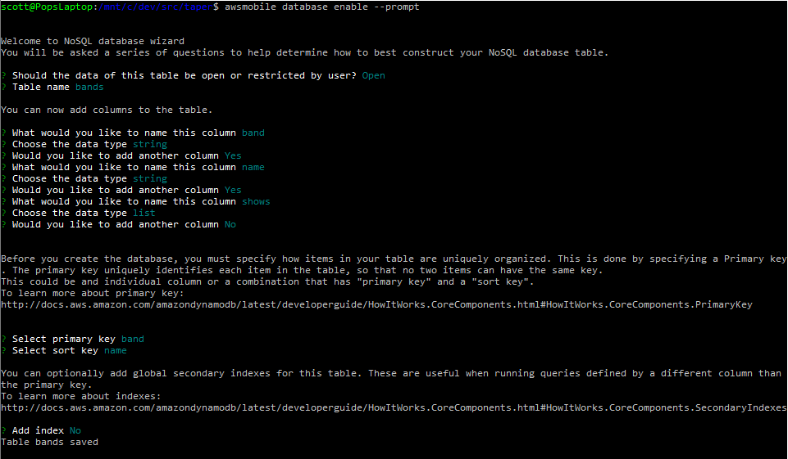

## Create an CRUD API for bands

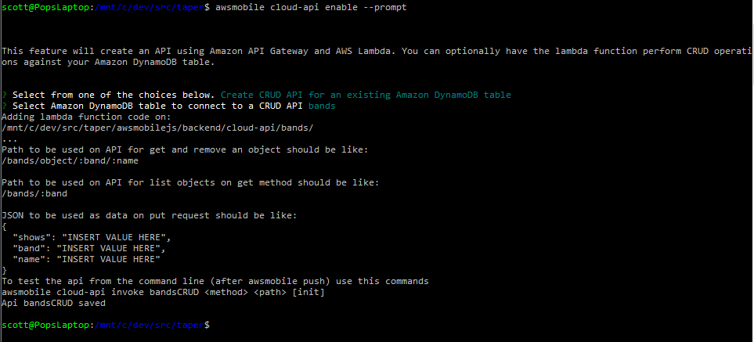

* Awsmobile push // to sync these changes to AWS

Manually add 4 most recent shows

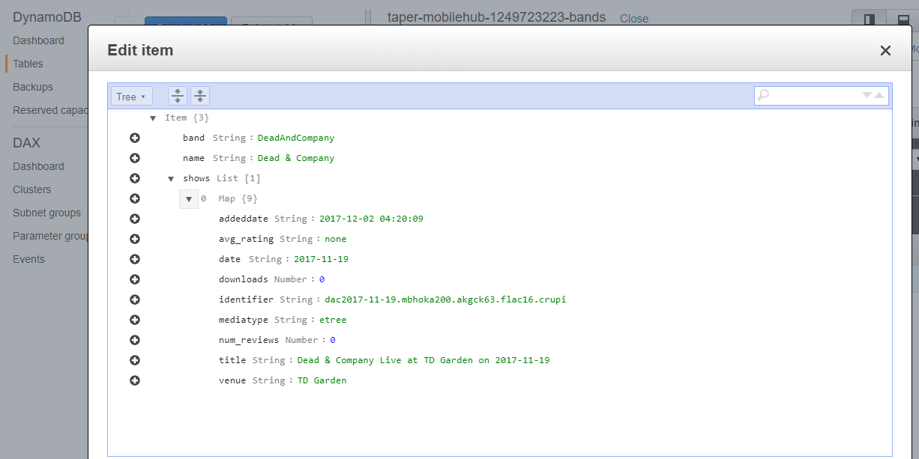

Pull them

Assemble an embed url

Play it

# 1/21/18

## Serverless Links

Serverless Architecture Security Top 10 = <https://www.puresec.io/resource-download>

Nordstrom’s Serverless Retail Example = <https://github.com/Nordstrom/hello-retail>

<https://github.com/serverless/site>

<https://dhruvkumarjha.com/building-a-todo-application-using-graphql-and-aws-appsync/>

<https://hackernoon.com/aws-appsync-up-and-running-560a42d96ba7>

ugh. I accidentally did a git add . and added all of the awsmobilejs/backend/cloudapi/bands/node_modules to git

need to add that path to .gitignore

and delete them from git. Need to figure out how to do that.

>git reset awsmobilejs/backend/cloudapi/bands/node_modules/*

# 1/22/18

## Search with CRUD API

## Create url

## Add iframe for archive.org/embed page

Simplest way to get it to play is to embed the archive.org/embed page in the test web app with an i-frame, so…

* Npm install --save react-iframe
* Commit
* Awsmobile publish

# 1/23/18

## Add first/last/random picker

* Keep selection state at parent level
* Create a search result filter component
* Send initial state to the child component with props
* Supply a state-change-handler callback as a prop too
* Child sets local state with onclick hanlder, then calls the parent callback to set parent state too!
* Commit
* Awsmobile publish

## Handy Internet Archive URLs

<http://archive.org/help/aboutsearch.htm>

<https://archive.org/services/swagger/?url=%2Fservices%2Fsearch%2Fv1%2Fswagger.yaml#!/search/get_scrape>

<http://ia600503.us.archive.org/27/items/gd1980-08-30.nak300.morris.102015.sbeok.flac16/>

<http://ia600503.us.archive.org/27/items/gd1980-08-30.nak300.morris.102015.sbeok.flac16/gd1980-08-30.nak300.morris.102015.sbeok.flac16_meta.xml>

<http://ia600503.us.archive.org/27/items/gd1980-08-30.nak300.morris.102015.sbeok.flac16/gd1980-08-30.102015.txt>

# 1/24/18

## Spring Batch

* Read Manning Ch 1; read through Pivotal docs/tuts
* Next, put my STS/Eclipse IDE together and build the tutorial app
* Then, build the batch process to 1) get all metadata, then 2) get data for each show, then 3) build the DB update file, then 4) update DB
* … REMEMBER TO THROTTLE THE ARCHIVE.ORG EXTRACT. DON’T WANT TO CAUSE SOME SORT OF DDOS BY ACCIDENT.

STS

* WORKSPACE = C:\dev\sts382\bench
* Ran existing spring-boot-neo4j app to verify all’s good in the hood

# 1/25/18

~~Lex meetup~~

Pivotal project page = <https://projects.spring.io/spring-batch/>

Documentation = <https://docs.spring.io/spring-batch/trunk/reference/html/>

Guide to creating a batch service = <https://spring.io/guides/gs/batch-processing/>

Spring Batch Service –getting started

Open STS

Open Spring Getting Started Project – Batch Processing – Gradle (buildship)

Create a person object

Create a PersonItemProcessor

Create a BatchConfiguration object

Create a JobCompletionNotification object

Create a runnable Application object

* Gradlew build
* Java –jar build/libs/gs-batch-processing-0.1.0.jar

Debug, rinse, repeat…

Success!

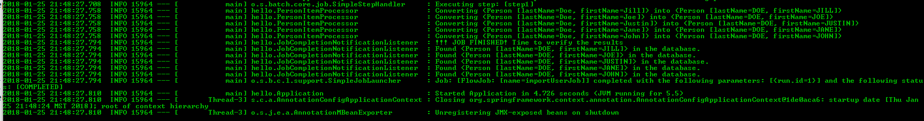

# 1/26/18

My first show; I don’t remember any of it. Wtf?

<https://archive.org/details/dead2003-07-02.adk-a51tl.moroney.18366.shnf>

**1) get all metadata**, then

2) get data for each show, then

3) build the DB update file, then 4) update DB

C:/dev/src/scripts/pyScript1.py contains sketches of 2 functions

getShows pulls all shows for given band. Can loop/parse respJson to get metadata and identifiers.

getShow does same thing, but allows you to specify one particular show. This is not the placefor this; I was just playing around.

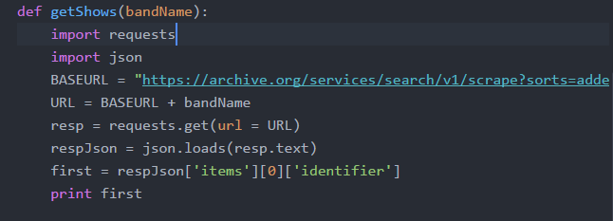

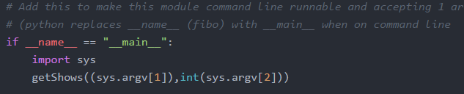

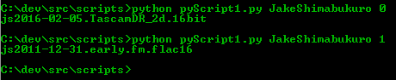

# 1/27/18

Pulling show metadata. Struggling to append metadata json items into the object I’ve already built.

Run the script; read the commented out bits. I’m just guessing; I need to learn the details.

# 2/1/18

## Planning

A week of coding saves an hour of planning.

### Stories

GIVEN a user has [browser] open; WHEN the user navigates to taper web site; THEN the taper web landing page appears.

GIVEN taper landing page is open; WHEN the user clicks on an available show; THEN the show page replaces the landing page.

GIVEN the show page is open; WHEN the page loads; THEN the first song will begin playing at 70% volume.

GIVEN a song is playing; WHEN the song ends; THEN the next song will begin.

### Components

index.js

assets/

layouts/

primaryLayout

layout-helpers/

primaryHeader

sideMenu

aside

band/

tour/

show/

setlist/

set/

track/

styles/

utils/

xhr

## Build Landing Page

* Import project into editor
* Update manifest.json and index.html to use my title and favicon.
* Build the directory structure
* Move the files to the right directories; change the imports as I move them to keep the app working.



* Replace react boilerplate in App js with my content
* Swiped some layout and xhr code to use as boiler plate from [Brad Westfall’s phx react meetup example](https://github.com/bradwestfall/PhxReactMeetupTalk)
* Got missing module errors, so added these two…
* npm install –save react-router-dom
* npm install –save axios
* here’s how it looks now



* git status
* git add .
* git commit –m “Add layout, bands page and simple xhr functionality”
* git push –u origin master
* removed the paging stuff from landing page
* added second page for bands
* added routing for the following
  + / -> landing
  + /bands -> landing
  + /bands/2 -> bands





* git status
* git add .
* git commit –m “Add routing between landing page and bands page; removed paging.”
* git push –u origin master

## Build taper back-end

### Stories

#### receive taperRequest objects

* Band
* showDate
* showContainsSong
* showVenue
* Order: first, last, random, all

#### parse them to determine how best to call archive.org

* if Band not valid, return error
* if showDate valid, use it in filter
* if showSong valid, use it in filter
* if showVenue valid, use it in filter
* if orderValid, use it in response construction
* // allow just year, just mo/year, or the whole thing; note that archive.org uses “ccyy-mm-ddThr:mn:scZ”
* // band, song, venue must be escaped
* // band, song, venue could be mapped to dictionary if that’ll help make the searches more robust

#### construct the url

* base url = https: //archive.org/services/search/v1/scrape?fields=dir,title,date,subject,venue,sources&sorts=date&q=collection%3A
* append (<bandName>)
* If (showDate) append %20AND%20(<formatted showDate>)
* If (showSong) append %20AND%20(<showSong>)
* If (showVenue) append %20AND%20(<showVenue>)

#### call archive.org to get archiveResponse object

#### parse archiveResponse

* when order=first
  + title = items[0].title; venue = …
  + url = EMBED_URL_HDR + items[0].identifier // this is vulnerable to cross-site scripting; remember the right way to do it.
* When order=last, get items.length for index
* When random, generate a rando index
* When all

#### return taperResponse

### Hand-built archive.org get requests

#### play a random dead show.

<https://archive.org/services/search/v1/scrape?fields=dir,title,date,subject,venue,source&sorts=date&q=collection%3AGratefulDead>

pick one at random from json, then build this url...

https://archive.org/embed/<identifier>&autoplay=1

#### play a random dead show with IKO IKO

<https://archive.org/services/search/v1/scrape?fields=dir,title,date,subject,venue,source&sorts=date&q=collection%3A(GratefulDead)%20AND%20(Iko%20Iko)>

pick one at random from json, then build this url...

https://archive.org/embed/<identifier>&autoplay=1

#### play the last dead show with IKO IKO

<https://archive.org/services/search/v1/scrape?fields=dir,title,date,subject,venue,source&sorts=date&q=collection%3A(GratefulDead)%20AND%20(Iko%20Iko)>

pick the last one from json, then build this url...

https://archive.org/embed/<identifier>&autoplay=1

#### play IKO IKO from the 1995 show at Riverport

<https://archive.org/services/search/v1/scrape?fields=dir,title,date,subject,venue,source&sorts=date&q=collection%3A(GratefulDead)%20AND%20(Iko%20Iko)%20AND%20(Riverport)%20AND%20(1995)>

pick one from json, then build this url...

https://archive.org/metadata/<identifier>

find name where title="IKO IKO", then build this url...

https://archive.org/embed/<identifier>/<name><&autoplay=1

#### play every IKO IKO [in chrological order | in the 90s | at Madison Square Garden]

<https://archive.org/embed/jj2008-06-14.mk4&autoplay=1>

<https://archive.org/details/deadco2017-07-01.travitz.schoepsMK4v.fob.flac16>

#### Get all dead shows from archive.org ...

<https://archive.org/services/search/v1/scrape?fields=dir,title,date&q=collection%3ADeadAndCompany>

<https://archive.org/services/search/v1/scrape?fields=dir,title,date,subject,venue,source&sorts=date&q=collection%3ADeadAndCompany>

<https://archive.org/services/search/v1/scrape?fields=dir,title,date,subject,venue,source&sorts=date&q=collection%3AGratefulDead>

#### Now, just the ones that have IKO IKO in them...

<https://archive.org/services/search/v1/scrape?fields=dir,title,date,subject,venue,source&sorts=date&q=collection%3A(GratefulDead)%20AND%20(Iko%20Iko)>

#### Here's the last IKO IKO show - 95 STL...

<https://archive.org/embed/gd95-07-05.sbd.9370.sbeok.shnf&autoplay=1>

#### And here's the IKO IKO from 95 STL show...

<https://archive.org/embed/gd95-07-05.sbd.9370.sbeok.shnf/gd95-07-05d1t08.shn&autoplay=1>

#### Slap this in your app, and you'll be playing der chicago show! snoit!

<https://archive.org/embed/deadco2017-07-01.travitz.schoepsMK4v.fob.flac16&autoplay=1>

<https://archive.org/embed/10-29-15DeadAndCompanyTimesUnionCenterAlbanyNy&autoplay=1>

Curl…

<https://archive.org/services/search/v1/scrape?fields=dir,title,date,subject,venue,source&sorts=date&q=collection%3AGratefulDead>

https://archive.org/services/search/v1/scrape?q=collection%3AGratefulDead&fields=dir,title,date,subject,venue,source

## NOTE: Lex chatbot to Alexa Skill

<https://aws.amazon.com/about-aws/whats-new/2017/09/export-your-amazon-lex-chatbot-to-the-alexa-skills-kit/>

you can port a lex app to alexa ; see Lex [doc](http://docs.aws.amazon.com/lex/latest/dg/export.html) and [faq](https://aws.amazon.com/lex/faqs/#alexa)

## New plan

At first, I thought about building the lambda/gateway backend all by itself instead of hooking it to awsmobile, but I am deciding now that awsmobile + a very simple web front end kind of belong together, so I will let awsmobile handle do the scaffolding for me. The front-end will probably remain webby and unpolished. I will create a separate mobile/web app to consume the taper api; that’s the one that will be user-facing.

Because of this decision, I realize I’ve named the project wrong. I’m going to rename taper-web to taper. Starting from a clean slate, I will build a taper react app, put it in a new github repo, add awsmobile, build out the interface to archive.org, configure the backend’s analytics, messaging, etc.

## RE-INIT

### Scaffold React Front-End

Open Ubuntu shell

* cd /mnt/c/dev/src
* create-react-app taper-web



… five minutes later …



### Serve React App Locally

* cd taper-web
* npm start



### Scaffold Node Back-end

Open Ubuntu shell

* cd /dev/src/taper
* awsmobile init



### Connect Front-end to Back-end with Amplify

* add to index.js: import Amplify from ‘aws-amplify’;
* add to index.js: import aws_exports from ‘./aws-exports.js’;
* add to index.js: Amplify.configure(aws_exports);
* note: this will break the locally running app because aws-amplify isn’t in node_modules yet.
* Awsmobile run // runs npm install to load new npm_modules, syncs local and cloud backends, pushes synced backend to awsmobile, then runs npm start









### Set up Repository

* Create new github repo – completely empty; no .gitignores, no readmes
* cd /mnt/c/dev/src/taper
* replace the huge react readme with one specific to taper
  + > mv README.md react-README.md
  + > vi README.md
  + add some basic stuff
* git init
* git status
* git add .
* git commit –m “Initial commit: create-react-app & awsmobile scaffolding”
* create github repo
* git remote add origin <https://github.com/ScottHensen/taper.git>
* git push –u origin master



### Deploy the front-end

* Pick One:
  + > awsmobile publish // does a prod build, deploys, serves it on mobile hub s3
  + > awsmobile publish –test // dash-dash; deploys it and runs it through aws device farm test service





### Finished!

* Start Time = 14:30
* Scaffolded a new react front-end with create-react-app
* Scaffolded a new node back-end with awsmobile init
* Connected the two
* Committed the working app to a repository before I started breaking things
* Deployed the front-end to aws mobile hub (the backend was deployed when it was scaffolded)
* Verified the app on aws device farm
* Stop Time = 15:50

## Build a basic front-end

* Rearrange the project folders/files to how I like them.
  + Add these folders to source: /assets, /components, /utils
  + Add these folders to components: /app, /layouts
  + Move App.* from /src to /src/app. Fix the bugs created by the move.
  + Move logo.svg to /src/assets. Fix the bug created.
  + Move registerServiceWorker.js to /src/utils. Fix the bug created.
* Update public components
  + index.html’s title,
  + manifest’s metadata, and
  + replace react favicon with Bob
* Add primary header and layout components; hook it into app.js
* Git commit
* Stop Time = ~1hr

## Add archiveRequestForm component

#### Story: receive taperRequest objects

* Band
* showDate
* showContainsSong
* showVenue
* Order: first, last, random, all

##### Build it

* Make this component a class so that a state object can be maintained
* Build a label/input-value table for each search parameter
* Add handleInputChange() to update state when a value is updated
* Add submit button and handleSubmit()
* Add archiveRequestForm.css to make it a little nicer looking
* Hook archiveRequestForm into PrimaryLayout component
* Git commit
* Stop Time = ~1hr



#### Story: parse them to determine how best to call archive.org

* if Band not valid, return error
* if showDate valid, use it in filter
* if showSong valid, use it in filter
* if showVenue valid, use it in filter
* if orderValid, use it in response construction
* // allow just year, just mo/year, or the whole thing; note that archive.org uses “ccyy-mm-ddThr:mn:scZ”
* // band, song, venue must be escaped
* // band, song, venue could be mapped to dictionary if that’ll help make the searches more robust

Build It

* Add buildArchiveRequest to utils
* Hook it to ArchiveRequestForm

#### Story: construct the url

* Modified buildArchiveRequest to encode, filter, join and build final url
* Returning url to caller ArchiveRequestForm
* Git commit
* Stop time = ~2hr

## Add archiveResponse component (to dispay json)

* Added component, hooked it into ArchiveRequestForm

## Add a get api to back-end

* Added xhr to archive.org with the built searchUrl
* Got a CORS error (testing on chrome local host)
* Executed npm run build (build a prod version, so I can run it on a server)
* npm install –g serve
* serve –s build

## Add an api call to the front-end

* added. Getting cors error

## Error Will Robinson! Design Error!

The /services searches work fine from browser url bar and curl, but they are being blocked by CORS when running from my domain. Try the advancedsearch feature…

* <https://archive.org/help/json.php>
* https://archive.org/advancedsearch.php?q=licenseurl:(*creativecommons.org*)&fl[]=identifier,title,mediatype,collection&rows=1&output=json
* <https://archive.org/services/search/v1/scrape?fields=dir,title,date,subject,venue,source&sorts=date&q=collection%3A(GratefulDead)%20AND%20(Iko%20Iko)%20AND%20(Riverport)%20AND%20(1995)>
* [https://archive.org/advancedsearch.php?q=Grateful+Dead+Iko+Iko+Riverport&fl[]=dir,title,date,venue,source&rows=50&output=json&callback=callback](https://archive.org/advancedsearch.php?q=Grateful+Dead+Iko+Iko+Riverport&fl%5b%5d=dir,title,date,venue,source&rows=50&output=json&callback=callback)
* LOOKS LIKE ARCHIVE.ORG DEFECTS ARE TRACKED IN A PRIVATE TOOL AND WORKED BY A PRIVATE TEAM, SO I CAN’T JUST GO UPDATE THE CORS HEADER. [SOMEONE ELSE MUST HAVE ALREADY TRIED THIS AND IT FAILED FOR SOME REASON; THERE’S NO WAY THIS PROBLEM WOULD STILL EXIST IF THE ANSWER WERE A SIMPLE CONFIG CHANGE. GOING TO LOOK FOR A PLAN B.

## Plan B: See if archive.org provides another way

internet archive s3 search <http://archive.org/help/abouts3.txt>

the new api… <https://archive.readme.io/docs/fulltext-search>

this works!... <https://api.archivelab.org/search?q=collection%3A(GratefulDead)>

NEXT… figure out how to add search criteria and sort to this new api call…. If that stuff exists.

The github repo is here… <https://github.com/ArchiveLabs/api.archive.org>

Could always go fix archive.org by adding the cors header and making a pull request.

## Plan C: Where there’s a will

If I can’t get api.archivelab.org to return the data I want, then I will do this…

* Build a little ETL script to
  + hit the search service from a linux shell
  + save the json as a flat file
  + Store the data in dynamoDB
* Change the front-end to pull data from dynamo to create embed url
* Phase 2 – build a batch job that’ll pull data and update the database with delta

At first, I’ll run the script manually. If that works, then I’ll see about adding a daily batch job to keep my dynamo instance in sync with archive.org.

Get all date/file items for GratefulDead =

<https://archive.org/services/search/v1/scrape?fields=date,identifier&sorts=date&q=collection%3AGratefulDead>

// that doesn’t work with curl, but this does…

<https://archive.org/services/search/v1/scrape?q=collection%3AGratefulDead>

// it only returns items[] of identifier. Page contains 5000 of 12868

Results =

{

"items":

[

{"date":"1965-11-01T00:00:00Z","identifier":"gd1965-11-01.sbd.bershaw.5417.sbeok.shnf"},

{"date":"1965-11-03T00:00:00Z","identifier":"gd65-11-03.sbd.vernon.9044.sbeok.shnf"},

…

{"date":"1983-04-16T00:00:00Z","identifier":"gd1983-04-16.137372.set2.m160.miller.flac24"}

],

"count":5000,

"cursor":"W3siZGF0ZSI6IjE5ODMtMDQtMTZUMDA6MDA6MDAuMFoifSx7ImlkZW50aWZpZXIiOiJnZDE5ODMtMDQtMTYuMTM3MzcyLnNldDIubTE2MC5taWxsZXIuZmxhYzI0In1d",

"total":11972

}

Get metadata for each identifier =

<https://archive.org/details/gd1994-07-27.AKG451.Darby.119473.Flac1648> <https://archive.org/metadata/gd1994-07-27.AKG451.Darby.119473.Flac1648>

// this works in curl

Results =

{

"created": 1516147639,

"d1": "ia601609.us.archive.org",

"d2": "ia801609.us.archive.org",

"dir": "/9/items/gd1994-07-27.AKG451.Darby.119473.Flac1648",

"files": Array[89][

{

"name": "Gd1994-07-27TicketStub.jpg",

"source": "original",

"format": "JPEG",

"title": "gd1994-07-27 Ticket Stub",

"mtime": "1331694768",

"size": "213444",

"md5": "d17966760d9e9fd79080da4834fe0727",

"crc32": "29ac3ca5",

"sha1": "738d9076fbd7975a6a969924519312fcb7c41993",

"rotation": "0"

},

…

{

"name": "gd1994-07-27.AKG451.t11.flac",

"source": "original",

"format": "Flac",

"length": "567",

"mtime": "1331695776",

"size": "75792100",

"md5": "b86a9962e8ce520a2cb4430c09589378",

"crc32": "31404c1e",

"sha1": "5df71d0984c7caaf2774968089679995538937b3",

"title": "Iko Iko",

"creator": "Grateful Dead",

"album": "1994-07-27 - Riverport Amphitheatre",

"track": "11",

"height": "768",

"width": "1024",

"external-identifier": "urn:acoustid:e45e5912-d461-4eaf-9a9c-5a522e08821f"

},

{

"name": "gd1994-07-27.AKG451.t11.mp3",

"source": "derivative",

"creator": "Grateful Dead",

"title": "Iko Iko",

"track": "11",

"album": "1994-07-27 - Riverport Amphitheatre",

"bitrate": "211",

"length": "09:27",

"format": "VBR MP3",

"original": "gd1994-07-27.AKG451.t11.flac",

"mtime": "1331782525",

"size": "14949603",

"md5": "aed3282ca048901503ef7ecefc25161f",

"crc32": "c91a2a66",

"sha1": "dc8c4fda1a72ad481f805c103d40d8ca69712806",

"height": "0",

"width": "0"

},

…

{

"name": "gd1994-07-27.AKG451.t19.png",

"source": "derivative",

"format": "PNG",

"original": "gd1994-07-27.AKG451.t19.flac",

"mtime": "1414116625",

"size": "10220",

"md5": "ec8d5ce97d121f8d3fbbedc1cfd830d0",

"crc32": "240685b3",

"sha1": "5e8ae221cee6e7f2cd2d5fd64e2c78d4406c7569"

}

],

"files_count": 89,

"item_size": 1691293493,

"metadata": {

"identifier": "gd1994-07-27.AKG451.Darby.119473.Flac1648",

"uploader": "mvernon54@yahoo.com",

"addeddate": "2012-03-14 12:31:28",

"date": "1994-07-27",

"title": "Grateful Dead Live at Riverport Amphitheatre on 1994-07-27",

"creator": "Grateful Dead",

"mediatype": "etree",

"collection": Array[2][

"GratefulDead",

"etree"

],

"type": "sound",

"description": "Set 1\n\nHere Comes Sunshine, Walkin' Blues, Jack-A-Roe, Black Throated Wind, Just Like Tom Thumb's Blues, Ramble On Rose, Let It Grow\n\nSet 2\n\nBox Of Rain, Iko Iko, Way to Go Home, Corinna-> Jam-> Drums-> Space-> The Last Time-> The Days Between-> Around & Around, E: Liberty\n\n* Weir on acoustic guitar",

"year": "1994",

"subject": "Audience;Darby;Keo",

"venue": "Riverport Amphitheatre",

"coverage": "Maryland Heights, MO",

"source": "<b>flac16/48kHz</b>; Master Audience Recorded By Mr. Darby; AKG451EB/CK1's (DIN/DFC/First 1/4 Of OTS/9 Feet High)> Whirlwind Phantoms>Teac DA-P20 @ 16/48; Transfer Information:Sony R500>Tascam HD-P2 @ 16/48> HDD>Amadeus Pro (Tracking/Fades/FLAC8); Tracks Renamed/Metadata Tagging With Tag&Rename By Keo",

"taper": "Mike Darby",

"transferer": "Keo",

"md5s": "9b7c3b591a6cb4a8446e8769f29b46df *gd1994-07-27.AKG451.t01.flac a8cb1189881ce869ec65594d81b78344 *gd1994-07-27.AKG451.t02.flac d5aaac6f2004352bf408b426902cad07 *gd1994-07-27.AKG451.t03.flac d260e5b593b323dcfbeee780a7a997cd *gd1994-07-27.AKG451.t04.flac 88e7342cfcacf90e62bd0d542495faab *gd1994-07-27.AKG451.t05.flac c3f3d7d0b5660261f98e362a808315f8 *gd1994-07-27.AKG451.t06.flac a42a1f6c042bdc663eef41de00549653 *gd1994-07-27.AKG451.t07.flac adbbd065c0b6a542f44911896c4e000a *gd1994-07-27.AKG451.t08.flac 9abf6ebc8435dac484d606134f89dd64 *gd1994-07-27.AKG451.t09.flac 8570c727d5d0ac69d53b49e974663500 *gd1994-07-27.AKG451.t10.flac b86a9962e8ce520a2cb4430c09589378 *gd1994-07-27.AKG451.t11.flac 959cbae08a4261357c3b1e42d8ba8de9 *gd1994-07-27.AKG451.t12.flac a0a1e1fdca8d38e743e4f39f97e9b91a *gd1994-07-27.AKG451.t13.flac b950e8f176df0395a9ce9813c9343a17 *gd1994-07-27.AKG451.t14.flac d00b5f1e264c9bf2912911b91e748d80 *gd1994-07-27.AKG451.t15.flac ea66fe1ae31c1aace8b7885c9ade49e7 *gd1994-07-27.AKG451.t16.flac 7c927fa008ba678ede649afd5944d476 *gd1994-07-27.AKG451.t17.flac 18de235cb766a7df5d76aa9f480f33ae *gd1994-07-27.AKG451.t18.flac 80e1e74a8582740eb43230ebb95691ac *gd1994-07-27.AKG451.t19.flac",

"notes": "* Bob Weir On Acoustic Guitar *\n\n Comments:And another Huge Thanks out to Mr. Darby\nfor recording and sharing his source for this GD\n1994 summer show!Another fantastic recording from\nthe Darby collection!Mr. Darby has a second set of\nmaster tapes from cassettes to share down the line!\nAs always ENJOY!!!!!!!!!!!!!!!!!!!!!!",

"publicdate": "2012-03-15 03:09:42",

"backup_location": "ia903800_9"

},

"server": "ia801609.us.archive.org",

"uniq": 1101409973,

"workable_servers": Array[2][

"ia801609.us.archive.org",

"ia601609.us.archive.org"

]

}

Date 1994-07-27 = files[n].name // alt track | files[n].title | files[n].original //orig track

Venue Riverport

Song Iko Iko

### Pull all GD shows; will take multiple GETs using cursor

Sorted by addeddate, so that it’ll be easer to pull/merge updated files.

curl -X GET --header 'Accept: application/json' 'https://archive.org/services/search/v1/scrape?sorts=addeddate%20desc%2cidentifier%20asc&fields=addeddate%2cidentifier%2cdate%2cnum_reviews%2cavg_rating%2cdownloads%2ctitle%2cmediatype&q=collection%3AGratefulDead' >> curl_GD_sorted_1.json

{"date":"1980-10-26T00:00:00Z","identifier":"gd1980-10-26.mtx.seamons.101967.flac16","addeddate":"2009-10-13T22:04:23Z","downloads":8550,"avg_rating":"4.57","num_reviews":7,"title":"Grateful Dead Live at Radio City Music Hall on 1980-10-26","mediatype":"etree"},{"date":"1981-05-12T00:00:00Z","identifier":"gd1981-05-12.nak300.friend.andrewf.101925.flac1644","addeddate":"2009-10-13T06:02:27Z","downloads":1423,"avg_rating":"3.00","num_reviews":1,"title":"Grateful Dead Live at Veterans' Memorial Coliseum on 1981-05-12","mediatype":"etree"}],"count":5000,"cursor":"W3siYWRkZWRkYXRlIjoiMjAwOS0xMC0xM1QwNjowMjoyNy4wWiJ9LHsiaWRlbnRpZmllciI6ImdkMTk4MS0wNS0xMi5uYWszMDAuZnJpZW5kLmFuZHJld2YuMTAxOTI1LmZsYWMxNjQ0In1d","total":12004}s

curl -X GET --header 'Accept: application/json' 'https://archive.org/services/search/v1/scrape?cursor=W3siYWRkZWRkYXRlIjoiMjAwOS0xMC0xM1QwNjowMjoyNy4wWiJ9LHsiaWRlbnRpZmllciI6ImdkMTk4MS0wNS0xMi5uYWszMDAuZnJpZW5kLmFuZHJ

ld2YuMTAxOTI1LmZsYWMxNjQ0In1d&sorts=addeddate%20desc%2cidentifier%20asc&fields=addeddate%2cidentifier%2cdate%2cnum_reviews%2cavg

_rating%2cdownloads%2ctitle%2cmediatype&q=collection%3AGratefulDead' >> curl_GD_sorted_2.json

{"date":"1982-07-18T00:00:00Z","identifier":"gd82-07-18.fob-senn441-weinberg.unknown.17030.sbeok.shnf","addeddate":"2004-06-16T14:31:52Z","downloads":23296,"avg_rating":"4.50","num_reviews":12,"title":"Grateful Dead Live at Ventura County Fairgrounds on 1982-07-18","mediatype":"etree"},{"date":"1982-05-28T00:00:00Z","identifier":"gd82-05-28.sbd.skinner.11362.sbeok.shnf","addeddate":"2004-06-16T14:31:51Z","downloads":10375,"avg_rating":"4.60","num_reviews":6,"title":"Grateful Dead Live at Moscone Convention Center on 1982-05-28","mediatype":"etree"}],"count":5000,"cursor":"W3siYWRkZWRkYXRlIjoiMjAwNC0wNi0xNlQxNDozMTo1MS4wWiJ9LHsiaWRlbnRpZmllciI6ImdkODItMDUtMjguc2JkLnNraW5uZXIuMTEzNjIuc2Jlb2suc2huZiJ9XQ==","previous":"W3siYWRkZWRkYXRlIjoiMjAwOS0xMC0xM1QwNjowMjoyNy4wWiJ9LHsiaWRlbnRpZmllciI6ImdkMTk4MS0wNS0xMi5uYWszMDAuZnJpZW5kLmFuZHJld2YuMTAxOTI1LmZsYWMxNjQ0In1d","total":7004}

curl -X GET --header 'Accept: application/json' 'https://archive.org/services/search/v1/scrape?cursor=W3siYWRkZWRkYXRlIjoiMjAwNC0wNi0xNlQxNDozMTo1MS4wWiJ9LHsiaWRlbnRpZmllciI6ImdkODItMDUtMjguc2JkLnNraW5uZXIuMTEzNjIuc2Jlb2suc2huZiJ9XQ%3D%3D&sorts=addeddate%20desc%2cidentifier%20asc&fields=addeddate%2cidentifier%2cdate%2cnum_reviews%2cavg_rating%2cdownloads%2ctitle%2cmediatype&q=collection%3AGratefulDead' >> curl_GD_sorted_3.json

{"date":"1986-03-31T00:00:00Z","identifier":"gd86-03-31.fob-schoeps-pasternak.miller.25527.sbeok.shnf","downloads":21533,"avg_rating":"3.00","num_reviews":3,"title":"Grateful Dead Live at on 1986-03-31","mediatype":"etree"},{"date":"1990-06-16T00:00:00Z","identifier":"gd90-06-16.sbd.ladner.8571.sbeok.shnf","downloads":12509,"avg_rating":"4.47","num_reviews":15,"title":"Grateful Dead Live at Shoreline Amphitheatre on 1990-06-16","mediatype":"etree"}],"count":2004,"previous":"W3siYWRkZWRkYXRlIjoiMjAwNC0wNi0xNlQxNDozMTo1MS4wWiJ9LHsiaWRlbnRpZmllciI6ImdkODItMDUtMjguc2JkLnNraW5uZXIuMTEzNjIuc2Jlb2suc2huZiJ9XQ==","total":2004}

### Munge all shows files together

### For each show, add details metadata

curl -X GET --header 'Accept: application/json' 'https://archive.org/metadata/gd1980-08-30.nak300.morris.102015.sbeok.flac16' >> curl_GD_metadata_gd1980-08-30.nak300.morris.102015.sbeok.flac16.json

{

"created":1516495893,

"d1":"ia600503.us.archive.org",

"d2":"ia800503.us.archive.org",

"dir":"/27/items/gd1980-08-30.nak300.morris.102015.sbeok.flac16",

"files":[

{"name":"gd1980-08-30.nak300.morris.102015.sbeok.flac16_reviews.xml","source":"original","format":"Metadata","mtime":"1255721038","size":"917","md5":"0aef3a557a4f81446294f55f13c3eb7d","crc32":"21272227","sha1":"a142e2222bb5a8ef05a8358806511e28c592b9ba"},

{"name":"gd1980-08-30.102015.ffp","source":"original","format":"Flac FingerPrint","md5":"0a917b294a5bc9c9e6db94ac2bd3e882","mtime":"1255541143","size":"1538","crc32":"2b64201e","sha1":"80c11e5a0e13e74e74e0c38f49371695903e5d14"},

Note:

http://<d1>+<dir> gives you this… [the whole show]

[../](http://ia600503.us.archive.org/27/items/)

[gd1980-08-30.102015.ffp](http://ia600503.us.archive.org/27/items/gd1980-08-30.nak300.morris.102015.sbeok.flac16/gd1980-08-30.102015.ffp) 14-Oct-2009 17:25 1538

[gd1980-08-30.102015.md5](http://ia600503.us.archive.org/27/items/gd1980-08-30.nak300.morris.102015.sbeok.flac16/gd1980-08-30.102015.md5) 14-Oct-2009 17:28 1565

[gd1980-08-30.102015.txt](http://ia600503.us.archive.org/27/items/gd1980-08-30.nak300.morris.102015.sbeok.flac16/gd1980-08-30.102015.txt) 14-Oct-2009 17:25 1202 << set list and description

[gd1980-08-30.nak300.morris.102015.sbeok.flac16_..>](http://ia600503.us.archive.org/27/items/gd1980-08-30.nak300.morris.102015.sbeok.flac16/gd1980-08-30.nak300.morris.102015.sbeok.flac16_archive.torrent) 20-Jun-2016 18:34 69503 << torrent

[gd1980-08-30.nak300.morris.102015.sbeok.flac16_..>](http://ia600503.us.archive.org/27/items/gd1980-08-30.nak300.morris.102015.sbeok.flac16/gd1980-08-30.nak300.morris.102015.sbeok.flac16_files.xml) 20-Jun-2016 18:34 91598 << files.xml

[gd1980-08-30.nak300.morris.102015.sbeok.flac16_..>](http://ia600503.us.archive.org/27/items/gd1980-08-30.nak300.morris.102015.sbeok.flac16/gd1980-08-30.nak300.morris.102015.sbeok.flac16_meta.xml) 20-Jun-2016 18:33 3140 << meta.xml

[gd1980-08-30.nak300.morris.102015.sbeok.flac16_..>](http://ia600503.us.archive.org/27/items/gd1980-08-30.nak300.morris.102015.sbeok.flac16/gd1980-08-30.nak300.morris.102015.sbeok.flac16_reviews.xml) 16-Oct-2009 19:23 917 << reviews.xml

[gd80-08-30audd1t01.afpk](http://ia600503.us.archive.org/27/items/gd1980-08-30.nak300.morris.102015.sbeok.flac16/gd80-08-30audd1t01.afpk) 28-Apr-2015 23:54 25376

[gd80-08-30audd1t01.flac](http://ia600503.us.archive.org/27/items/gd1980-08-30.nak300.morris.102015.sbeok.flac16/gd80-08-30audd1t01.flac) 14-Oct-2009 17:26 11147763

[gd80-08-30audd1t01.mp3](http://ia600503.us.archive.org/27/items/gd1980-08-30.nak300.morris.102015.sbeok.flac16/gd80-08-30audd1t01.mp3) 28-Apr-2015 23:11 2655232

[gd80-08-30audd1t01.ogg](http://ia600503.us.archive.org/27/items/gd1980-08-30.nak300.morris.102015.sbeok.flac16/gd80-08-30audd1t01.ogg) 28-Apr-2015 23:23 1429982

[gd80-08-30audd1t01.png](http://ia600503.us.archive.org/27/items/gd1980-08-30.nak300.morris.102015.sbeok.flac16/gd80-08-30audd1t01.png) 28-Apr-2015 23:25 8001

[gd80-08-30audd1t01_esshigh.json.gz](http://ia600503.us.archive.org/27/items/gd1980-08-30.nak300.morris.102015.sbeok.flac16/gd80-08-30audd1t01_esshigh.json.gz) 28-Apr-2015 23:59 1821

[gd80-08-30audd1t01_esslow.json.gz](http://ia600503.us.archive.org/27/items/gd1980-08-30.nak300.morris.102015.sbeok.flac16/gd80-08-30audd1t01_esslow.json.gz) 28-Apr-2015 23:31 22703

[gd80-08-30audd1t01_spectrogram.png](http://ia600503.us.archive.org/27/items/gd1980-08-30.nak300.morris.102015.sbeok.flac16/gd80-08-30audd1t01_spectrogram.png) 28-Apr-2015 23:29 250268

…

[gd80-08-30audd3t10.afpk](http://ia600503.us.archive.org/27/items/gd1980-08-30.nak300.morris.102015.sbeok.flac16/gd80-08-30audd3t10.afpk) 28-Apr-2015 23:51 59344

[gd80-08-30audd3t10.flac](http://ia600503.us.archive.org/27/items/gd1980-08-30.nak300.morris.102015.sbeok.flac16/gd80-08-30audd3t10.flac) 14-Oct-2009 18:01 33081077

[gd80-08-30audd3t10.mp3](http://ia600503.us.archive.org/27/items/gd1980-08-30.nak300.morris.102015.sbeok.flac16/gd80-08-30audd3t10.mp3) 28-Apr-2015 23:13 6709248

[gd80-08-30audd3t10.ogg](http://ia600503.us.archive.org/27/items/gd1980-08-30.nak300.morris.102015.sbeok.flac16/gd80-08-30audd3t10.ogg) 28-Apr-2015 23:21 3560787

[gd80-08-30audd3t10.png](http://ia600503.us.archive.org/27/items/gd1980-08-30.nak300.morris.102015.sbeok.flac16/gd80-08-30audd3t10.png) 28-Apr-2015 23:24 10330

[gd80-08-30audd3t10_esshigh.json.gz](http://ia600503.us.archive.org/27/items/gd1980-08-30.nak300.morris.102015.sbeok.flac16/gd80-08-30audd3t10_esshigh.json.gz) 28-Apr-2015 23:58 1840

[gd80-08-30audd3t10_esslow.json.gz](http://ia600503.us.archive.org/27/items/gd1980-08-30.nak300.morris.102015.sbeok.flac16/gd80-08-30audd3t10_esslow.json.gz) 28-Apr-2015 23:35 26622

[gd80-08-30audd3t10_spectrogram.png](http://ia600503.us.archive.org/27/items/gd1980-08-30.nak300.morris.102015.sbeok.flac16/gd80-08-30audd3t10_spectrogram.png) 28-Apr-2015 23:29 265580

<http://ia600503.us.archive.org/27/items/gd1980-08-30.nak300.morris.102015.sbeok.flac16/gd1980-08-30.102015.txt>

Grateful Dead - August 30, 1980

Spectrum - Philadelphia, Pennsylvania

Nakamichi CM-300 (CP-1) x2 > Cassette Master

(Marantz Superscope CD320/Maxell UDXLII)

Cassette Master (Nakamichi DR-1) > Korg MR-1000 (1-bit/5.6MHz) >

Audiogate (1-bit/5.6MHz > 16-bit/44.1KHz) > cdwav (edits)

Disc One

Set 1:

01 tuning

02 Feel Like A Stranger

03 Peggy-O

04 Cassidy

05 Friend of the Devil

06 New Minglewood Blues

07 Cold Rain & Snow ->

08 Looks Like Rain

09 tuning

10 Easy To Love You

11 Althea

12 tuning

13 Jack Straw

Set 2:

Disc Two

01 Scarlet Begonias ->

02 Fire on the Mountain

03 C.C. Rider ->

04 Ramble On Rose

Disc Three

01 tuning

02 Estimated Prophet ->

03 Eyes of the World ->

04 drums ->

05 space ->

06 Not Fade Away ->

07 Black Peter ->

08 Sugar Magnolia

Encore

09 tuning

06 One More Saturday Night

Notes - Tape flip in drums at 5:15 -- spliced using Soundforge 9.0.

Dropout in C.C. Rider (at 0:57) edited using CD Wave Editor.

Left-channel noise in drums patched with right channel:

1:09-1:29; 1:54-1:59; 2:34; 4:03-4:09; 4:18.

Recorded by Bob Morris -- thanks to Sam for help & Dave B for his Naks.

Transferred, edited, & patched by Bob M 7/09.

Flaced and shared by Chuck T./Crazyfingers

<http://ia600503.us.archive.org/27/items/gd1980-08-30.nak300.morris.102015.sbeok.flac16/gd1980-08-30.nak300.morris.102015.sbeok.flac16_meta.xml>

<metadata>

<script id="tinyhippos-injected"/>

<identifier>gd1980-08-30.nak300.morris.102015.sbeok.flac16</identifier>

<title>Grateful Dead Live at The Spectrum on 1980-08-30</title>

<creator>Grateful Dead</creator>

<mediatype>etree</mediatype>

<collection>GratefulDead</collection>

<collection>etree</collection>

<type>sound</type>

<description>

Set 1 Feel Like A Stranger, Peggy-O, Cassidy, Friend Of The Devil, Minglewood Blues, Cold Rain & Snow-> Looks Like Rain, Easy To Love You, Althea, Jack Straw Set 2 Scarlet Begonias-> Fire On The Mountain, CC Rider-> Ramble On Rose, Estimated Prophet-> Eyes Of The World-> Drums-> Not Fade Away-> Black Peter-> Sugar Magnolia, E: One More Saturday Night

</description>

<date>1980-08-30</date>

<year>1980</year>

<subject>Audience;Bob Morris</subject>

<publicdate>2009-10-15 06:15:24</publicdate>

<addeddate>2009-10-14 19:53:38</addeddate>

<uploader>mvernon54@yahoo.com</uploader>

<venue>The Spectrum</venue>

<coverage>Philadelphia, PA</coverage>

<source>

Nakamichi CM-300 (CP-1) x2 > Cassette Master (Marantz Superscope CD320/Maxell UDXLII)

</source>

<lineage>

Cassette Master (Nakamichi DR-1) > Korg MR-1000 (1-bit/5.6MHz) > Audiogate (1-bit/5.6MHz > 16-bit/44.1KHz) > cdwav (edits)

</lineage>

<taper>Bob Morris</taper>

<transferer>Bob Morris</transferer>

<runtime>175:23.40</runtime>

<md5s>

d35d0698b49668e58789dbaa4f4f7fb8 *gd80-08-30audd1t01.flac cc15058069160c1341667506e01a22f3 *gd80-08-30audd1t02.flac 69a0622a359fd64dac01e09358e2a5d6 *gd80-08-30audd1t03.flac c70f8c5ef8f78ebcfacb24f74d8e66bd *gd80-08-30audd1t04.flac ed9893ac29cb316dc4e8a88ed907e0fc *gd80-08-30audd1t05.flac 3dd3f4d06cab6363391b526c0a7436ca *gd80-08-30audd1t06.flac ef82a6dbdbef25728eb135e9e43c9110 *gd80-08-30audd1t07.flac ca07864fd30d8d65a92ea4e5157d7a84 *gd80-08-30audd1t08.flac 850be369841c7d696b0e9376323aa41c *gd80-08-30audd1t09.flac 57be65cce144302f8f24d441a380c16e *gd80-08-30audd1t10.flac e847a39a75db07adc3b79547f423814a *gd80-08-30audd1t11.flac 8262ecefcc3d082ddd13535395b6bf83 *gd80-08-30audd1t12.flac 7af04ec878a8a5a672438b01c35a1af6 *gd80-08-30audd1t13.flac 4437bc4671a9dc3efac43d95cbb1aeb5 *gd80-08-30audd2t01.flac fc8c506ee8f15dd26d8b05a7242e555c *gd80-08-30audd2t02.flac 4d8d1e5a72bc2d625b8c205b1575057c *gd80-08-30audd2t03.flac 21979bffaa607409ec1012329ce3bd6a *gd80-08-30audd2t04.flac f1c93556769cfdb556724b9f4247e8b6 *gd80-08-30audd3t01.flac 5c4a08971d03495eb04188fb0eb7f857 *gd80-08-30audd3t02.flac 86af5f23708d3f9ccdea9eb6855aa889 *gd80-08-30audd3t03.flac 6406691144e4937d911e7e695f5a04b3 *gd80-08-30audd3t04.flac 5068a6678fc4b358422c8e53a977abdc *gd80-08-30audd3t05.flac e9e83a63284b632de2909e181b7a44f0 *gd80-08-30audd3t06.flac 46996d31302f83f98431c3fdce512a41 *gd80-08-30audd3t07.flac e2e7c2b27eb247362763b1d08aedd801 *gd80-08-30audd3t08.flac eb54d87fc68ca57d39d5bb0f2394b42a *gd80-08-30audd3t09.flac c339bb6a44b7ae087e3b9f08c7f24f08 *gd80-08-30audd3t10.flac

</md5s>

<updatedate>2009-10-15 06:16:12</updatedate>

<updater>Matthew Vernon</updater>

<backup_location>ia903604_4</backup_location>

</metadata>

NOTES:

* Xml looks just like the json we already got.
* Do all shows have a *.txt file? If so, that seems like the thing we

OK, so lets start by storing band, venue, date

{“bands”: [

{“band”:”GratefulDead”,

“name”:”Grateful Dead”,

“shows” :[

{“identifier”: “foo-bar-qux.flac123”,

“date”: “1990-12-31T00:00:00Z”,

“venue”: “Oakland-Alameda County Coliseum”,

“addeddate”: “2018-01-20T11:45:01Z”,

“title”: “Grateful Dead Live at Oakland-Alameda County Coliseum on 1990-12-31”,

“mediatype”: “etree”},

“downloads”: 2342,

“avg_rating”: “3.4”,

“num_reviews”: 13

{…}

]

},

{“band”:”DeadAndCompany”,

“name”:”Dead & Company”,

“shows” : []

}

]}

Build csv record with metadata + generated url for each entry

Store DB rows in Dynamo by processing csv

### Create a DynamoDB for bands



### Create a CRUD API for bands



* Awsmobile push // to sync these changes to AWS

Manually add 4 most recent shows



Pull them

Assemble an embed url

Play it

## Serverless Links

Serverless Architecture Security Top 10 = <https://www.puresec.io/resource-download>

Nordstrom’s Serverless Retail Example = <https://github.com/Nordstrom/hello-retail>

<https://github.com/serverless/site>

<https://dhruvkumarjha.com/building-a-todo-application-using-graphql-and-aws-appsync/>

<https://hackernoon.com/aws-appsync-up-and-running-560a42d96ba7>

ugh. I accidentally did a git add . and added all of the awsmobilejs/backend/cloudapi/bands/node_modules to git

need to add that path to .gitignore

and delete them from git. Need to figure out how to do that.

>git reset awsmobilejs/backend/cloudapi/bands/node_modules/*

## Search with CRUD API

## Create url

## Add iframe for archive.org/embed page

Simplest way to get it to play is to embed the archive.org/embed page in the test web app with an i-frame, so…

* Npm install --save react-iframe
* Commit
* Awsmobile publish

## Add first/last/random picker

* Keep selection state at parent level
* Create a search result filter component
* Send initial state to the child component with props
* Supply a state-change-handler callback as a prop too
* Child sets local state with onclick hanlder, then calls the parent callback to set parent state too!
* Commit
* Awsmobile publish

## Handy Internet Archive URLs

<http://archive.org/help/aboutsearch.htm>

<https://archive.org/services/swagger/?url=%2Fservices%2Fsearch%2Fv1%2Fswagger.yaml#!/search/get_scrape>

<http://ia600503.us.archive.org/27/items/gd1980-08-30.nak300.morris.102015.sbeok.flac16/>

<http://ia600503.us.archive.org/27/items/gd1980-08-30.nak300.morris.102015.sbeok.flac16/gd1980-08-30.nak300.morris.102015.sbeok.flac16_meta.xml>

<http://ia600503.us.archive.org/27/items/gd1980-08-30.nak300.morris.102015.sbeok.flac16/gd1980-08-30.102015.txt>

## Python

C:/dev/src/scripts/pyScript1.py contains sketches of 2 functions

getShows pulls all shows for given band. Can loop/parse respJson to get metadata and identifiers.

getShow does same thing, but allows you to specify one particular show. This is not the placefor this; I was just playing around.







Pulling show metadata. Struggling to append metadata json items into the object I’ve already built.

Run the script; read the commented out bits. I’m just guessing; I need to learn the details.

## Spring Batch

* Read Manning Ch 1; read through Pivotal docs/tuts
* Next, put my STS/Eclipse IDE together and build the tutorial app
* Then, build the batch process to 1) get all metadata, then 2) get data for each show, then 3) build the DB update file, then 4) update DB
* … REMEMBER TO THROTTLE THE ARCHIVE.ORG EXTRACT. DON’T WANT TO CAUSE SOME SORT OF DDOS BY ACCIDENT.

STS

* WORKSPACE = C:\dev\sts382\bench
* Ran existing spring-boot-neo4j app to verify all’s good in the hood

Pivotal project page = <https://projects.spring.io/spring-batch/>

Documentation = <https://docs.spring.io/spring-batch/trunk/reference/html/>

Guide to creating a batch service = <https://spring.io/guides/gs/batch-processing/>

Spring Batch Service –getting started

Open STS

Open Spring Getting Started Project – Batch Processing – Gradle (buildship)

Create a person object

Create a PersonItemProcessor

Create a BatchConfiguration object

Create a JobCompletionNotification object

Create a runnable Application object

* Gradlew build
* Java –jar build/libs/gs-batch-processing-0.1.0.jar

Debug, rinse, repeat…

Success!



My last show; I don’t remember any of it. Wtf?

<https://archive.org/details/dead2003-07-02.adk-a51tl.moroney.18366.shnf>

**1) get all metadata**, then

2) get data for each show, then

3) build the DB update file, then 4) update DB

## New DB – Add CRUD API

Finished phase one of the batch process to ETL data from archive.org to taper.io . Manually execute these three steps:

* dev/sts382/bench/taper-job-*-shows-for-band/build/libs> java –jar taper-job-extract-shows-for-band-0.0.1-SNAPSHOT.jar <bandId>
* dev/sts382/bench/taper-job-*-shows-for-band/build/libs> java –jar taper-job-transform-shows-for-band-0.0.1-SNAPSHOT.jar <bandId>
* data/files/test> awsDynamoDbBatchLoader <bandId>

Now, build crud api to so we can pull from the new database, then we’ll add the crud calls to the front-end app.

* Go to app in Mobile hub

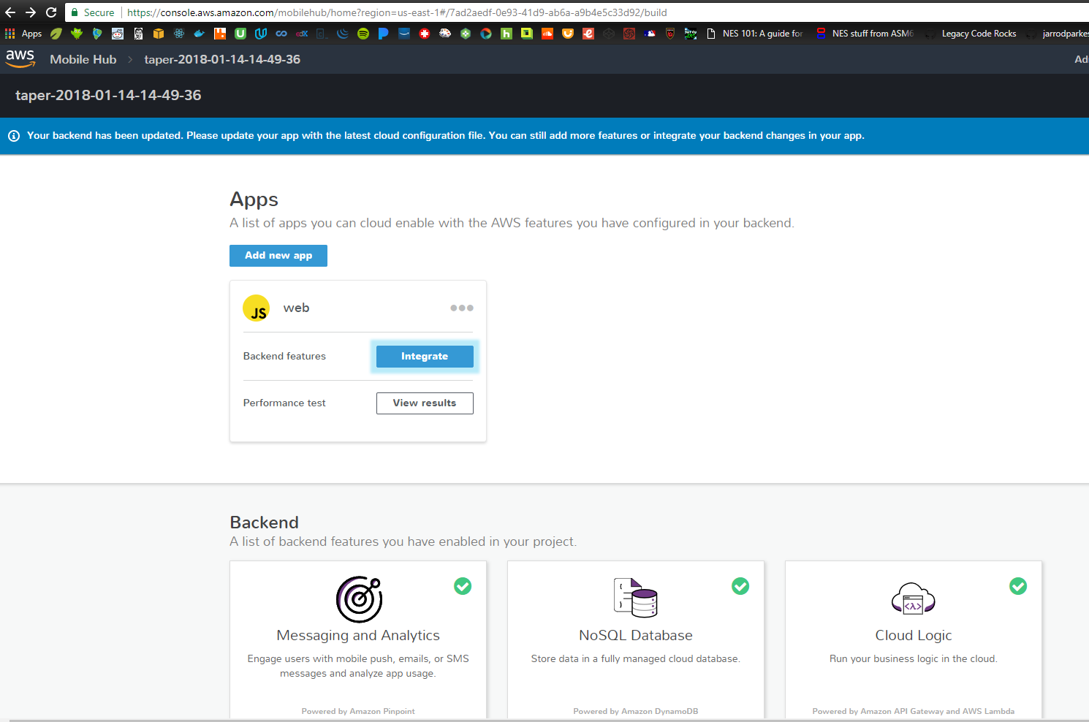

* Click Cloud Logic

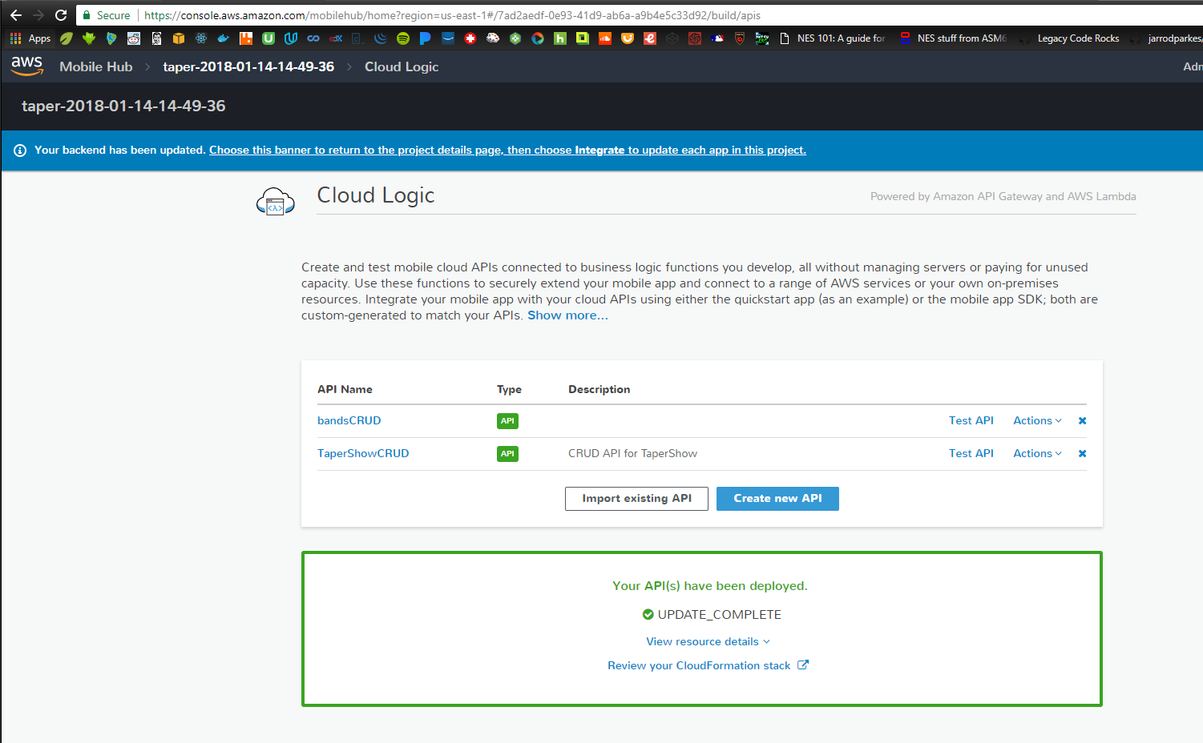

* Click Create new API
* 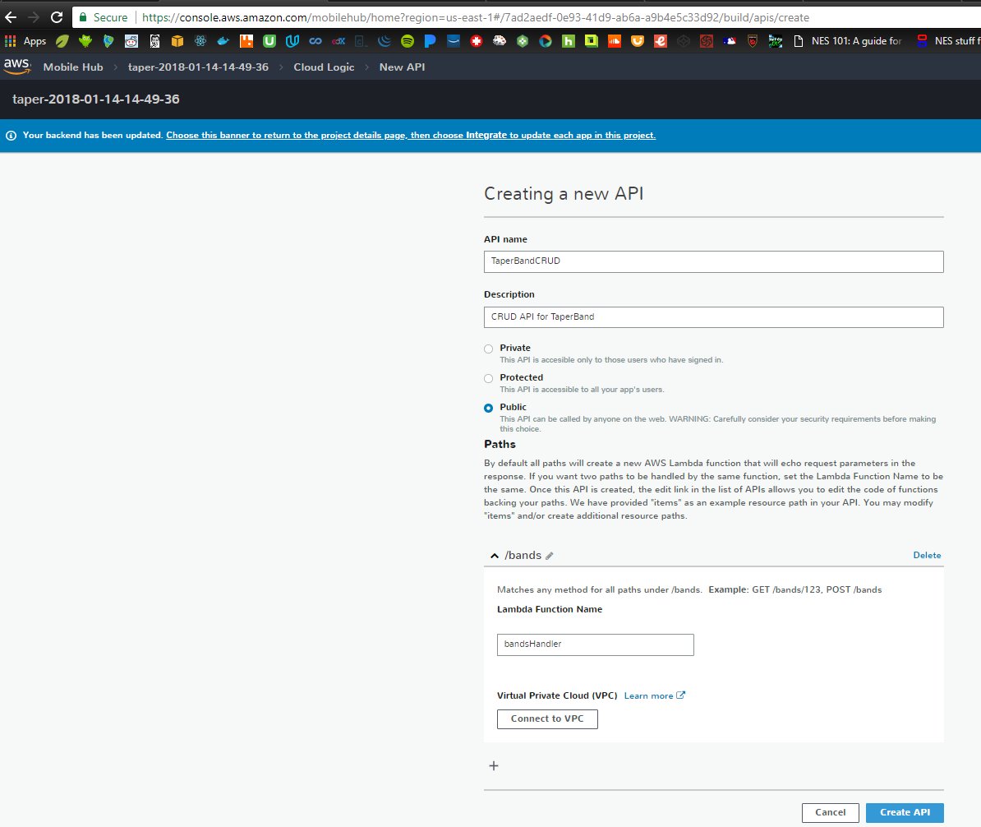
* Fill in the blanks and click Create API
* 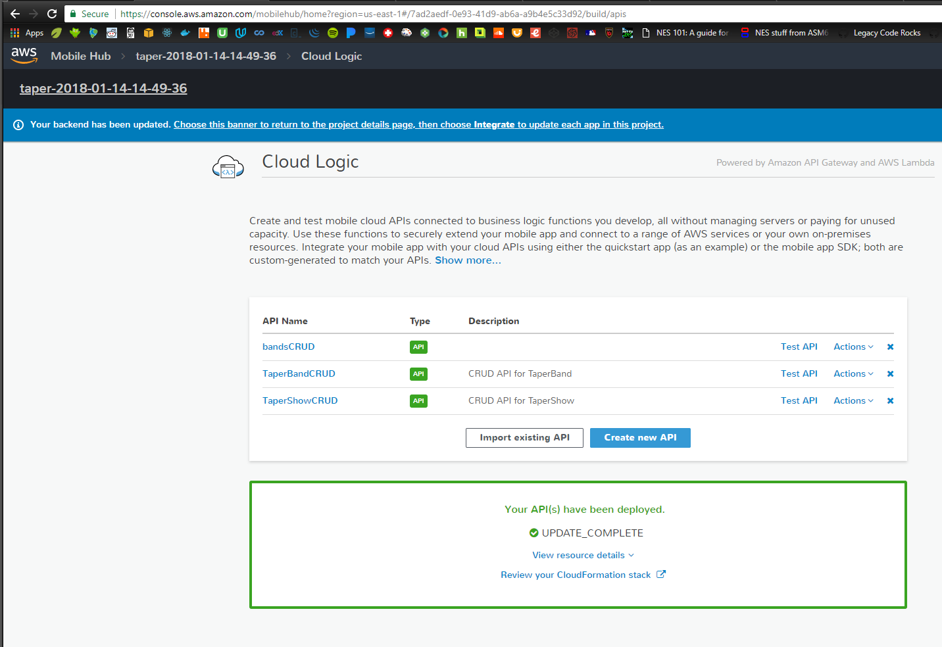
* Pull the updated API into our local app
* 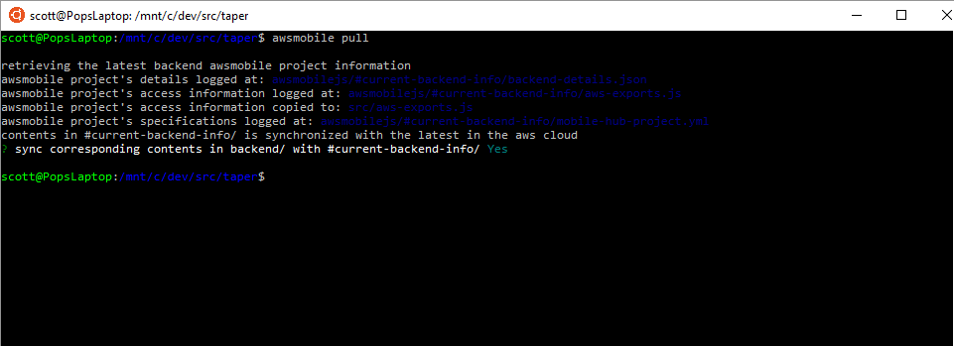

## Add CRUD calls to app to use new API

* Spin up local app
  + C:/dev/src/taper> npm start
  + 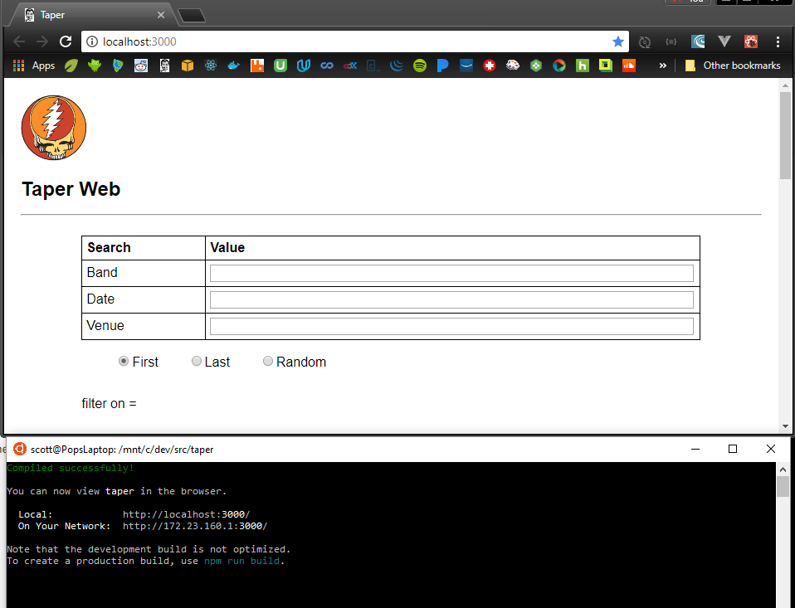

Redoing crud function and api

* Serverless framework
  + <https://serverless.com/framework/docs/providers/aws/examples/hello-world/node/>
  + > sls create –t aws-nodejs –p helloworld
  + > sls deploy
  + > sls invoke –f hello
  + Success! { statusCode : 200, body : { ….} }
  + Naming scheme is **<service>**-**<env>**-**<function>**

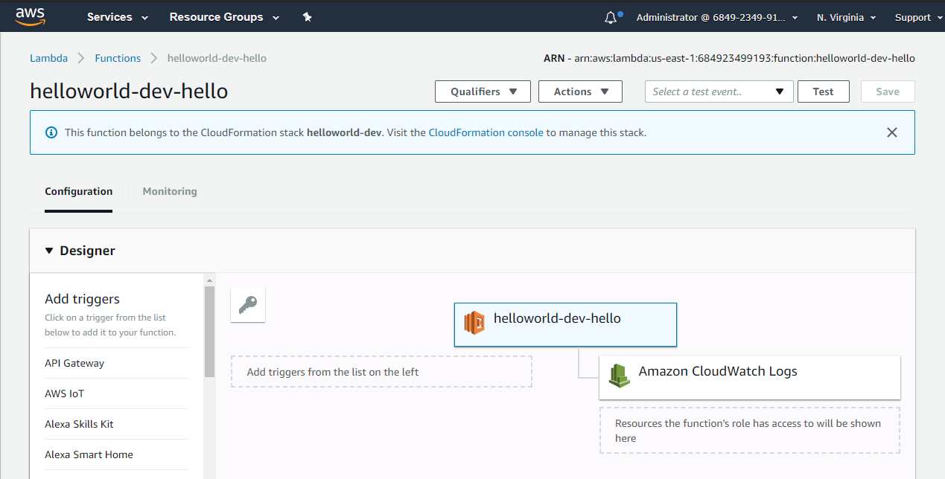

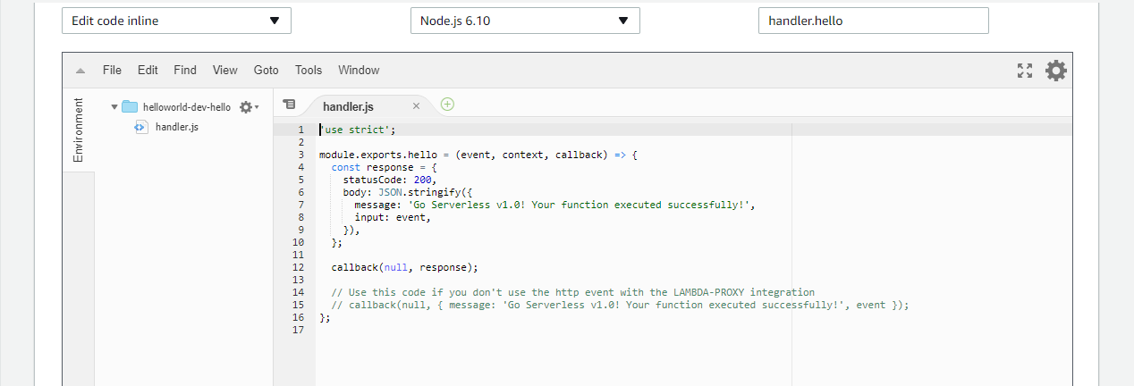

* Serverless rest api w/ serverless framework
  + NOTE: we can use npm module serverless-dynamodb-local to build our app locally, but before I get bogged down in more config, I want to just try and set up the READ part of the CRUD .
  + >cd c:/dev/src
  + >sls create –t aws-nodejs –p taper-band-crud
  + >cd taper-band-crud
  + >npm init –y
  + >npm i –save dotenv // config with .env; don’t store config keys in github!
  + Add CRUD functions to serverless.yml file

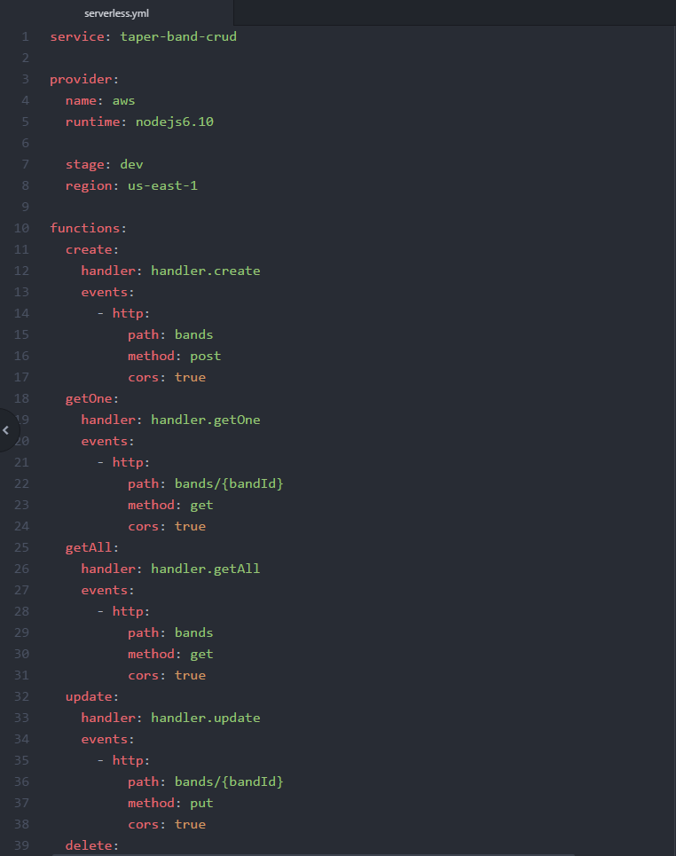

* + Test a getAll from cli

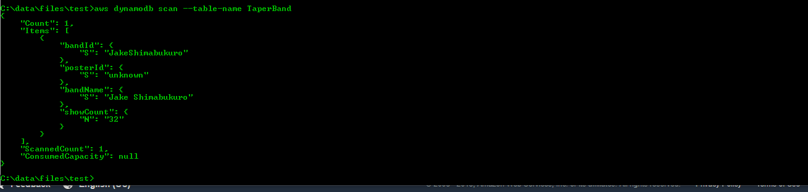

* + Build the getAll handler
  + 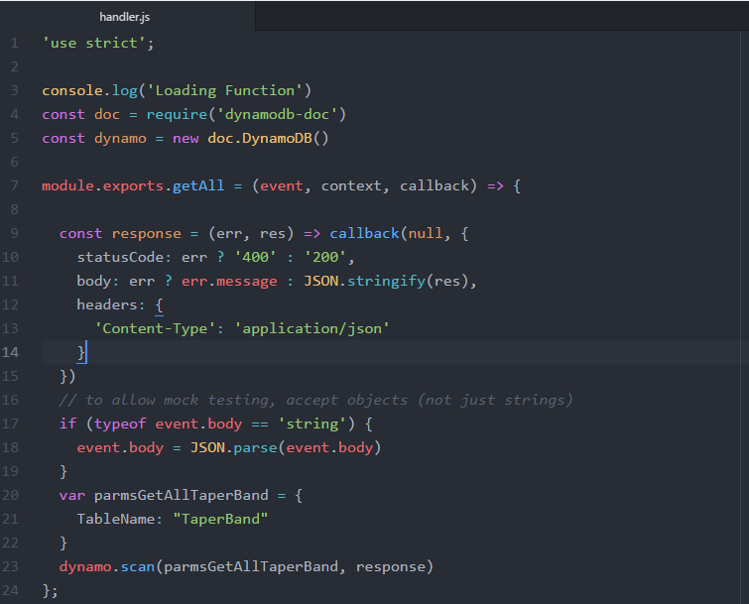
  + >sls deploy
  + 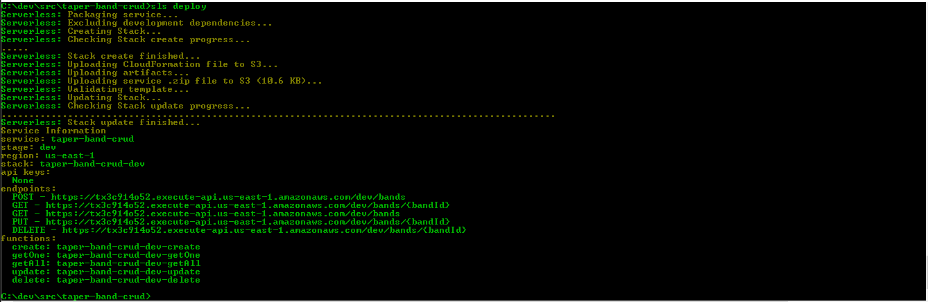
  + Here it is in AWS
  + 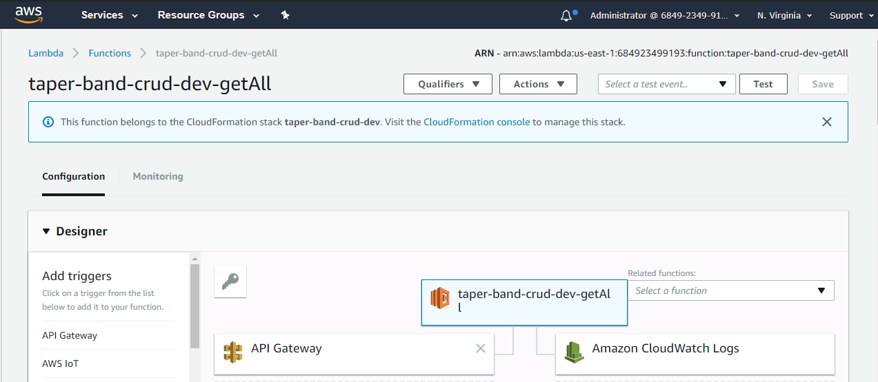
  + Test it from the command line
  + 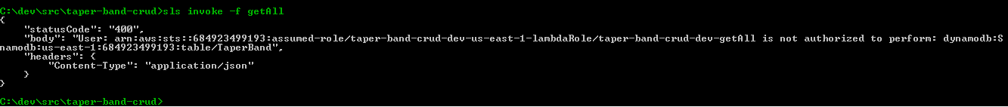
  + Derp. I always/never get the dang IAM stuff straight. Good news is that the api-gateway/lambda-function are working as designed.
  + Read this… <https://docs.aws.amazon.com/amazondynamodb/latest/developerguide/api-permissions-reference.html>
  + Reason: I had my table named incorrectly. Two problems… I was using ${self.provider.environment}, but I hadn’t defined that variable. Also, I was using the table naming convention = {service}-{stage}, but my table is named TaperBand.
  + Solution: defined the self.provider.environment.DYNAMODB_TABLE. For now, I named it TaperBand to match what I have already built for Jake. [Mental note: circle back and rebuild the dynamo table to use naming convention service-stage, so that I can have different tables for dev/qa/prod.
  + 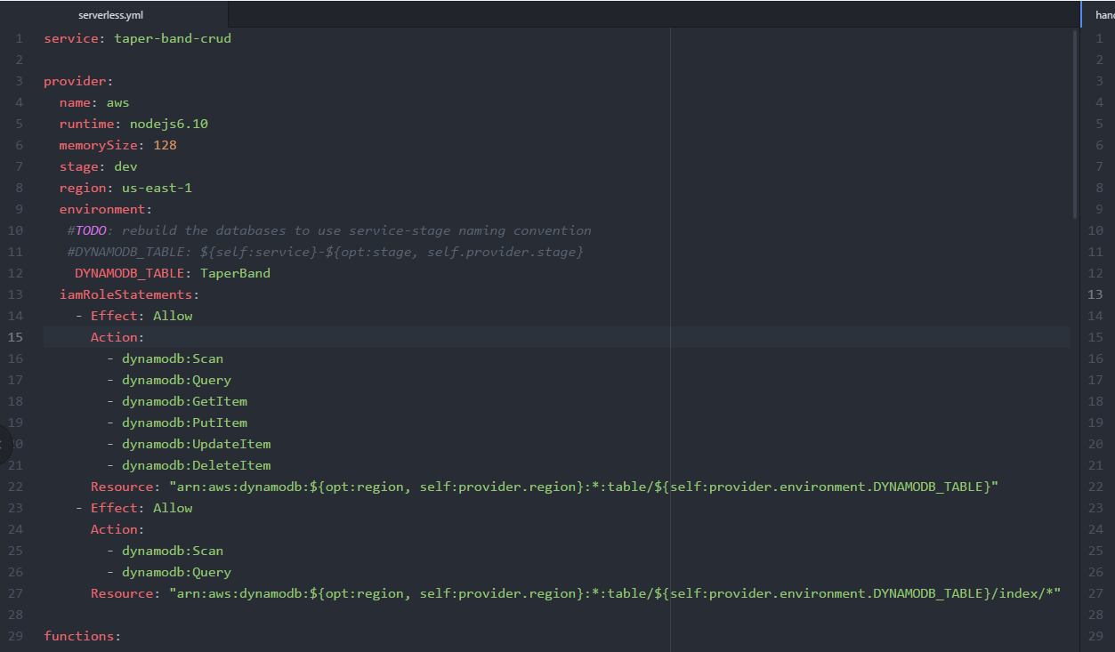
  + >sls deploy
  + >sls invoke –f getAll
  + 
  + Success!
  + getAll & getOne look like this…
  + 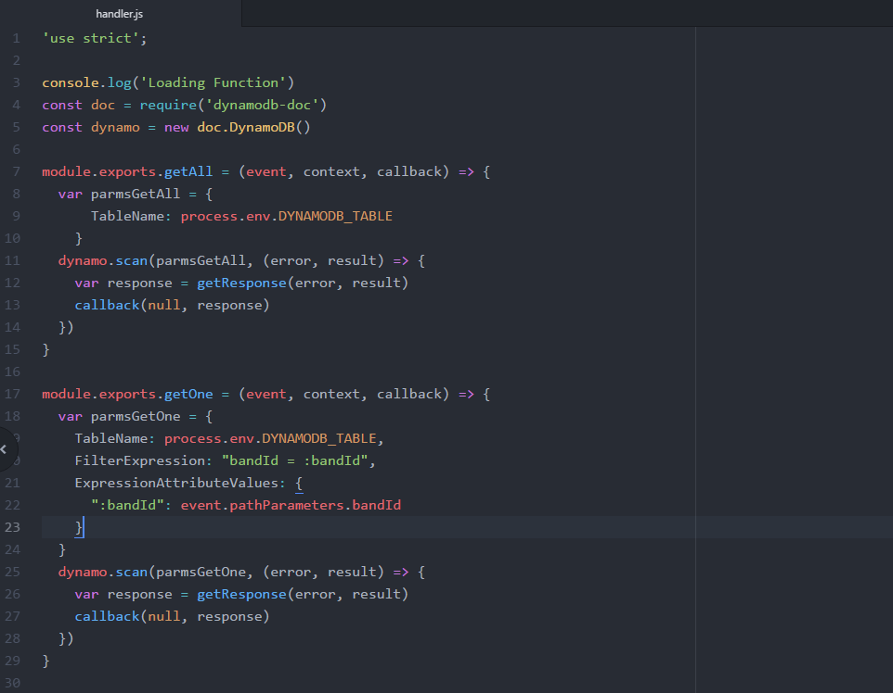
  + Testing getOne from CLI
    - Build a little json file to supply the pathParameters
    - 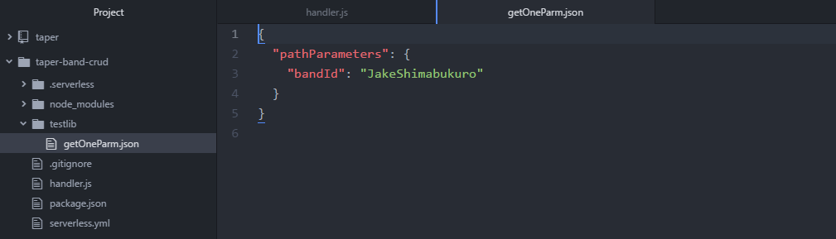
    - >sls invoke –f getOne –p testlib/getOneParm.json
    - 
  + I will add create, update, delete functions as needed.
  + For now, go to front-end and plug this in.
  + I added the dev-taper-band-crud api to my taper awsmobile project in the cloud logic console
  + 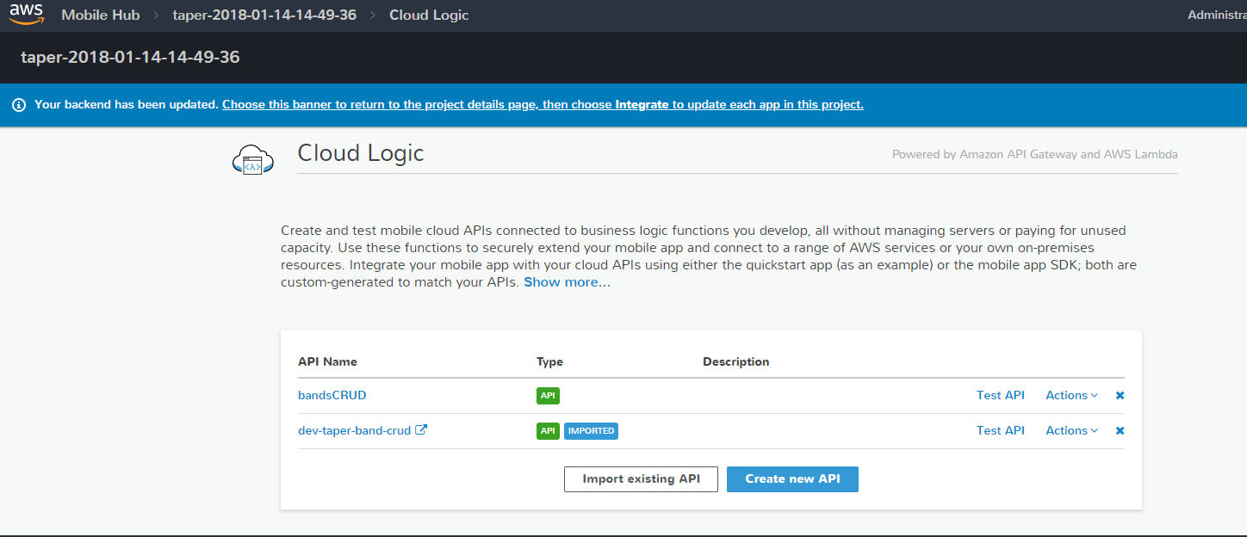
  + >awsmobile pull
  + Didn’t update my local version with the api, but I can see the new api listed in the backend/mobilehub-project.yml file, so I did an awsmbile publish
  + UGH! The stupid awsmobile push/publish is broken again. Same error I got weeks ago when I had to start using Ubuntu to get around it.
  + This mobile hub has such promise, but it is shite!
  + The api is available from the web though. Here’s a test curl…
  + 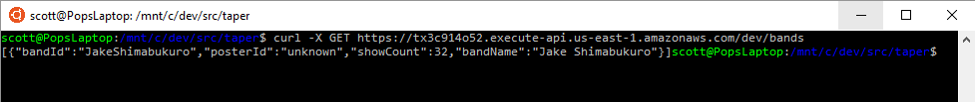
  + So, instead of using the flipping awsmobile api, I could just plug in actual http calls. Yet another kluge, but whatever.

## DO OVER: DB = dev-taper-shows

### Build table from Dynamo Console

Go to AWS Console – DynamoDB Dashboard; Click create table

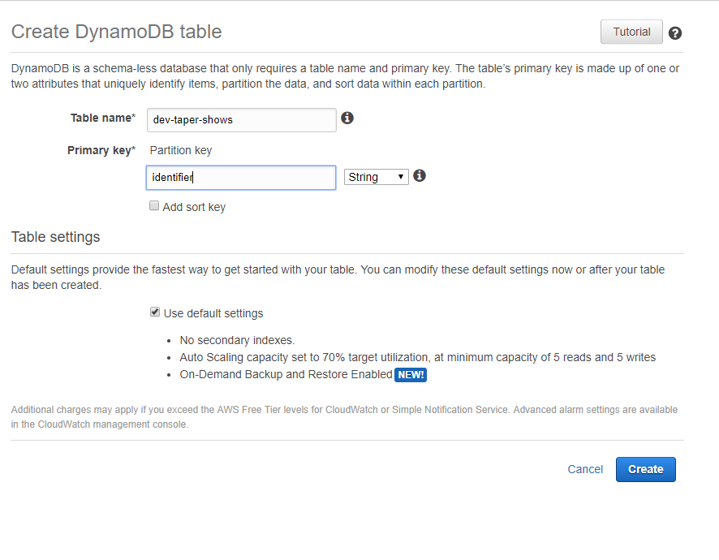

Supply a name and primary key; click create. (I am using identifier for the key name instead of showId because I wanted it to map directly to the key/value pair at archive.org.)

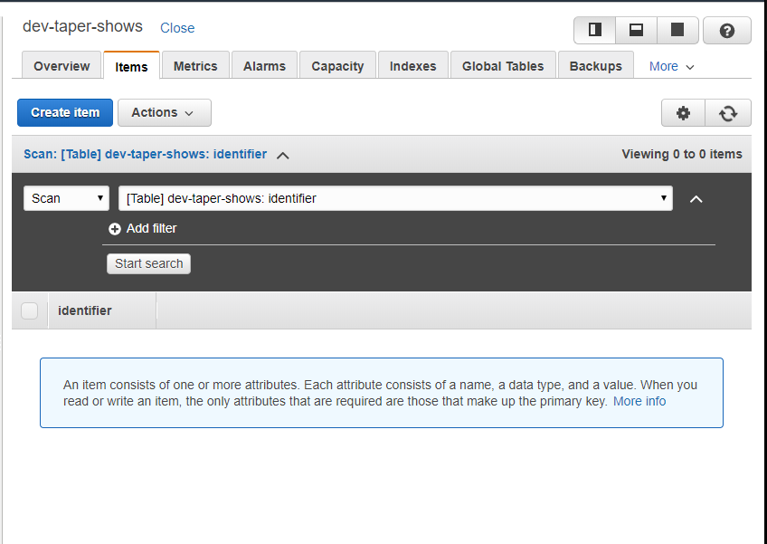



### Populate table with batch jobs

C:/dev/sts382/bench/taper-job-*-shows-for-band/build/libs> java –jar taper-job-extract-shows-for-band-0.0.1-SNAPSHOT.jar <bandId>

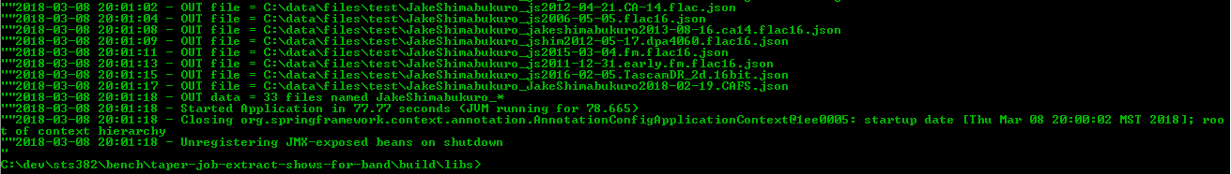

C:/dev/sts382/bench/taper-job-*-shows-for-band/build/libs> java –jar taper-job-transform-shows-for-band-0.0.1-SNAPSHOT.jar <bandId>

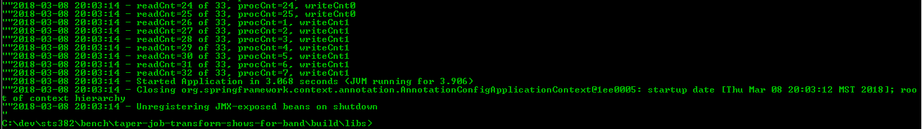

C:/data/files/test> awsDynamoDbBatchLoader <bandId>

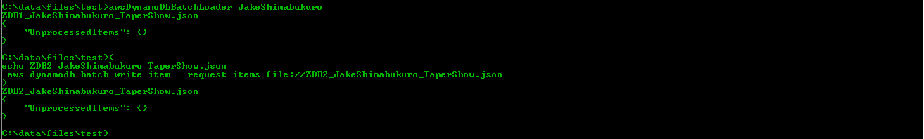

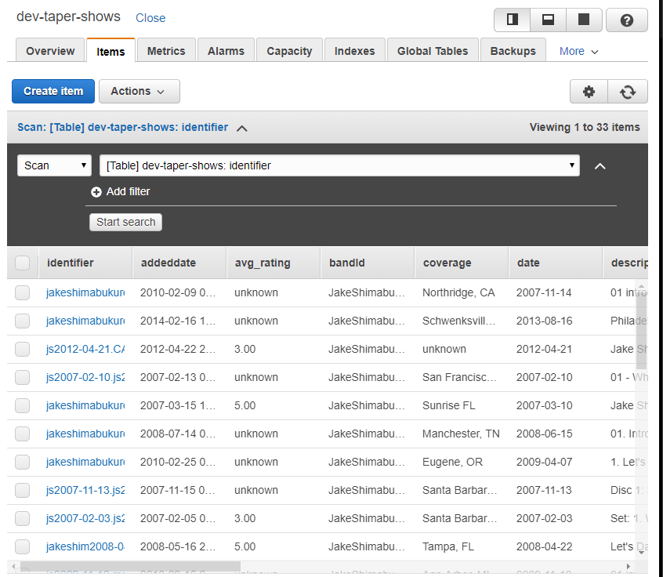

### Build Serverless-Lambda for CRUD

#### Scaffold a new serverless node app

>cd c:/dev/src

>sls create –t aws-nodejs –p taper-shows

>cd taper-shows

>npm init –y

>npm i –save dotenv // config with .env; don’t store config keys in github!

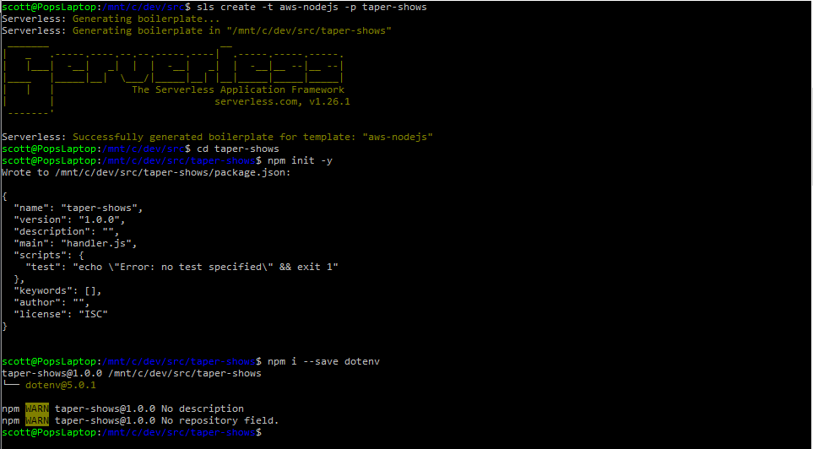

#### Add CRUD functions to serverless.yml file

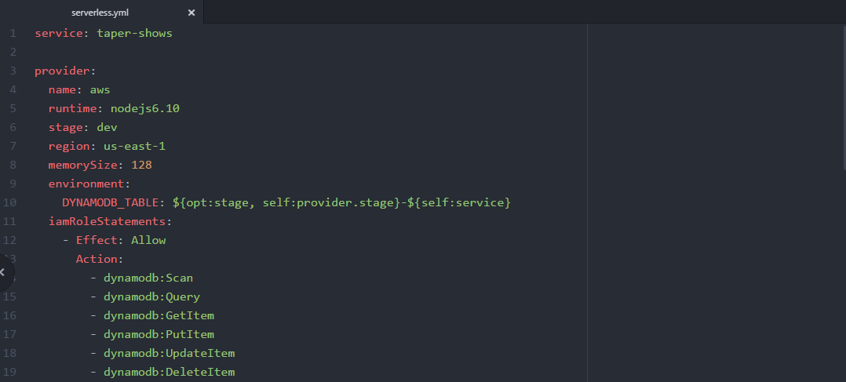

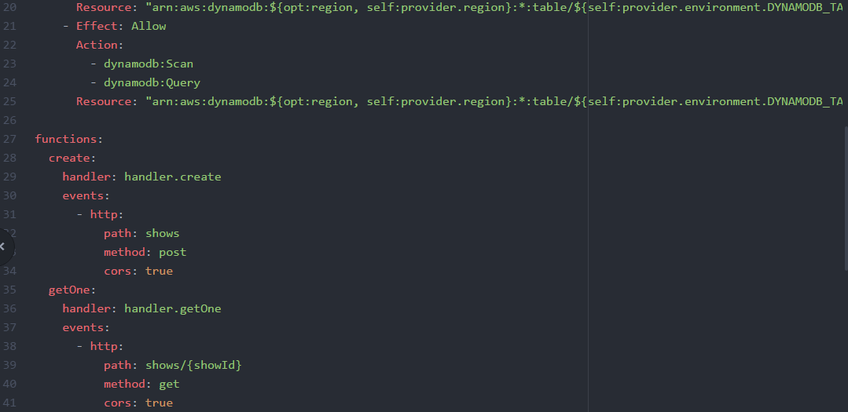

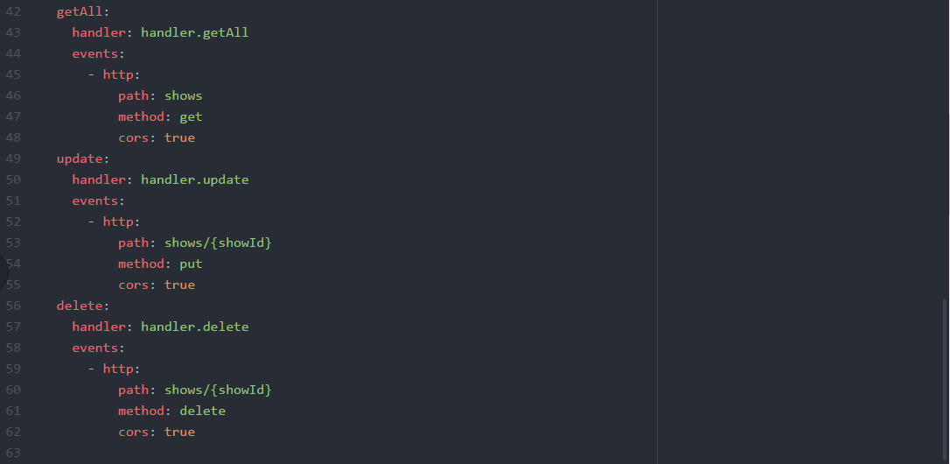

#### Add some functionality to the handler

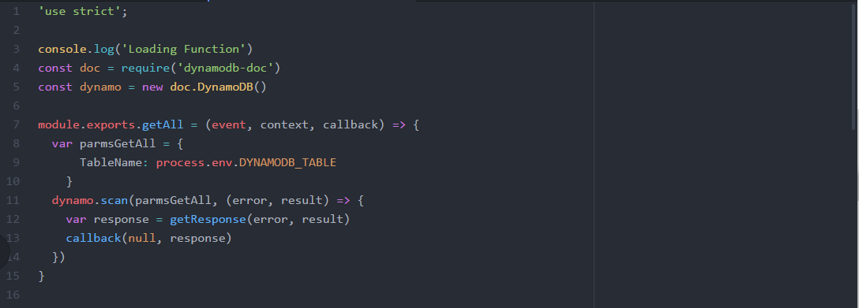

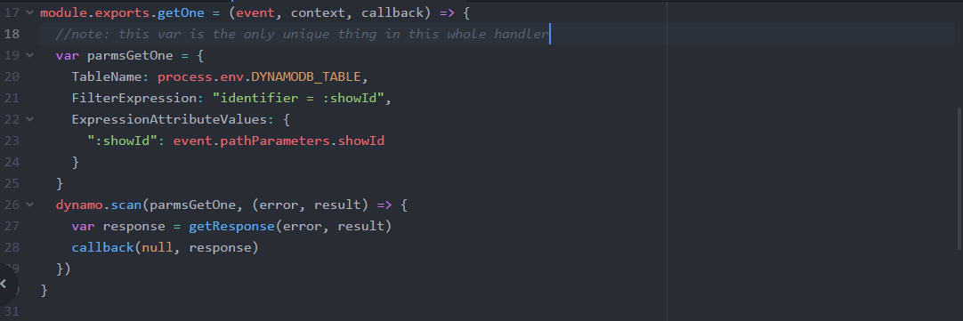

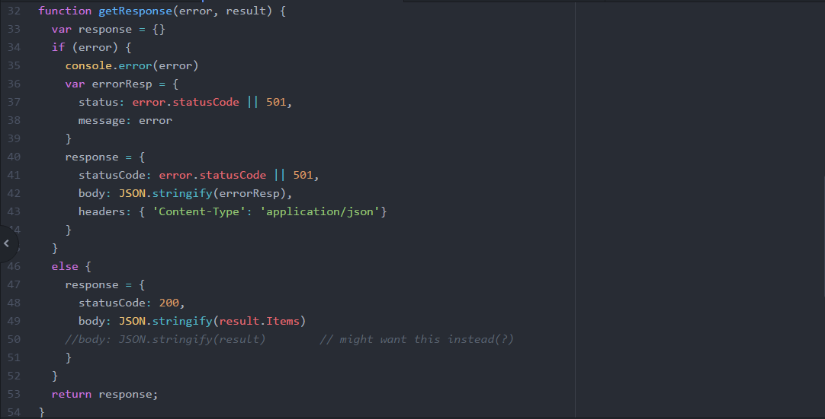

#### Deploy to AWS

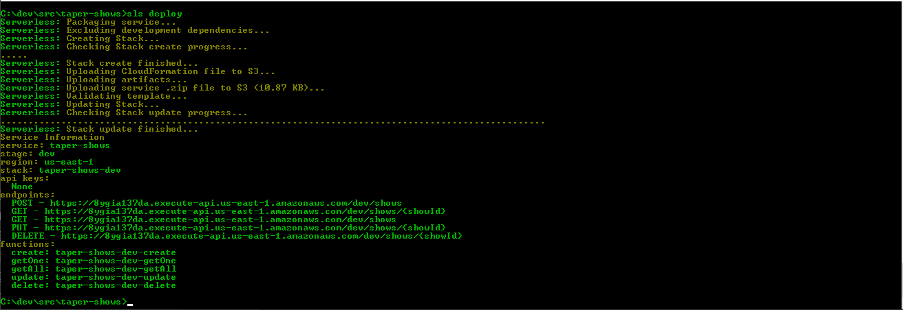

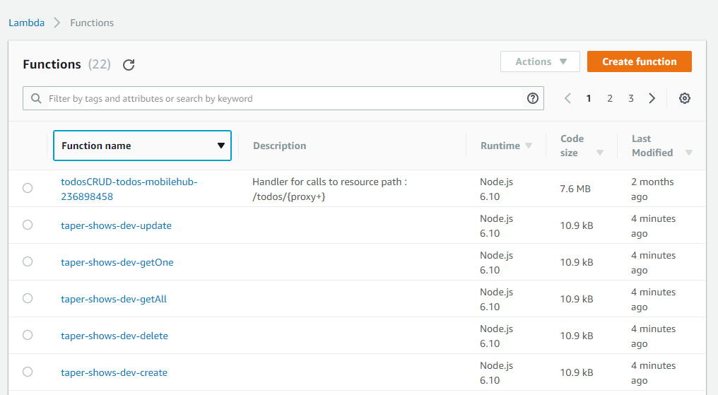

#### Test it

GetAll

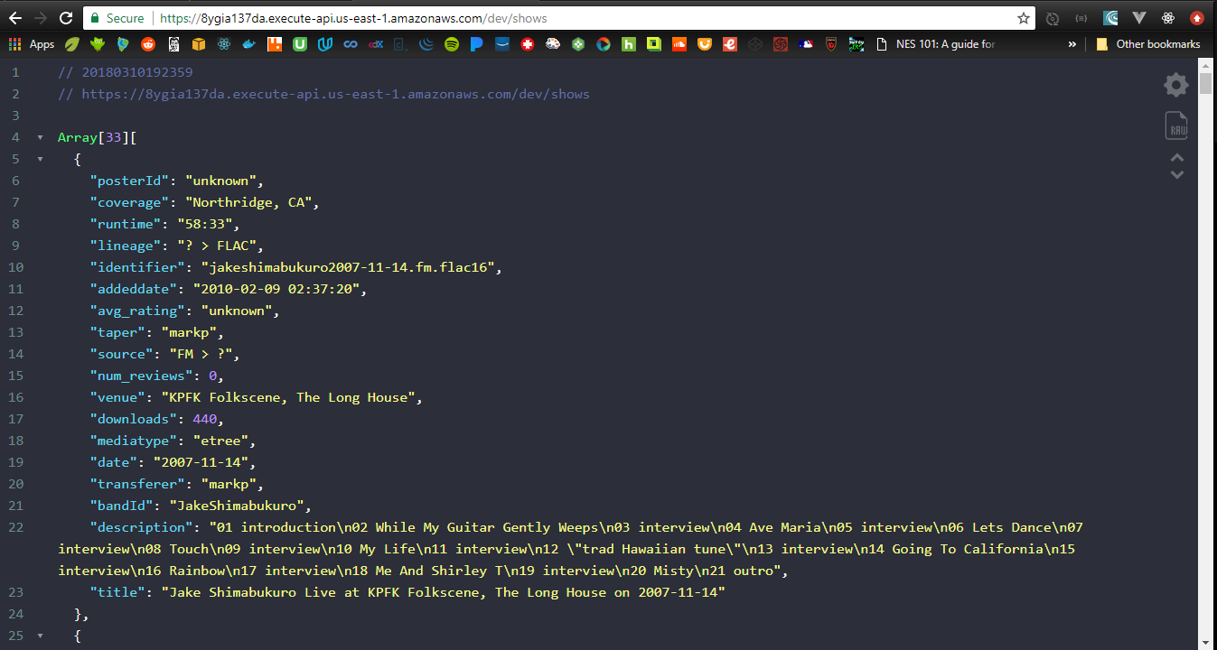

GetOne

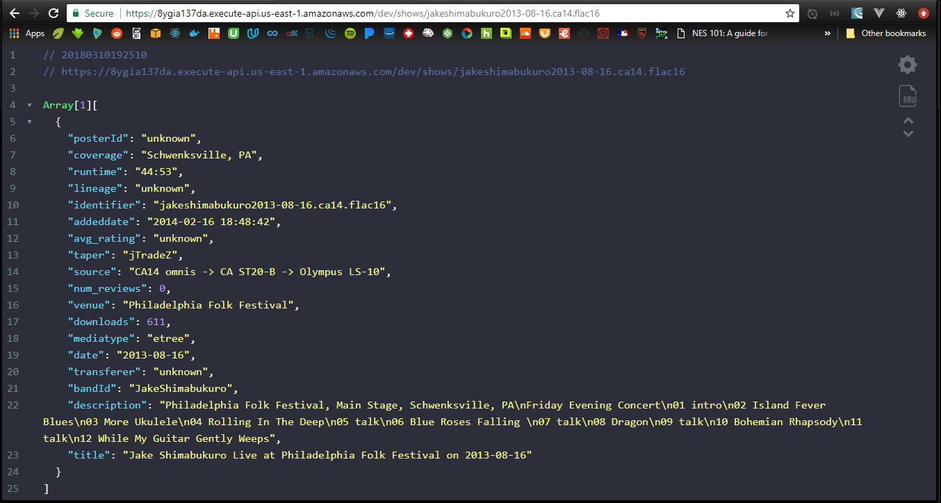

Refactor: want getAllShows, getOneShow, getAllShowsForBand

Change serverless yaml file

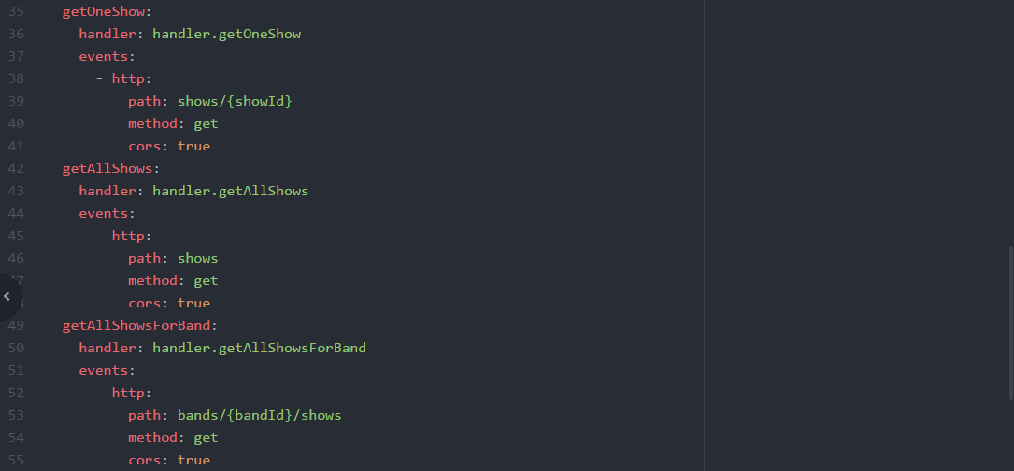

Change handler functions

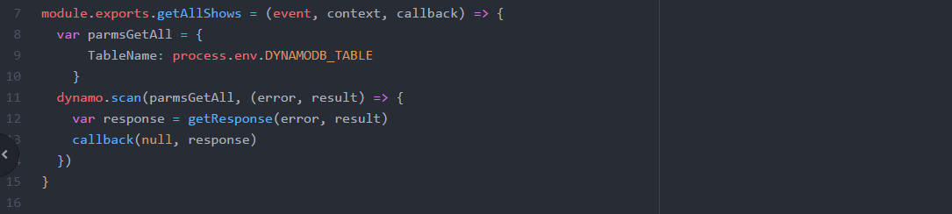

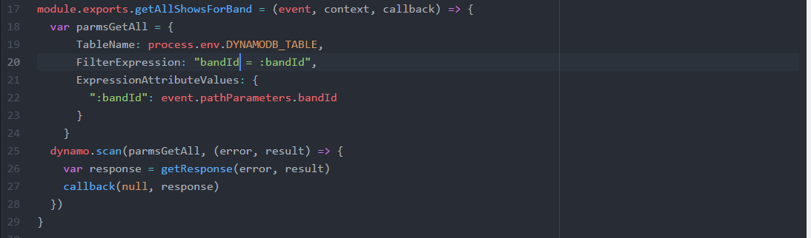

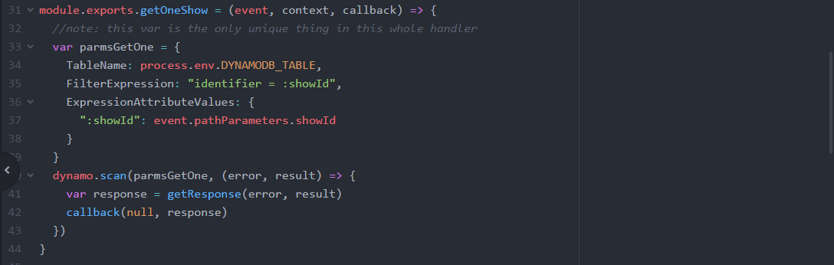

Redeploy

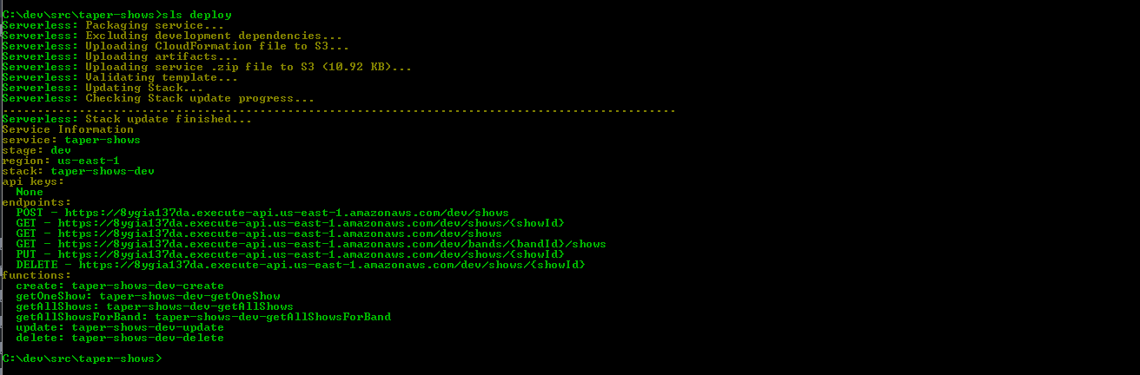

Retest

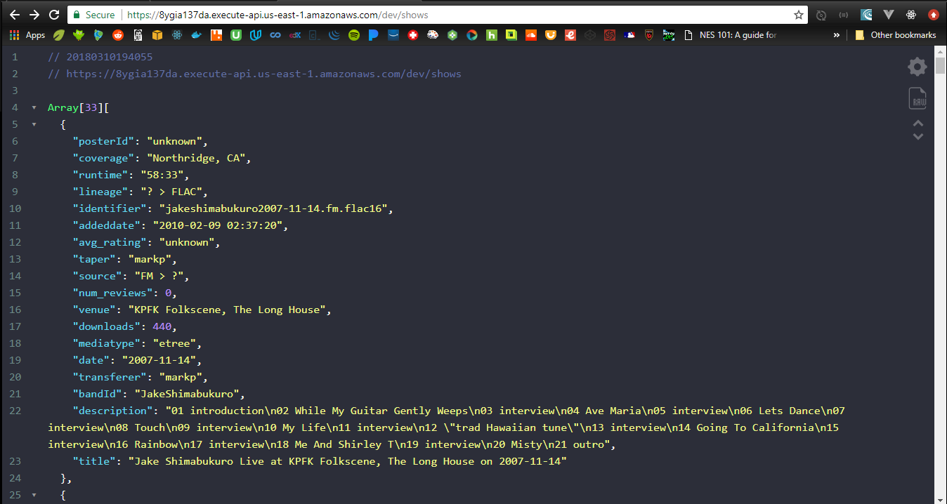

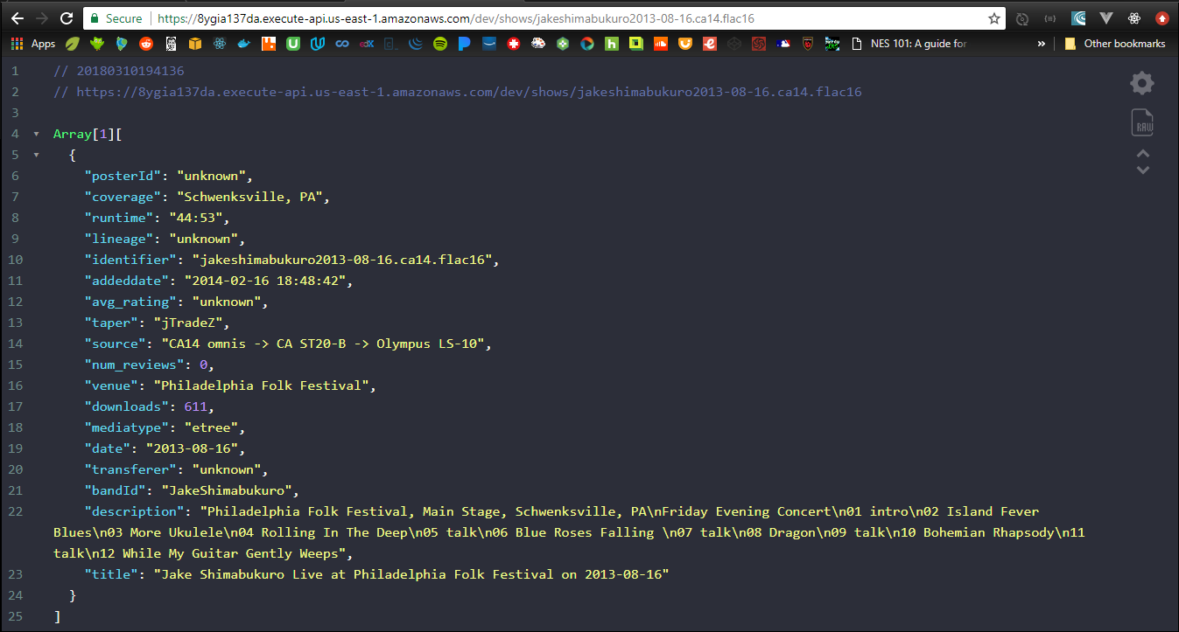

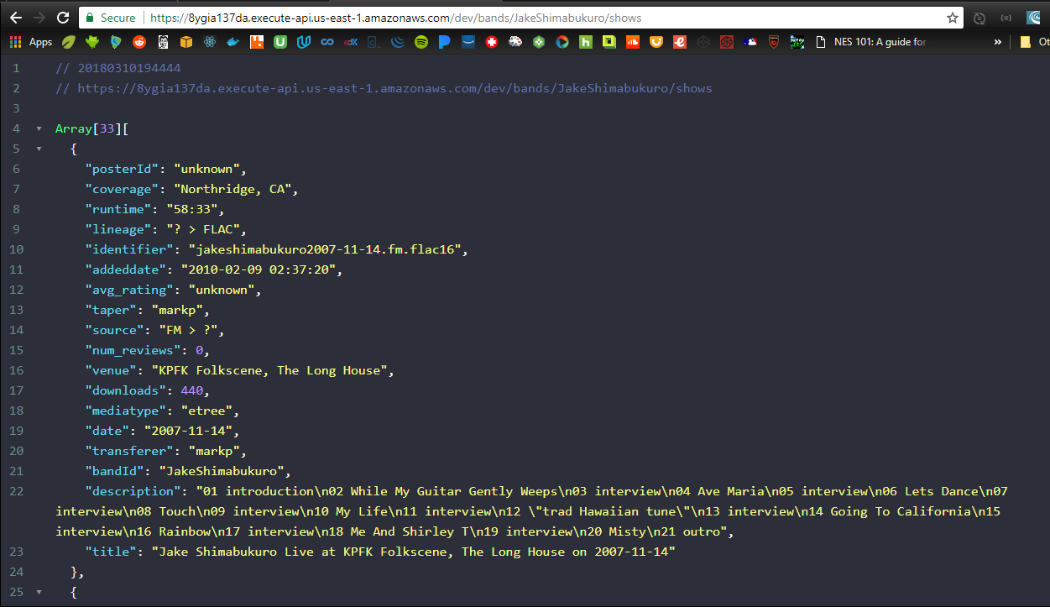

### Build API Gateway

Serverless builds the API gateways for you! Here they are...

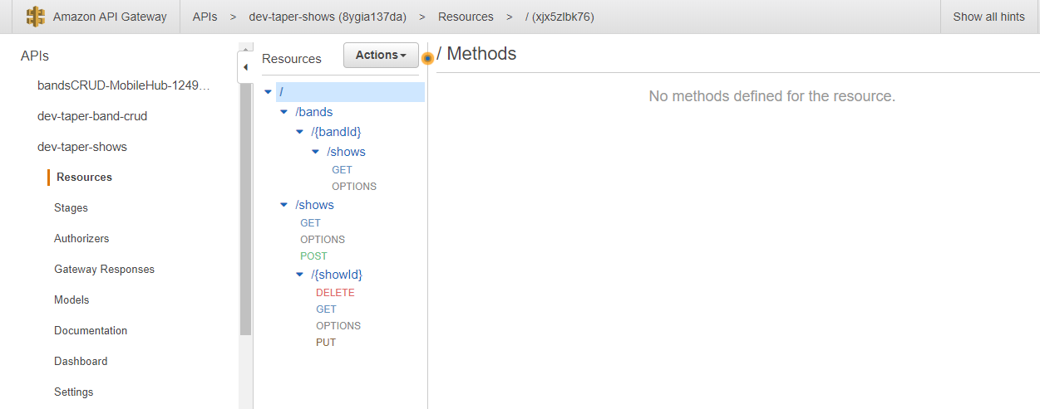

### Check code into Git/Github

Create new github repo, local repo, add the files and sync

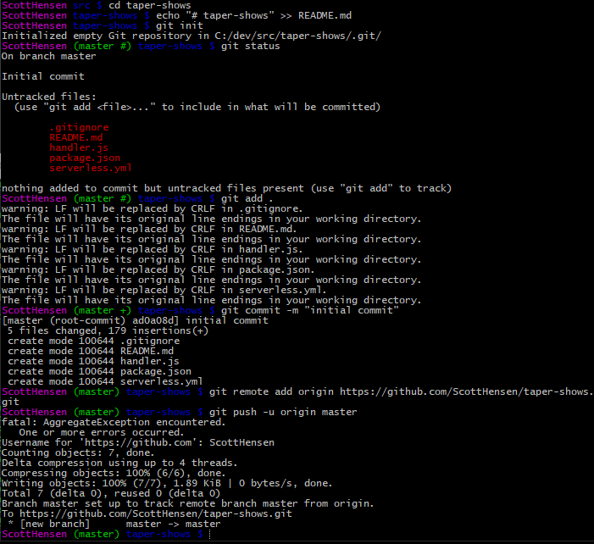

READY TO GIVE API A BETTER DOMAIN NAME.

The naming convention requires a base path to map to a particular api, so if I wanted separate apis for band db and show db, then I’m looking at a naming scheme like this…

Taper.io/band-api/bands…

Taper.io/show-api/shows/…

That’s kind of clunky. What if we put *all* db stuff into one api? Then we could use this…

Taper.io/data/bands… and Taper.io/data/shows…

bandId, bandName, posterId, showCount

### Refactor. Again.

#### Scaffold the new serverless node app

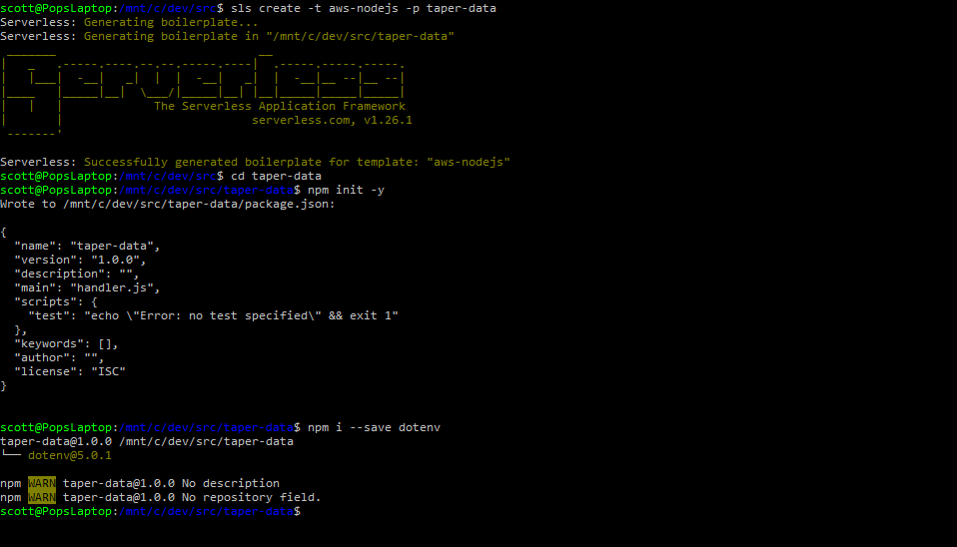

#### Add CRUD functions to serverless yaml file

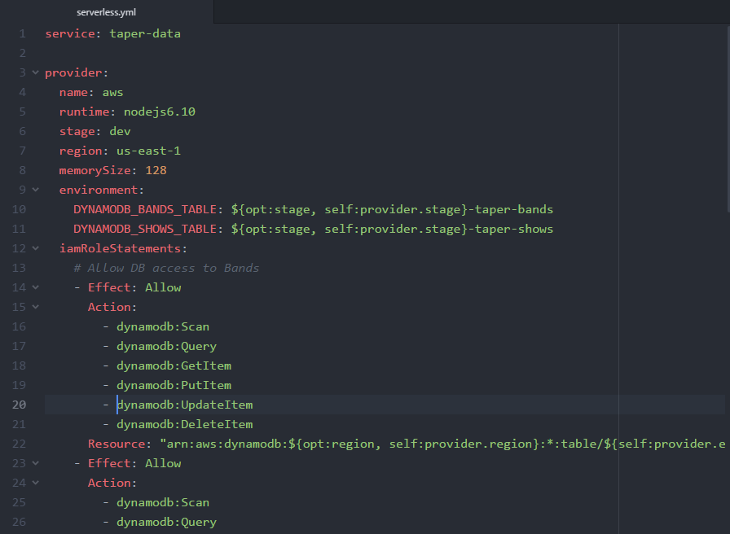

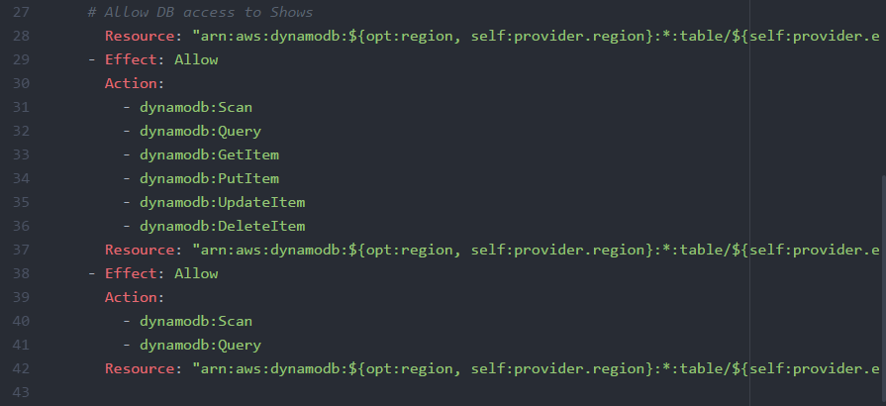

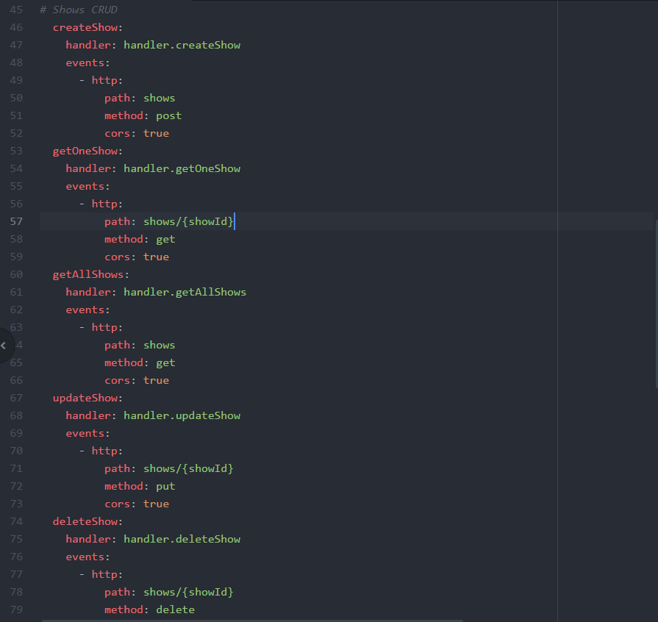

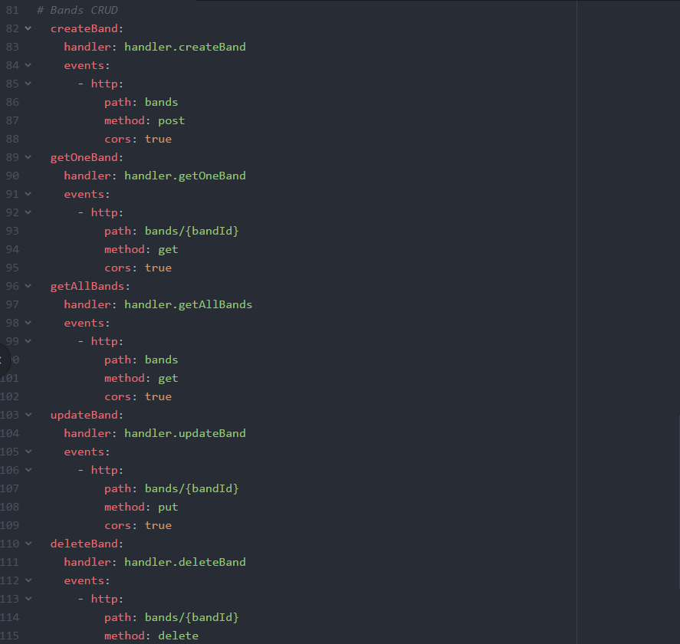

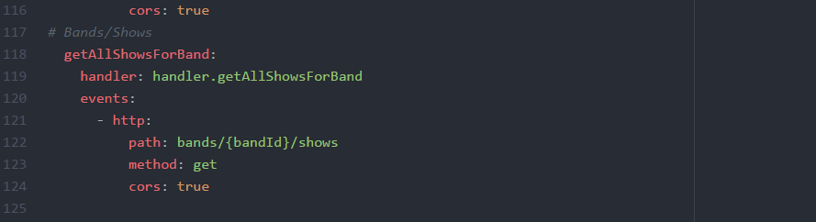

#### Add GET functions to the handler file

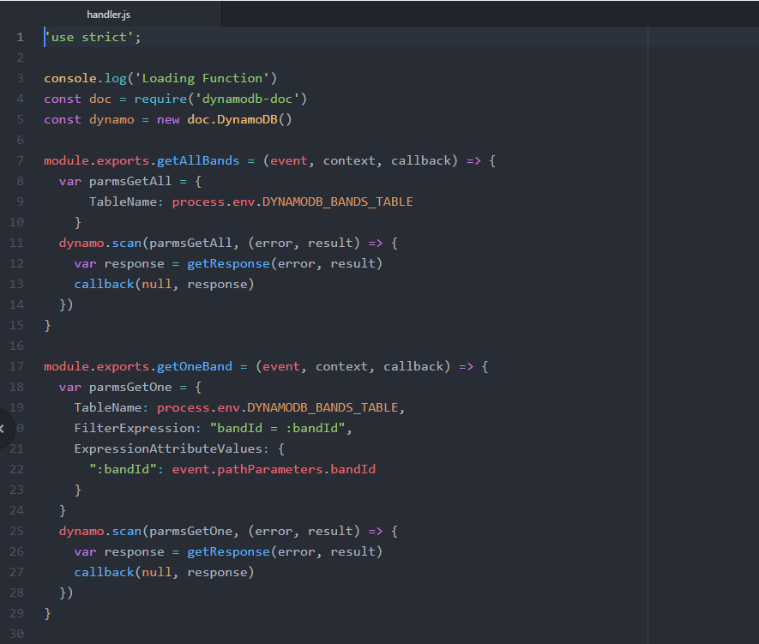

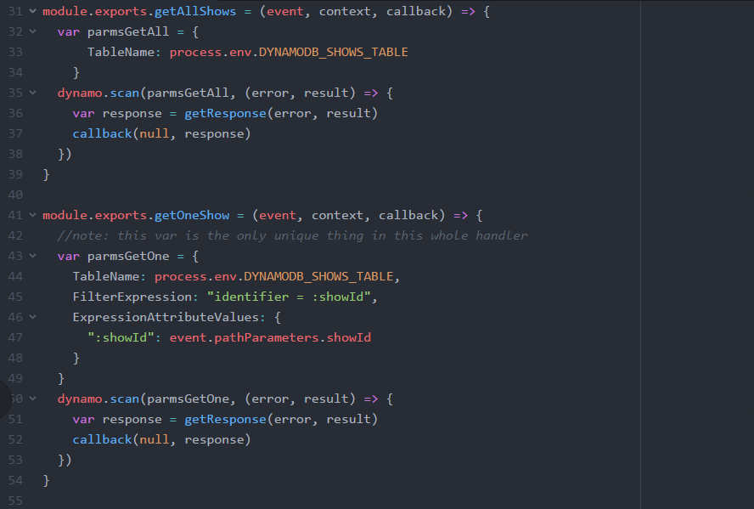

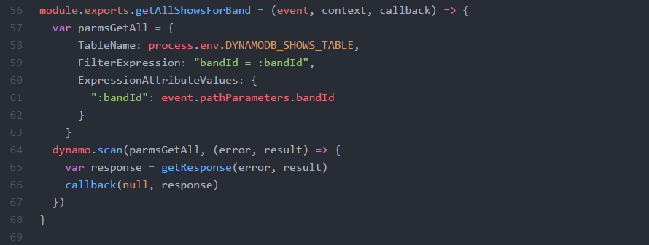

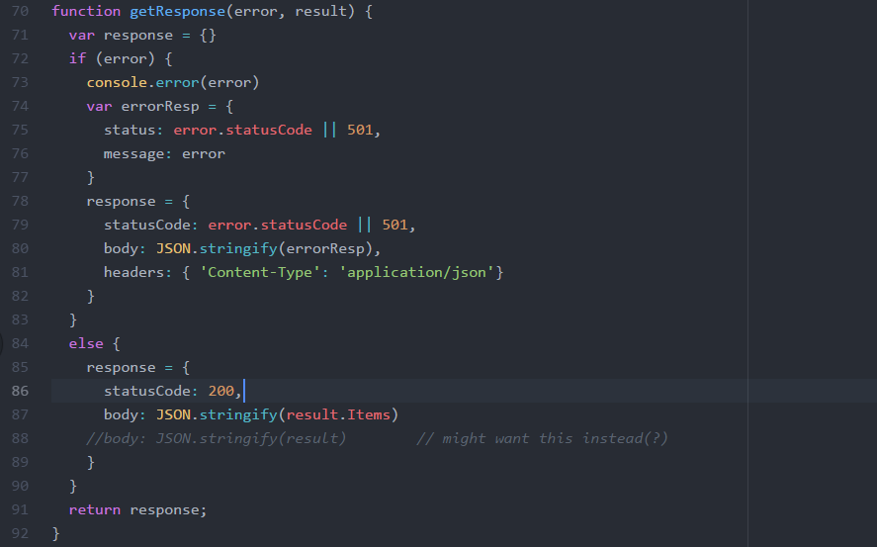

#### Deploy to AWS

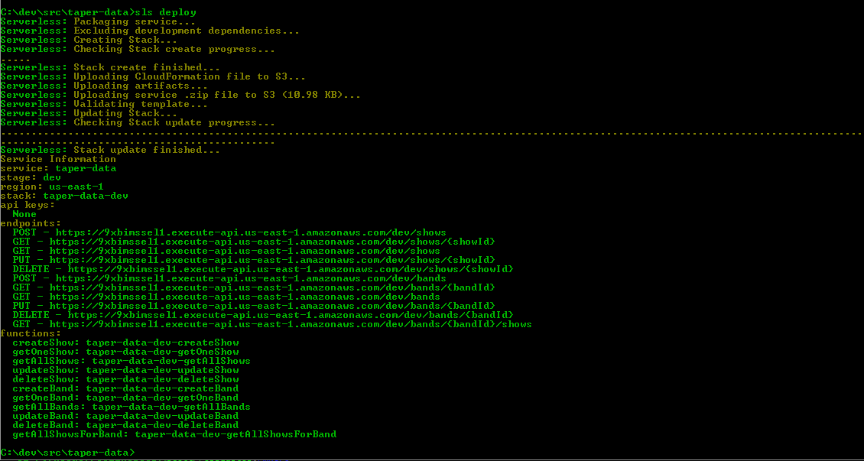

#### Test It

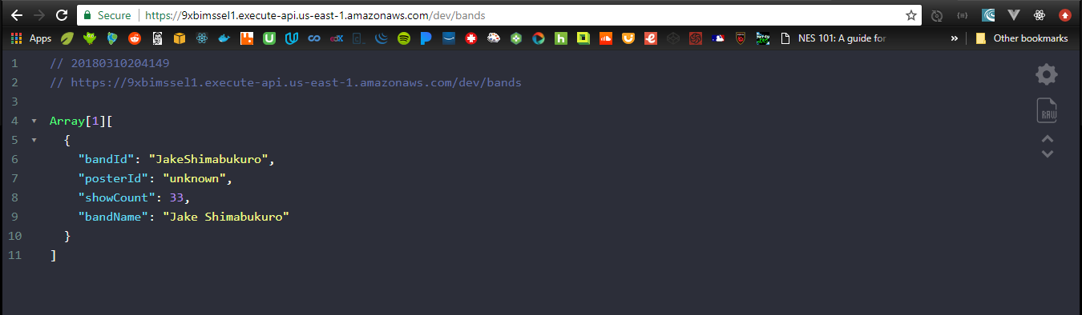

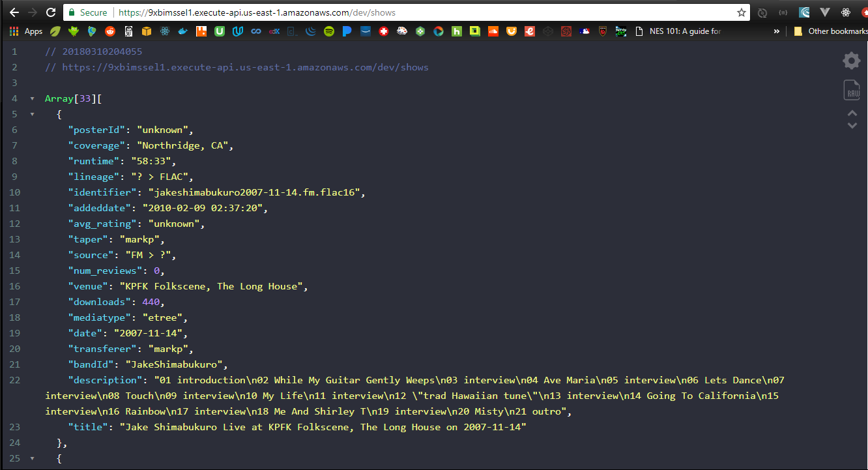

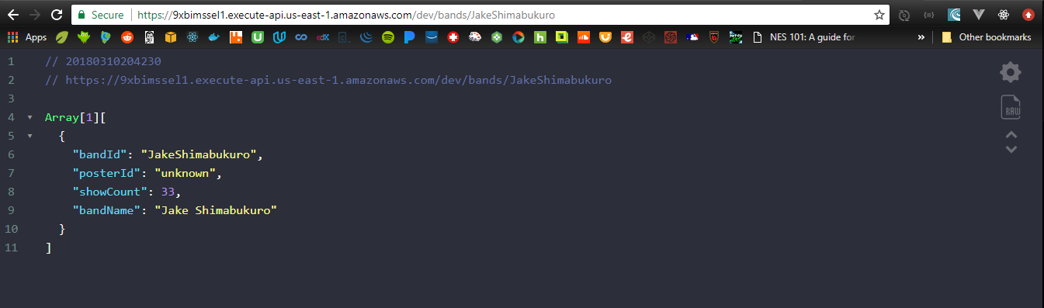

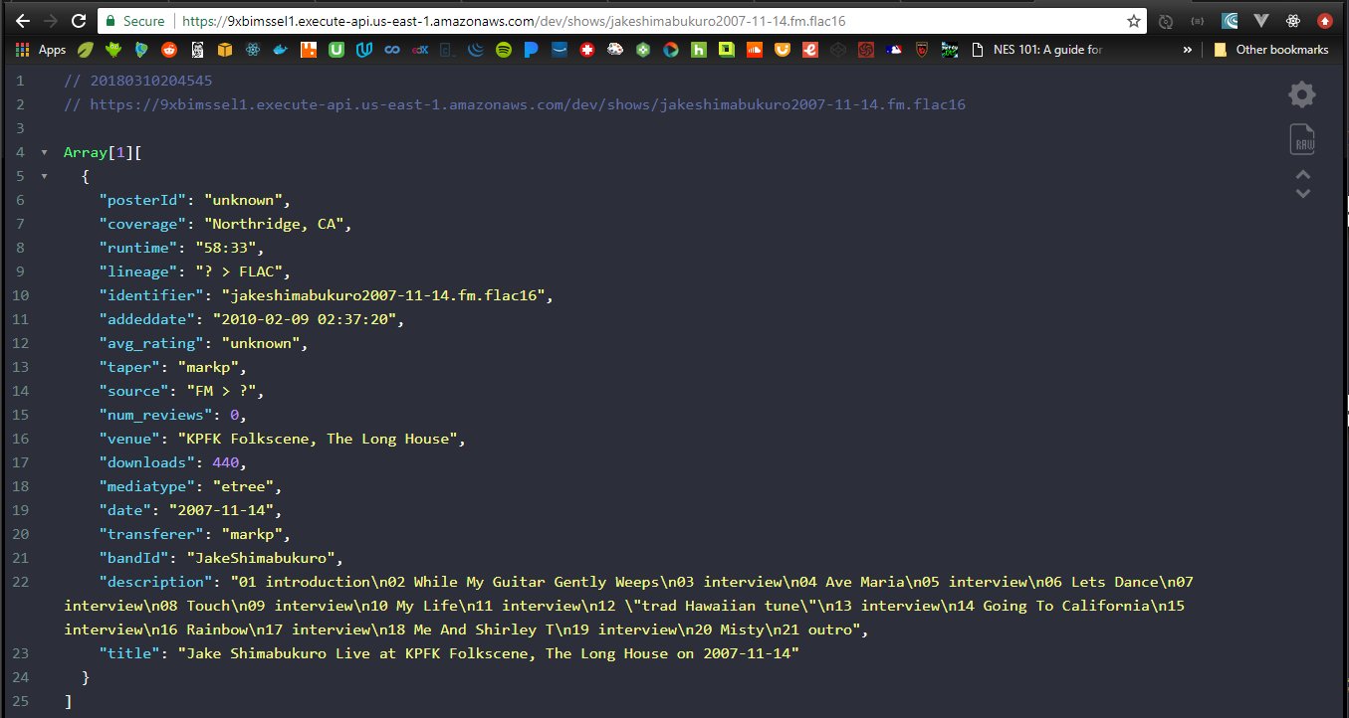

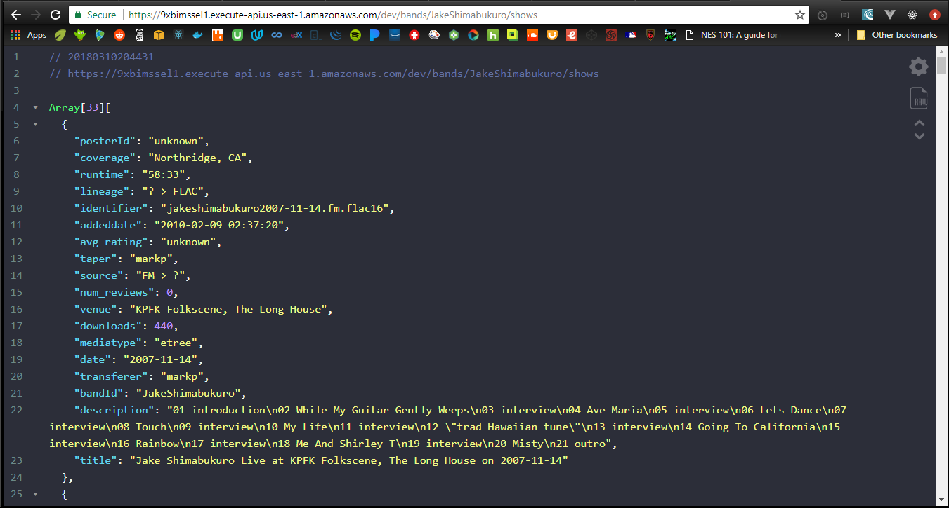

#### Verify AWS Lambda, & API Gateway

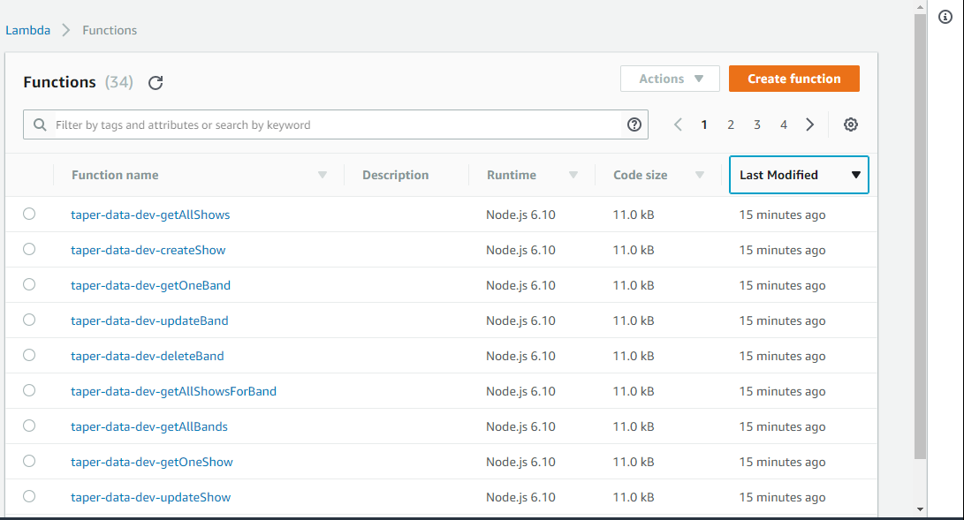

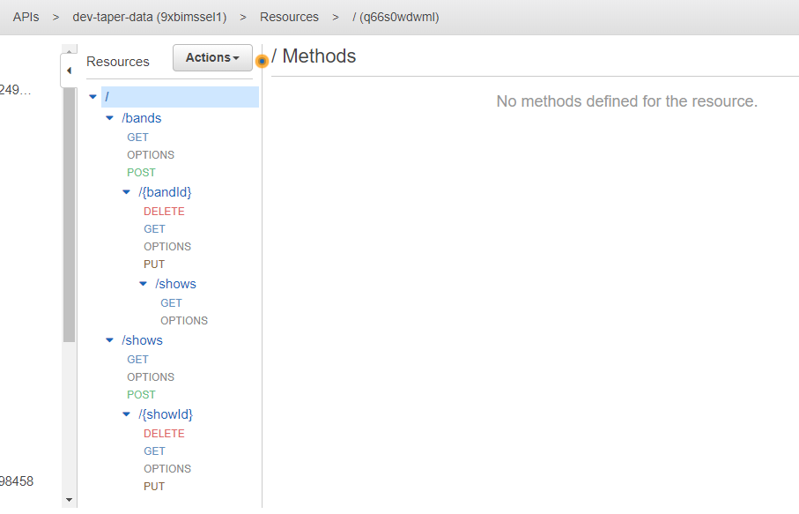

#### Check into Git/Github

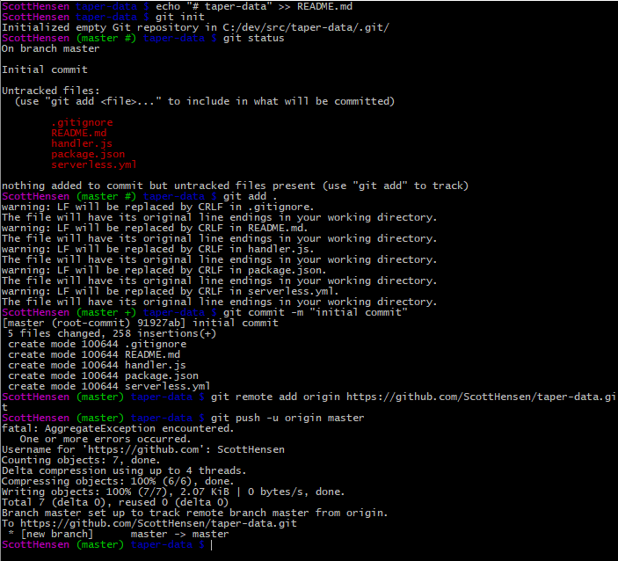

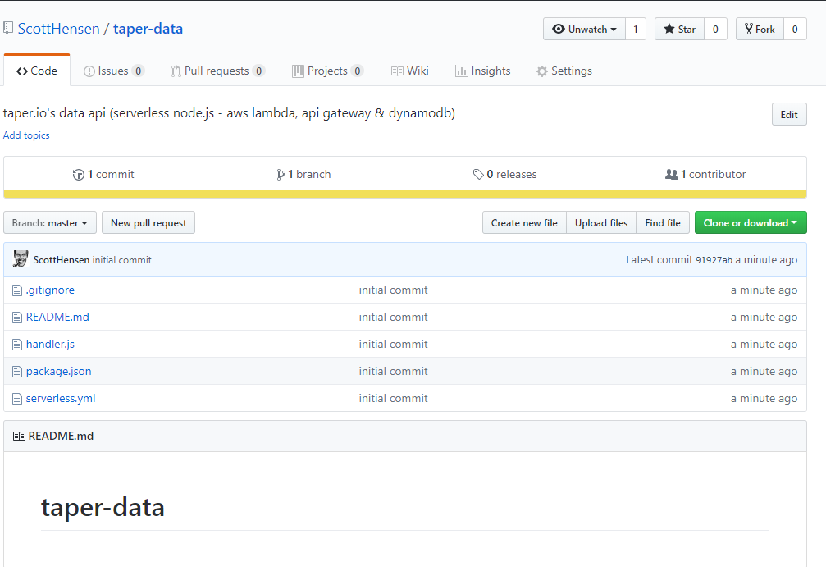

### Add to front-end

I’m not sure I’m sold on awsmobile now… publish/push has been janky.

Would like to IMPORT my existing api into awsmobile, but that doesn’t look like an option.

So, I’m building a brand new API from scratch. …I think I am going to stop using awsmobile until it gets better.

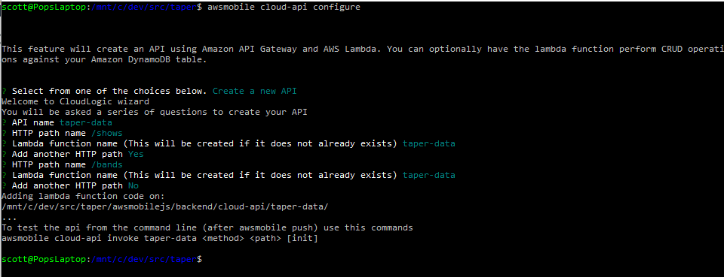

### Give the API a nicer name

taper.io/data/

<https://docs.aws.amazon.com/apigateway/latest/developerguide/how-to-custom-domains.html>

# 3/14/18

## Wrap it up man.

This little effort got way out of control. Here’s a recap of what I did… or, what I would have done if my brain allowed me to progress in a sensible way

1. First, I picked up React.
2. Then, after building a backend to serve up the embeddable urls from archive.org, I realized that I couldn’t use their search api because they don’t have cors opened up. Works fine from command line or browser bar, just not from another app. Argh.
3. So, I built a batch process that would hit their search/scrape functionality from a commandline.
4. With the collected json results, I populate my own smaller version of their giant tape database.
5. Then, I built lambda functions to pull data from my databases.
6. Now, I am ready to add the lambda functions to the front-end.

# Final Project Notes

## Project Description

This project – Taper.io – will provide an interface for the archive.org audio vault. I love their collection of taped shows; I’ve been listening to them for twenty years maybe? I’m not really sure, but I know it’s been a really long time. When Dead and Co did their big Fare Thee Well tour a couple years ago, I really wanted to follow them around for the summer. But, being an old man… I didn’t. Instead, I listened to their shows as soon as our dear taper brothers and sisters put them on the archive. I wanted to learn vue, so I built a simple vue app and a list of archive.org urls to embed the shows into my app. Each day, as a new show came out, I’d add it to my app, so that I could listen to the show from my phone. I knew my app was clunky, but it served its purpose. I decided to polish up a better solution before they went on tour the following year. …like most good intentions, I didn’t hit my date, but I finally did get started on it.

## Project Specs

* Front-End = react.js
* Back-End = node.js
* Cloud Services = AWS – S3, CloudFront, API Gateway, Lambda, DynamoD3
* Batch = Spring Boot Command Line Runner

## Initiate Project

### Github Setup

* create new repo called taper-web; keep it empty - no readme, ignore, license

### Create React App

Open Ubuntu shell

* cd /mnt/c/dev/src
* create-react-app taper-web



### Serve React App Locally

* cd taper-web
* npm start





### Git Setup

Open a new Ubuntu shell

* cd taper-web
* mv README.md CreateReactApp-readme.md

(That readme is huge; it’s the one on create-react-app’s github repo. Make one for THIS project.)

* vi README.md
  + cut/paste the npm start, npm run, etc instructions into the readme
* git init
* git add .
* git commit –m “Initial commit: create-react-app scaffolding”

### Sync Git and Github

* git remote add origin <https://github.com/ScottHensen/taper-web.git>
* git push –u origin master



### Create this dev log

Woah… meta.

* mkdir doc
* save the log to taper-web/doc/devlog.docx
* git status
* git add .
* git commit –m “Add devlog doc”
* git push –u origin master

## Planning

A week of coding saves an hour of planning.

### Stories

GIVEN a user has [browser] open; WHEN the user navigates to taper web site; THEN the taper web landing page appears.

GIVEN taper landing page is open; WHEN the user clicks on an available show; THEN the show page replaces the landing page.

GIVEN the show page is open; WHEN the page loads; THEN the first song will begin playing at 70% volume.

GIVEN a song is playing; WHEN the song ends; THEN the next song will begin.

### Components

index.js

assets/

layouts/

primaryLayout

layout-helpers/

primaryHeader

sideMenu

aside

band/

tour/

show/

setlist/

set/

track/

styles/

utils/

xhr

## Build Landing Page

* Import project into editor
* Update manifest.json and index.html to use my title and favicon.
* Build the directory structure
* Move the files to the right directories; change the imports as I move them to keep the app working.



* Replace react boilerplate in App js with my content
* OK, since this is my first react app, I’m going to just swipe some code to use as a boilerplate. Sometimes changing somebody else’s code to fit your needs is easier than starting with a blank page.
* I attended a really good meetup the other day that was aimed directly at beginner react folks, so I’m going to use that demo code as my boilerplate. Thanks Brad! [Brad Westfall’s phx react meetup example](https://github.com/bradwestfall/PhxReactMeetupTalk)
* Got missing module errors, so added these two…
* npm install –save react-router-dom
* npm install –save axios
* here’s how it looks now



* git status
* git add .
* git commit –m “Add layout, bands page and simple xhr functionality”
* git push –u origin master
* removed the paging stuff from landing page
* added second page for bands
* added routing for the following
  + / -> landing
  + /bands -> landing
  + /bands/2 -> bands





* git status
* git add .
* git commit –m “Add routing between landing page and bands page; removed paging.”
* git push –u origin master

## Build Database

### Build dev-taper-shows table from Dynamo Console

Go to AWS Console – DynamoDB Dashboard; Click create table



Supply a name and primary key; click create. (I am using identifier for the key name instead of showId because I wanted it to map directly to the key/value pair at archive.org.)





### Build dev-taper-bands table

Rinse. Repeat.

### Data Structures

Shows[{…}]

Addeddate

Avg_rating

bandId

coverage

date

description

downloads

identifier

lineage

metatype

num_reviews

posterId

runtime

files{…}]

format : “flac”

name : <der title for der url>

title: “Touch of Grey”

creator : “Grateful Dead”

album :”Fenway last Thursday”

track: “01”

source

taper

title

transferer

venue

## Build Batch ETL to populate database

### NOTES

#### How to extract driver metadata file from archive.org

<https://www.petrikainulainen.net/programming/spring-framework/spring-batch-tutorial-reading-information-from-a-rest-api/>

#### Sample url / metadata

BASEURL = "https://archive.org/services/search/v1/scrape?sorts=addeddate%20desc%2cidentifier%20asc&fields=addeddate%2cidentifier%2cdate%2cnum_reviews%2cavg_rating%2cdownloads%2ctitle%2cmediatype&q=collection%3A"

URL = BASEURL + bandName

<https://archive.org/services/search/v1/scrape?sorts=addeddate%20desc%2cidentifier%20asc&fields=addeddate%2cidentifier%2cdate%2cnum_reviews%2cavg_rating%2cdownloads%2ctitle%2cmediatype&q=collection%3ADeadAndCompany>

ShowsMetadata = {"items":

[{

"date":"2017-11-24T00:00:00Z",

"identifier":"DeadCo2017-11-24",

"addeddate":"2017-12-08T15:28:03Z",

"downloads":3158,

"avg_rating":"2.50",

"num_reviews":2,

"title":"Dead & Company Live at Little Caesar's Arena on 2017-11-24",

"mediatype":"etree"

}, … ] }

#### Spring Boot CommandLineRunner that does an http get

<https://www.mkyong.com/spring-boot/spring-boot-non-web-application-example/>

#### HttpURLConnection GET with parms example

<https://techtavern.wordpress.com/2015/11/30/httpurlconnection-and-get-query-parameters/>

#### Spring Boot Slf4j config

<https://www.mkyong.com/spring-boot/spring-boot-slf4j-logging-example/>

#### Spring Boot CommandLineRunner vs ApplicationRunner & Args

<https://www.concretepage.com/spring-boot/spring-boot-commandlinerunner-and-applicationrunner-example>

#### Write Input Stream to File

<http://www.baeldung.com/convert-input-stream-to-a-file>

### My Code to extract all shows for given band

<https://github.com/ScottHensen/taper-job-extract-shows-for-band>

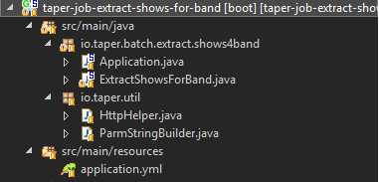

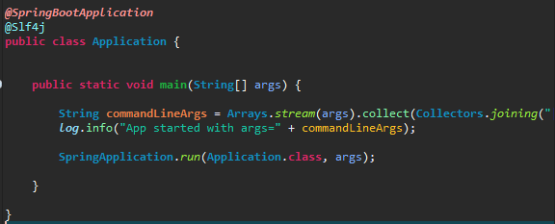

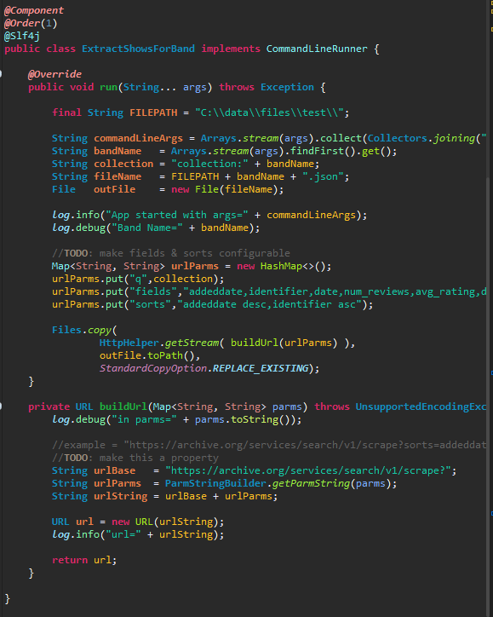

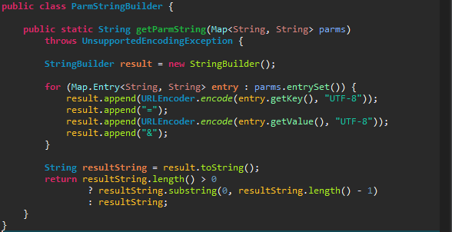

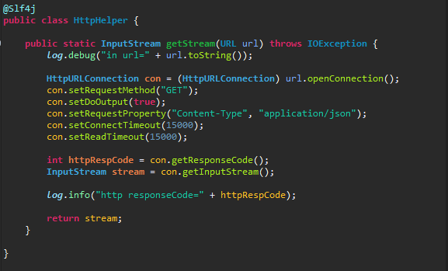

### Loop thru driver to get show for show-identifier

#### Design

* Read json extract file
* Parse it into showsForBand object
* Stream that object . for each show:
  + Build url
  + Hit url
  + Write results to file

#### Develop

* Add @Data objects to io.taper.domain
  + ShowMetadata
  + ShowsForBand
* Use Jackson to parse/map the file to objects

<https://springframework.guru/processing-json-jackson/>

* Stream the shows.items . forEach,
  + Hit [https://archive.org/metadata/<identifier](https://archive.org/metadata/%3cidentifier)> to pull the detailed metadata, which will be used later for search
  + Write each result to a separate json file
* https://archive.org/embed/<identifier>&autoplay=1
* Revisit the constants and configurable stuff

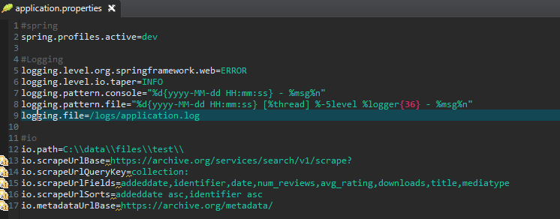

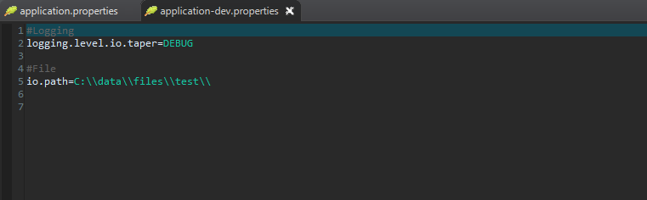

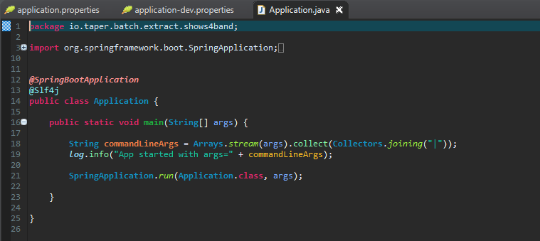

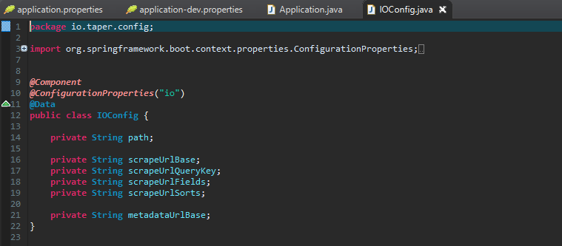

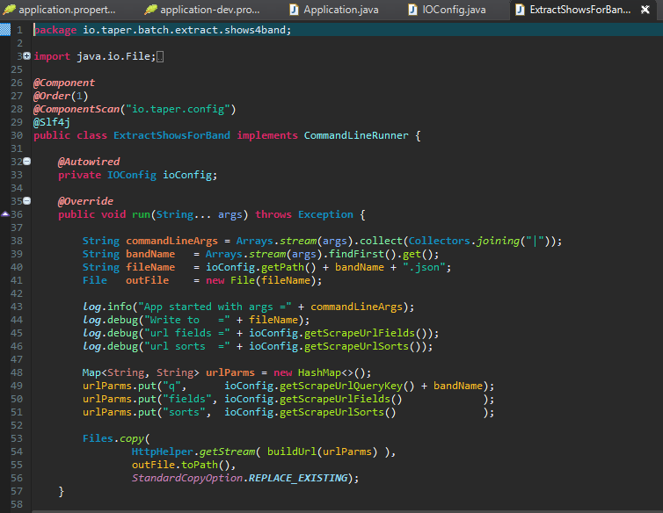

#### Code Coverage

##### Add Unit tests

AssertJ tutorial = <http://joel-costigliola.github.io/assertj/assertj-core-features-highlight.html>

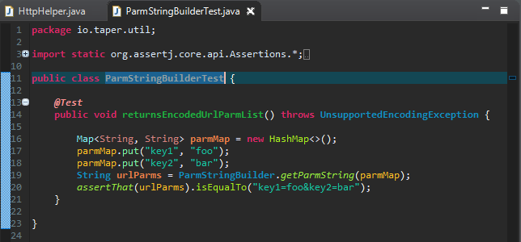

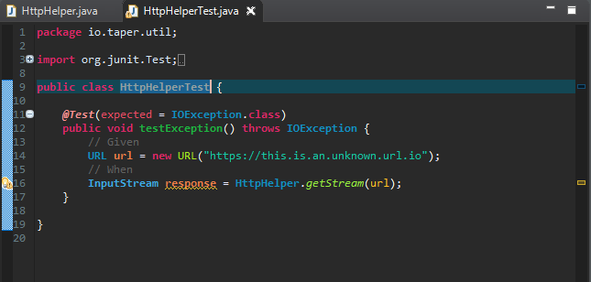

##### Add Jacoco

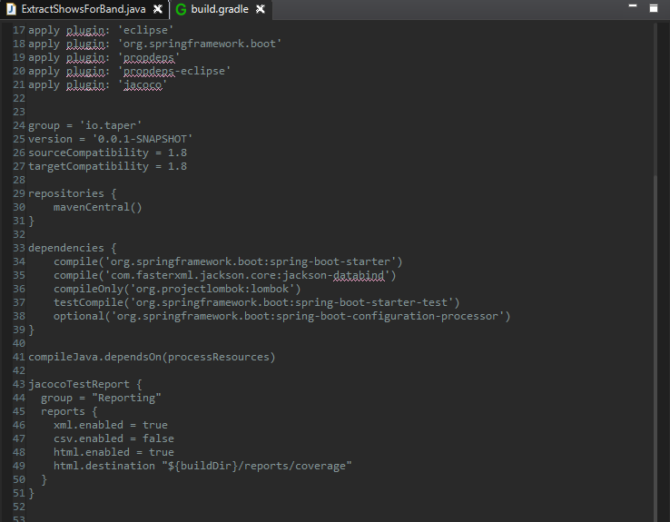

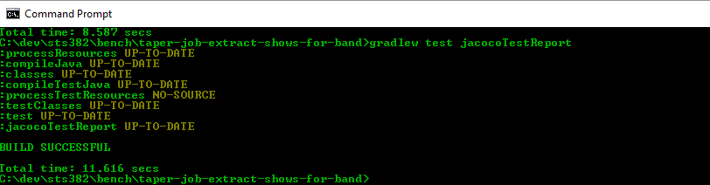

### Transform each file into DB-ready json

* Use parallel streams
* Read
* Map input record to db layout record
* Write

Or… if we want to clean the detailed show files before saving them ( to save GBs when we do a band like GD), we could…

Parse out JUST the metadata element and throw the rest of the file away. Here’s an example of only parsing “age”…

<http://www.baeldung.com/jackson-streaming-api>

while (jParser.nextToken() != JsonToken.END_OBJECT) {

    String fieldname = jParser.getCurrentName();

    if ("age".equals(fieldname)) {

        jParser.nextToken();

        parsedAge = jParser.getIntValue();

        return;

    }

}

jParser.close();

This is really starting to look like a SQL database. If that’s the plan, the I think we could just write the final output files as flat files, then we could merge them with linux sort/merge/cat commands. This could be done very wide by getting a count of shows up front, then dividing that by N to determine number of threads to spin up. …or number of lambdas to hit or number of queues to write… whatever.

### Merge all show files into showDBLoader file

sort -k 8,40 -k 43,49 filea fileb > filec

that sorts filea and fileb with keys in pos 8-40 and 43-49 respectively, then merges them into filec

* If running one BASH script that spins up the commandlinerunners, this is a good idea to just use BASH commands for sort/merge/glue.
* For the single-threaded all java version though, I’m just mapping each show file into the dbload object.
* I will then write the big band-sized dbload object with one read.

### Write showDBLoader rows to db

* I am going to use dynamodb
* I think I will partition by year to avoid hotspots inherent in partitioning by band. (GD has 50,000k shows; Jake has 29.)
* I will sort by band.
* The SCAN will probably be used the most though.
* This data seems to fit nicely into an RDBMS. Why Dynamo again? 25GB free. Nuff said.
* Learn about DynamoDB
  + Part Key = show date : ccyy-mm-dd …or, just band name. …or, band-year
  + Partition = max 10GB, 3000 reads, 1000 writes
  + Scans read the entire table or the entire secondary index
* Sample Data Load tutorial
  + <https://docs.aws.amazon.com/amazondynamodb/latest/developerguide/CodeSamples.html>
  + create forum, thread and reply tables
  + > aws dynamodb batch-write-item –request-items file://Forum.json [dash-dash]
  + User AWS-ASK got an AccessDeniedException on dynamodb:BatchWriteItem
  + Go to AWS Console – IAM. Add DynamoDB full access to AWS-ASK user.
  + > aws dynamodb batch-write-item –request-items file://Forum.json [dash-dash]
  + > aws dynamodb batch-write-item –request-items file://Thread.json [dash-dash]
  + > aws dynamodb batch-write-item –request-items file://Reply.json [dash-dash]
  + Note the layout of these JSON files (C:/data/files/dynamoTutorial. Our ETL will need to build this layout to do a CLI batch load.
* TaperBand
  + ID
  + Name
  + Poster
  + ShowCount
* TaperShow
  + identifier
  + addeddate
  + coverage
  + date
  + mediatype
  + title
  + venue
  + source
  + lineage
  + taper
  + transferer
  + runtime
  + description
  + downloads
  + avg_rating
  + num_reviews
  + files[]
    - name
    - track
    - format
    - title

"files": {

"L": [

{

"M": {

"name": {

"S": "jshimabukuro2006-06-09t03.flac"

},

"track": {

"S": "03"

},

"format": {

"S": "Flac"

},

"title": {

"S": "Dragon"

}

}

},

{

"M": {

"name": {

"S": "jshimabukuro2006-06-09t04.flac"

},

"track": {

"S": "04"

},

"format": {

"S": "Flac"

},

"title": {

"S": "Cross Current"

}

}

}

]

},

* batch-write-item expects data in this format…

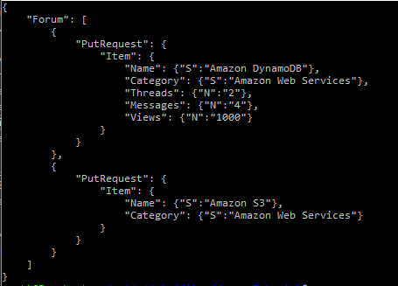

* DynamoDBMapper
  + <https://docs.aws.amazon.com/amazondynamodb/latest/developerguide/DynamoDBMapper.CRUDExample1.html> String
  + <https://docs.aws.amazon.com/amazondynamodb/latest/developerguide/DynamoDBMapper.BatchWriteExample.html>

.:. redo transform to build a load file that looks like that!

* + > aws dynamodb batch-write-item –request-items file://ZDB_JakeShimabukuro_TaperShow.json
    - Remove last 7 put requests because the max is 25. TODO: change the stream to an iter loop,so can break out and write at each 25 increment.
  + It worked! Stored data to dynamoDB!



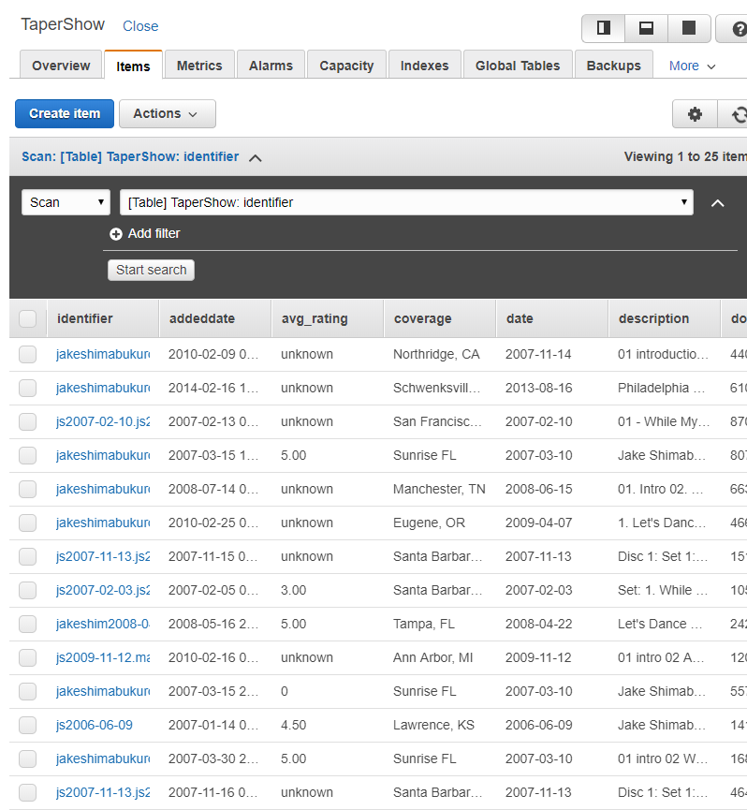

… then put it all in a BASH script. The extract, the transform, the load, the clean up.

* Script:
  + > java –jar taper-job-extract-shows-for-band-0.0.1-SNAPSHOT.jar <bandId>
  + > java –jar taper-job-transform-shows-for-band-0.0.1-SNAPSHOT.jar <bandId>
  + Loop for every ZDB*_<bandId>_TaperShow.json
    - > aws dynamodb batch-write-item –request-items file://ZDB<n>_<bandId>_TaperShow.json

### Refine the DB data

Iterated on the ETL several times to get the data how I wanted it. Probably still not done.

… just pulled sorted list of flacs out of big files[]. Want to store those on the db too. The log of setList looks good; still need to plug setlist into the putRequest item object.

Here’s what I need to build…

“files”: {

“L”: [

{

“M”: {

“name”: {“S”: “jake1.flac”},

“track”: {“S”: “01”},

…

}

},

{

“M”: {

“name”: {“S”: “jake2.flac”},

“track”: {“S”: “02”},

…

}

}

]

}

Change some of the naming. Planned to leave it with same names as archive.org, but the returned taper data just seems a little janky. Going to do some renaming to improve readability of the json.

* Coverage = geolocation
* Identifier = showId
* Addeddate = addedDate
* Avg_rating = avgRating
* Taper = taperName
* Num_reviews = numReviews
* Mediatype = mediaType
* Date = showDate
* files = tracks
* track = trackNo

## Populate dev-taper-shows with batch jobs

C:/dev/sts382/bench/taper-job-*-shows-for-band/build/libs> java –jar taper-job-extract-shows-for-band-0.0.1-SNAPSHOT.jar <bandId>



C:/dev/sts382/bench/taper-job-*-shows-for-band/build/libs> java –jar taper-job-transform-shows-for-band-0.0.1-SNAPSHOT.jar <bandId>



C:/data/files/test> awsDynamoDbBatchLoader <bandId>





## Build Serverless CRUD API for Database

### Scaffold the new serverless node app



### Add CRUD functions to serverless yaml file











### Add GET functions to the handler file









### Deploy to AWS



### Test It











### Verify AWS Lambda, & API Gateway





### Check into Git/Github





## Build the Front-End

### Mockup

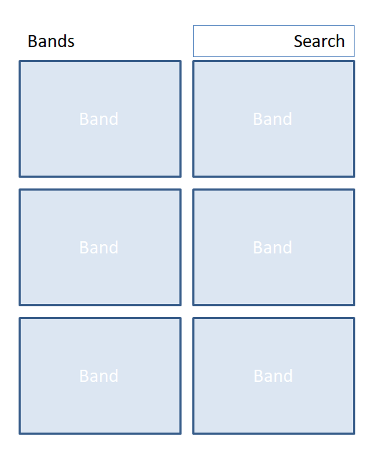

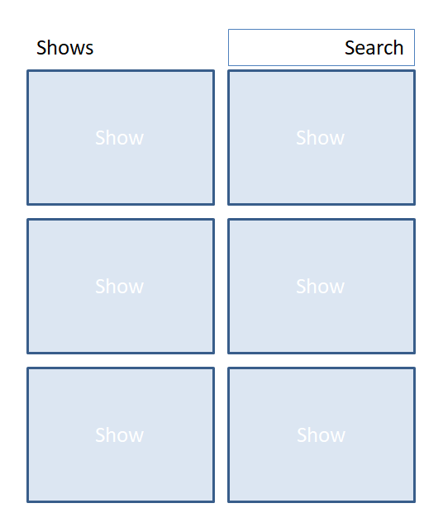

Track -> SetList

Show - > Shows

Build Show Component, then Shows

### Setup

#### Github Setup

* create new repo called taper-web; keep it empty - no readme, ignore, license

#### Create React App

Open Ubuntu shell

* cd /mnt/c/dev/src
* create-react-app taper-web



#### Serve React App Locally

* cd taper-web
* npm start





#### Git Setup

Open a new Ubuntu shell

* cd taper-web
* mv README.md CreateReactApp-readme.md

(That readme is huge; it’s the one on create-react-app’s github repo. Make one for THIS project.)

* vi README.md
  + cut/paste the npm start, npm run, etc instructions into the readme
* git init
* git add .
* git commit –m “Initial commit: create-react-app scaffolding”

#### Sync Git and Github

* git remote add origin <https://github.com/ScottHensen/taper-web.git>
* git push –u origin master



#### Create this dev log

Woah… meta.

* mkdir doc
* save the log to taper-web/doc/devlog.docx
* git status
* git add .
* git commit –m “Add devlog doc”
* git push –u origin master

### Planning

A week of coding saves an hour of planning.

#### Stories

GIVEN a user has [browser] open; WHEN the user navigates to taper web site; THEN the taper web landing page appears.

GIVEN taper landing page is open; WHEN the user clicks on an available show; THEN the show page replaces the landing page.

GIVEN the show page is open; WHEN the page loads; THEN the first song will begin playing at 70% volume.

GIVEN a song is playing; WHEN the song ends; THEN the next song will begin.

#### Components

index.js

assets/

layouts/

primaryLayout

layout-helpers/

primaryHeader

sideMenu

aside

band/

tour/

show/

setlist/

set/

track/

styles/

utils/

xhr

### Initialize Project in Editor

* Import project into editor
* Update manifest.json and index.html to use my title and favicon.
* Build the directory structure
* Move the files to the right directories; change the imports as I move them to keep the app working.



### Steal from your neighbor

I don’t even know where to start. I’ve never done a react app before. So… best place to start is with someone else’s code! I am swiping layout and xhr code [Brad Westfall’s phx react meetup example](https://github.com/bradwestfall/PhxReactMeetupTalk). It will serve as my boiler plate. Thanks Brad!

* Got missing module errors, so added these two…
* npm install –save react-router-dom
* npm install –save axios
* here’s how it looks now



* git status
* git add .
* git commit –m “Add layout, bands page and simple xhr functionality”
* git push –u origin master
* removed the paging stuff from landing page
* added second page for bands
* added routing for the following
  + / -> landing
  + /bands -> landing
  + /bands/2 -> bands





* git status
* git add .
* git commit –m “Add routing between landing page and bands page; removed paging.”
* git push –u origin master

### Barebones App & API Calls

Index.html

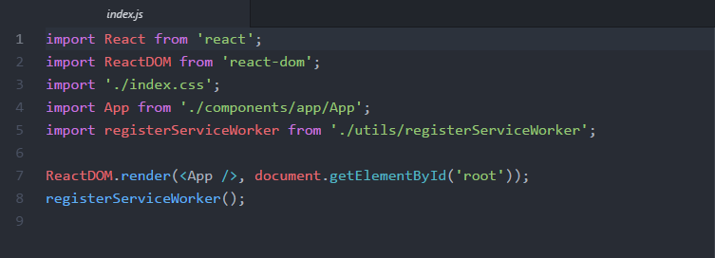

utils/xhr.js

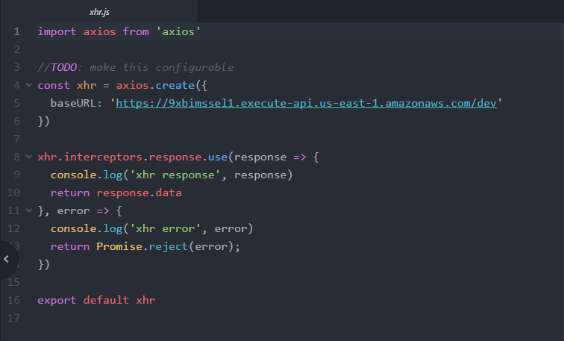

components/app/app.js

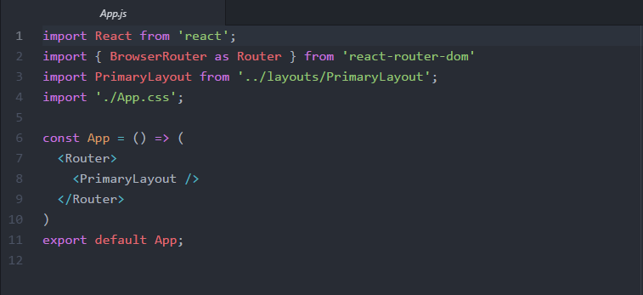

components/layouts/primaryLayout.js

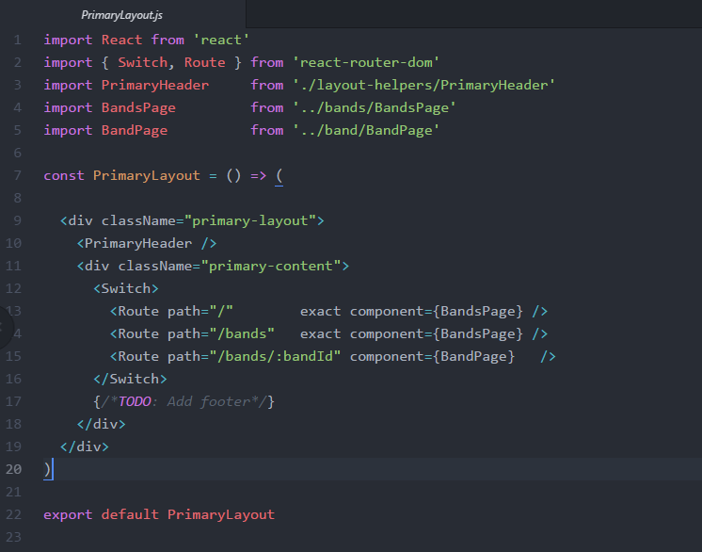

Components/layouts/PrimaryHeader.js

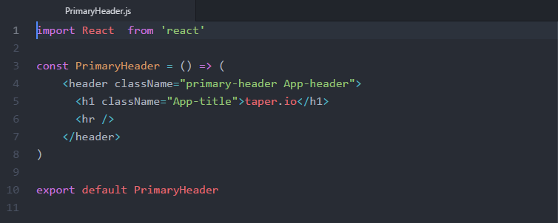

components/bands/bandsPage.js

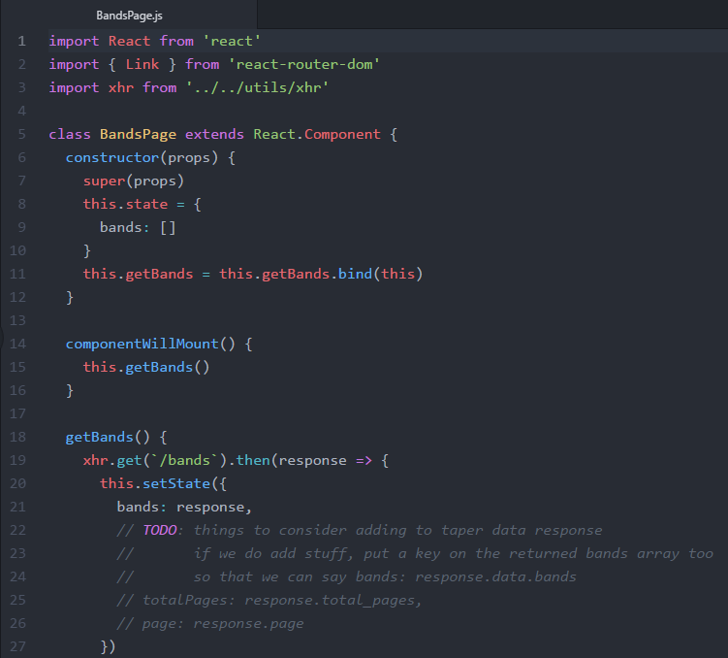

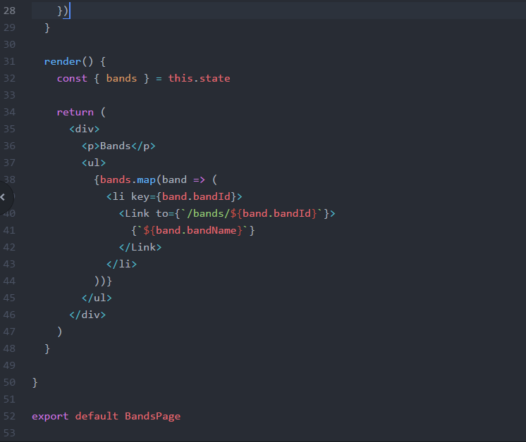

components/band/bandPage.js

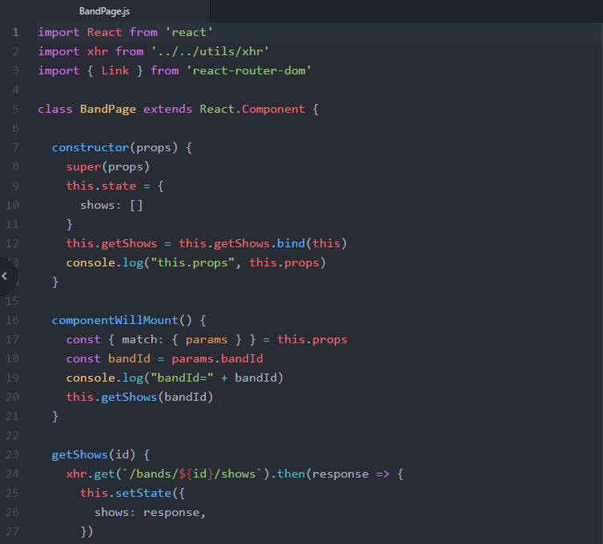

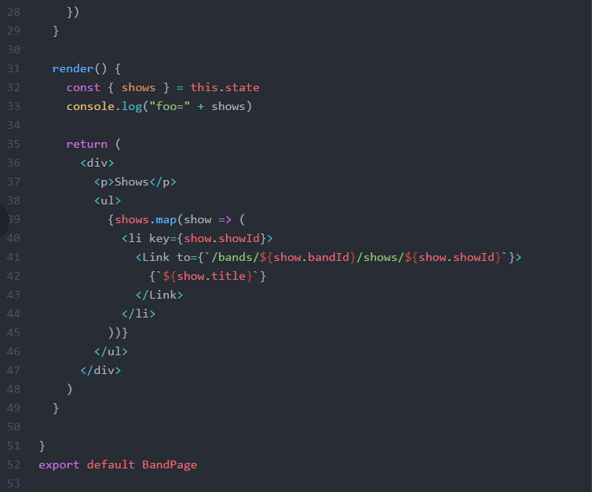

### Fix CORS error in taper-data api

Checked taper-data api. Had it set up with cors=true in serverless.yml, but was not sending back the CORS headers in the response. So, the chrome browser was throwing the CORS error, not the taper api. Added the headers to the taper-data/handler.js and redeployed.

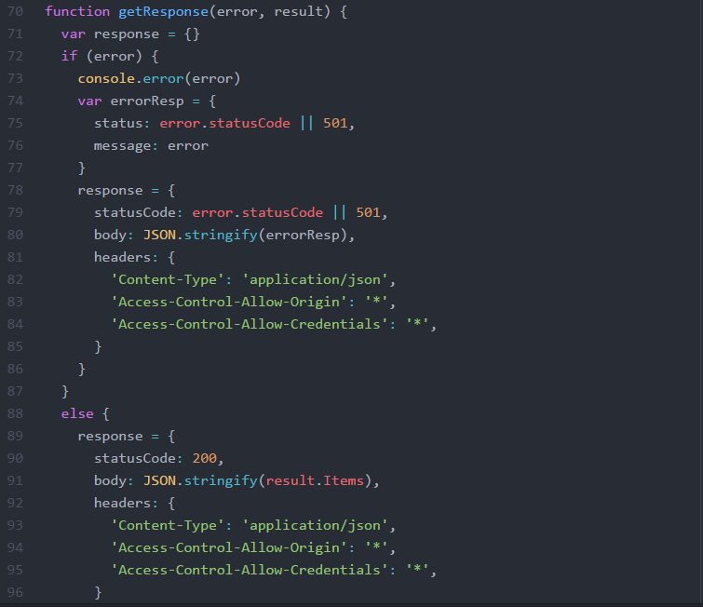

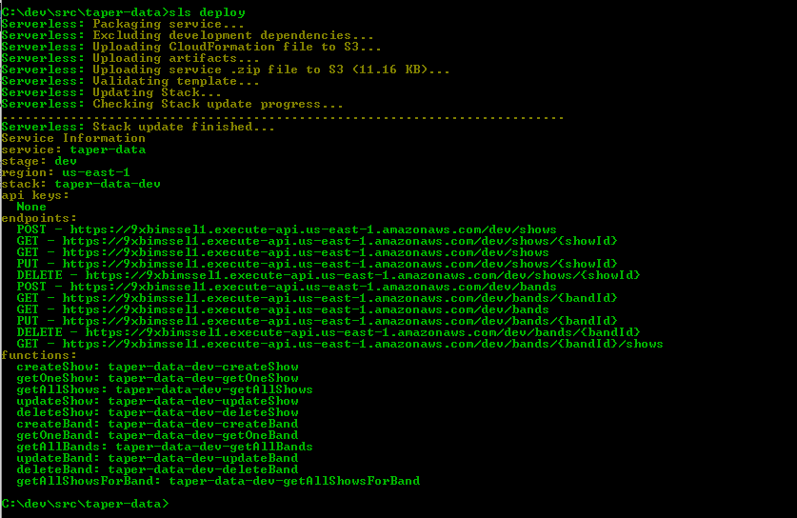

See here for more details… <https://enable-cors.org/>

## Wrap it up man.

This little effort got way out of control. Here’s a recap of what I did…

1. First, I picked up React.
2. Then, after building a backend to serve up the embeddable urls from archive.org, I realized that I couldn’t use their search api because they don’t have cors opened up. Works fine from command line or browser bar, just not from another app. Argh.
3. So, I built a batch process that would hit their search/scrape functionality from a commandline.
4. With the collected json results, I populate my own smaller version of their giant tape database.
5. Then, I built lambda functions to pull data from my databases.
6. Now, I am ready to add the lambda functions to the front-end.